**Workbook**

**NHÀ XUẤT BẢN GIÁO DỤC VIỆT NAM**

**OXFORD**

**UNIVERSITY PRESS**



**Contents**



|  |  |
| --- | --- |
| Introduction | 4 |
| Unit 1 Feelings | 8 |
| Unit 2 Adventure | 16 |
| Unit 3 Onscreen | 24 |
| Unit 4 Our planet | 32 |
| Unit 5 Ambition | 40 |
| Unit 6 Money | 48 |
| Unit 7 Tourism | 56 |
| Unit 8 Science | 64 |
| Cumulative Review | 72 |
| Functions Bank | 82 |

**Lời nói đâu**

Tiếng Anh 10 Friends Global - Workbook do Nhà xuất bản Giáo dục Việt Nam tổ chức biên soạn giúp học sinh củng cố và mở rộng kiến thức ngôn ngữ và kĩ năng giao tiếp tiếng Anh mà các em đã học trong sách giáo khoa Tiếng Anh 10 Friends Global - Student Book.

Sách gồm một bài Introduction và 8 đơn vị bài tương ứng với 8 đơn vị bài học trong sách giáo khoa Tiếng Anh 10 Friends Global - Student Book. Mỗi đơn vị bài đều có 8 phần được thiết kế nhất quán với sách học sinh để luyện tập ngữ pháp, củng cố kĩ năng, ôn luyện từ vựng theo chủ điể’m đã học.

Cuối sách có 5 bài Cumulative Review phối hợp kiể’m tra kiến thức giữa các bài học giúp học sinh có cơ hội ôn luyện kĩ hơn những kĩ năng đã học trong sách học sinh; ngoài ra còn có phần Functions Bank tóm tắt cô đọng các mẫu câu tiêu biể’u đã học.

Chúng tôi mong rằng Tiếng Anh 10 Friends Global - Workbook sẽ là một phương tiện hỗ trợ tốt cho các em học sinh lớp 10 phát triển kĩ năng tiếng Anh.

**Các tác giả**



Likes and dislikes

1. can talk about likes and dislikes.
2. **Look at the pictures and complete the chart with the phrases below. Then complete sentences 1-5 with the information from the chart.**
3. **love I don't like I don't mind I like I can't stand**
4. **hate I'm really keen on**



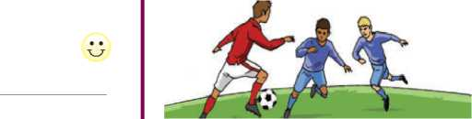

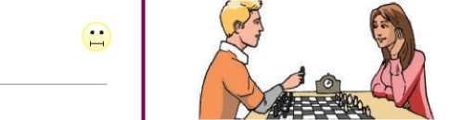

1. **Complete the dialogue with the phrases below. More than one answer may be possible.**

**can't stand hate don't mind quite like really keen love terrible isn't bad is great**

**Kim** So, are you excited about the start of school? **Dave** No, I'm not really excited. I 1 school,

but it's not my favourite thing in the world.

**Kim** We're very different. I *[1] [2]* school! I really

enjoy learning new things. What subjects do you like?

**Dave** 1[3] IT, because I'm interested in

computers. And there's one subject I really enjoy - drama. I'm *[4] [5]* on drama. I think acting

5

**Kim** Really? We're very different that way too.

1. 6 drama. I just get too scared in front

of people. What do you think of maths?

**Dave** I really don't like it. Actually, I 7 maths!

1. just can't understand it. It's 8 !

**Kim** Different again! I like maths, and I enjoy science a lot too.

**Dave** OK, science 9 . It's actually kind of

interesting.

**Kim** Well, I'm happy we agree on something ...

1. **Read definitions 1-9 and match them with the activities below.**

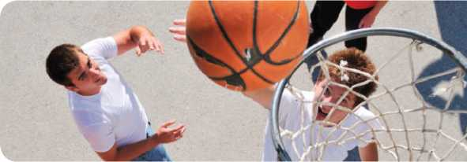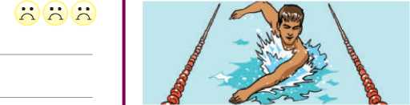

**cycling volleyball chess ice hockey board games basketball swimming drawing video games**

1. a game where you bounce a ball and try to throw it

through a hoop

1. making pictures with a pencil or pen
2. exercising in water
3. a game with 32 pieces on a board, including a king and

queen

1. games with pieces that you play on a table
2. games you play on a computer or TV screen
3. riding a bike
4. a game you play on ice with a long stick
5. a game where you hit a ball with your hands over a high

net



Contrast: present simple and present continuous

I can distinguish the use of the present simple and present continuous.

**3 Match sentences a-f with the uses of the present**

1. **Complete the dialogues with the correct present simple form of the verbs in brackets.**
2. A: (you / go) to the gym every day?

B: No, I (not go) every day.

1. (go) three times a week.
2. A: (Sam / study) at your school?

B: No, he (not study) there. He

(study) at a private school.

1. A: Does your mother (teach) English?

B: Yes, she does. She also (teach)

French and Spanish. She (be) very

good at languages.

1. A: (your parents / work) in London?

B: No, they don't. They both (work) in

Oxford.

1. A: (you / practise) much before you

perform a new play?

B: Yes, we (practise) for weeks

before the first performance, and the director (make) a lot of changes.

1. **Complete the voice message with the correct present continuous form of the verbs in brackets.**

Hi Steve! It's Sean. How are things? I hope you are well.

1. (you / have) a good time in Hull?
2. [6] [7] [8] (call) from my grandparents' house

in Cornwall. My sister and I [9] (stay)

here for a couple of weeks, and we [10]

(enjoy) it a lot. I [11] (plan) to study for

my exams later, but now I [12] (relax).

I'm not totally lazy, though - I 7 (run) every

morning. Jake and I 8 (think) about

spending a month in Spain. Would you like to go with us? Let me know! Well, the sun 9 (shine)

so I think I'll go for a walk. Bye!

1. **Complete the sentences with the correct present simple or present continuous form of the verbs in brackets.**
2. Josh at least one point in every game he

plays. (score)

1. I that they will give Kate a place on the

team. (believe)

1. Susan to finish her homework today. (try)
2. My dad Chinese food tonight. (cook)
3. My brother loves books. He a book every

week. (read)

1. I all of my old *Friends* DVDs this week.

(watch)

1. Sam before 7 a.m., even on Sundays.

(get up)

1. Look out of the window. A big storm !

(come)

1. Lisa usually video games when she gets

home. (play)

1. I what you're saying, but I don't agree with

it. (understand)

1. **Complete the email with the correct present simple or present continuous form of the verbs in brackets.**



Hi Lauren,

How 1 (be) everything? I hope you 2

(have) a great time at football camp this week. I 3

(enjoy) my summer drama project. Every summer we 4

(put on) a play by Shakespeare, and this year we 5

(work) on *A Midsummer Night's Dream.* It's a great play because it

1. (have) so many different roles. We
2. (practise) about six hours a day and we're performing the play in

public next week. I 8 (try) very hard to learn my lines.

1. 9 (play) two parts in the play, and sometimes I
2. (forget) which part I'm playing! Anyway, I
3. (believe) it will be a great performance. My grandparents
4. (travel) from Leeds next week just to see me in the play.

I know you 13 (be) very busy at camp, but I

14 (hope) to hear from you soon.

Take care!

Daisy

,

**a** I am leaving for London at 6 a.m. tomorrow.

**b** The Earth goes around the sun.

**c** I always play basketball on Saturdays.

**d** They are spending a lot of time together these days.

**e** I need some help with homework.

**f** Look outside - it's snowing!



**IC**

Describing people

I can describe people’s appearance.

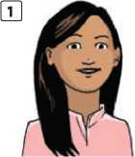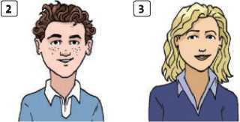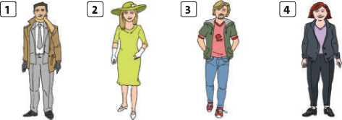

**curly dark fair straight wavy**

**1**

1. **Look at the pictures and describe the people's hair with the adjectives below. Make sure the adjectives are in the correct order.**

**long medium-length short black**

1. **Write short descriptions of the people. Describe their hair, facial hair and clothes.**

**2**

**3**

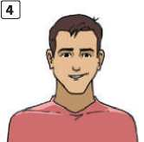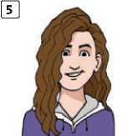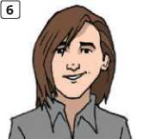

1. Maria’s got hair.
2. Tom’s got hair.
3. Alice’s got hair.
4. Sea n’s got hair.
5. Lara’s got hair
6. Alex’s got hair.
7. **Match the words below with the descriptions. boots dress coat gloves hoodie jeans socks T-shirt tie trainers**
8. I wear them in winter to keep my feet warm and dry.
9. I wear it over my other clothes when it’s very cold

outside.

1. I wear them on my feet, inside my shoes.
2. Men often wear one around their necks when they go

to work.

1. I wear these on my feet when I run or exercise.
2. It’s like a jacket. It’s very soft and warm, and it has a

part to cover my head.

1. I wear these to cover my lower body. They are dark blue

and very strong.

1. You can wear this short-sleeved top on its own or under a jumper. It sometimes has pictures or words on it.
2. 

. You

and a blue

I sat next to you on the 6.30 train from Oxford to London. You left your umbrella on the seat. I've got it. You are tall, with 1 2

1. hair. You wore a light
2. and a dark 5 .

Please contact me and I'll return your umbrella.



Grammar

Articles

I can correctly use a I an and the with nouns.

1. **Match sentences a-f with uses of the article or**

**no article (1-6).**

1. it is clear what we are talking about **I I**
2. saying what someone's job is **I I**
3. something mentioned for the first time I I
4. the only one of something **I I**
5. a generalisation I I
6. something mentioned for the second time I I

**a** There is **a** strange man in our street.

**b** Chad has a new car. **The** car is black and silver.

**c The** moon is very bright tonight.

**d** We meet in **the** café after school.

**e** Gemma is **a** shop assistant.

**f** I'm really interested in **(-)** science.

1. **Complete the gaps with *the* or no article (-).**
2. I enjoy walking in rain - it's so peaceful.
3. Some young people don't see point of

studying history.

1. I'll meet you at railway station at 6 o'clock.
2. Do you like action films?
3. I don't like to see young children playing

violent sports like rugby.

1. It's likely I'll be late for school tomorrow.
2. I love food in this restaurant, but then I

always enjoy Italian food.

1. All over world, people have

similar problems.

1. **Complete the gaps with *a I an, the* or no article (-).**

|  |  |  |
| --- | --- | --- |
| **1** | This is | _ school where I study English. |
| **2** | She has  better one. | nice car, but she wants a |
| **3** | Do you watch | TV often? |
| **4** | There is newspaper. | interesting article in |
| **5** | I want to go to | cinema this evening. |
| **6** | I like watching | baseball. |
| **7** | She is in | hospital because she had |
|  | accident. | |
| **8** | Julie's mum is | doctor. |
| **9** | It is so nice to see _ | sun again! |
| **10** | Is it time to go to _ | bed already? |

1. **Complete the gaps with *a I an, the* or no article (-).**

Hl Mason,

How are you? Are you enjoying 1 winter holidays?

You asked about my school, so I'll tell you a bit about it. It's 2 very old building - they built 3

'new' part in 1930! It's very nice inside, though. *4*

classrooms are bright and clean, and some of them have interactive whiteboards. Of course, everyone wants to use 5 classrooms with 6 new

whiteboards! We have lovely playing fields near the school, but there isn't 7 swimming pool.

1. looked up your school online, and it looks like 8

very new building from 9 photographs I saw.

Do you like it there?

Write to me soon.

Best wishes,

Tom

1. **Complete the sentences with *there IS* or *there are.***
2. three new students in our class.
3. a great drama class at my school.
4. about 50 laptops in our computer lab.
5. I think a good film on at the cinema.
6. only two shows I watch on TV.
7. some really nice clothes in that shop.
8. Ethan, a man here who wants to talk

to you.

1. I know an answer to this problem, but
2. can't find it.
3. people from many different countries

in London.

1. I want to go home. a storm coming.
2. **Find and correct the mistakes in the sentences.**
3. It is a first day of school tomorrow. **X** the first day
4. They are three students from China in my class this

year. **X**

1. I play in football team with classmates from my school. **X**
2. My dad leaves for the work at 7 a.m. every morning. **X**
3. Kelly's sister is an dancer. **X**
4. It is a great film on TV tonight. **X**
5. We have the great computer lab in our school. **X**
6. We have a new car. A car is very fast. **X**
7. I'm giving Maggie the CD of dance music for her birthday. **X**
8. I'm interested in the geography. It's my favourite subject. **X**

How do you feel?

I can describe how people are feeling.

**1 Look at the pictures and complete the puzzle with adjectives to describe feelings.**

**1**

**3**

**10**

What is the mystery word?

**2 Which adjective best describes each person's feelings?**

**Use the adjectives below.**

**anxious delighted embarrassed frightened proud relieved ~~shock~~e~~d~~ upset**

1. The waiter was really rude to me when I asked for a glass of water. I was a bit shocked.
2. I got a new smartphone for my birthday. I was
3. My dad started to dance at my party and all my friends

saw him! I was really !

1. My little brother won a singing competition. I was very
2. Our dog is very old and is really ill. I think he might die.

We’re very .

1. I’ve got a difficult, important exam tomorrow. I’m feeling

a little bit .

1. I went on the tallest, fastest ride at the theme park. I was

really .

1. I left my mobile on the bus, but someone found it. I was

extremely .

**Q1.02**

**Listen. How are the people feeling? Choose from**

**the adjectives below. There are two extra adjectives.**

**cross delighted envious relieved suspicious**

**Speaker 1 Speaker 3**

**Speaker 2**

**4 Complete the sentences with your own words.**

**1** I feel confused when

1. I feel bored when
2. I feel proud when
3. I feel excited when
4. I feel disappointed when

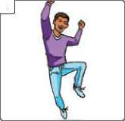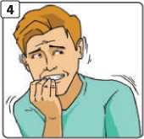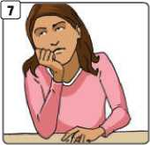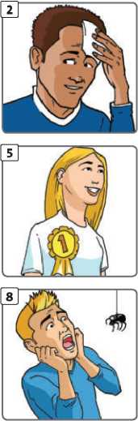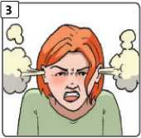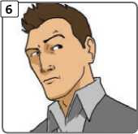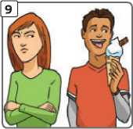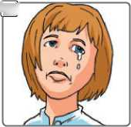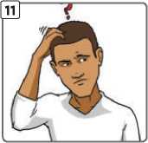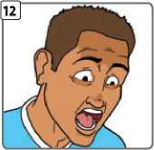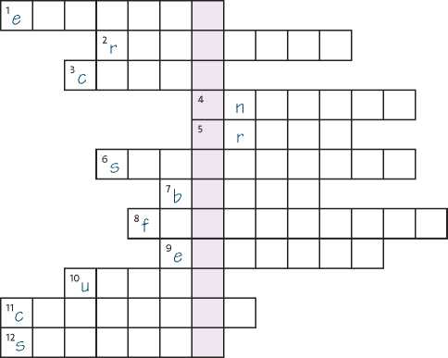



**IB**

Past simple (affirmative)

I can use the past simple affirmative.

1. **Complete the sentences with the past simple affirmative form of the regular verbs below.**

**decide die drop look marry move stop study talk want**

1. My dad maths at university.
2. We live in Oxford. We here five years ago.
3. Jason at me and smiled.
4. The train at the station and we got off.
5. Jenny on the phone with her friend for

over two hours!

1. In the end, we to go on holiday to Italy, not

to France.

1. The goalkeeper had the ball, but then he it.
2. My mum my dad in 1988.
3. I to go to the shopping mall, but my mum

said no.

1. Sadly, my grandma last year. She was 98.
2. **Write five true sentences about what you did last weekend. Use past simple form of the verbs below to help you, or your own ideas.**

**be get go have phone play study take talk visit watch**



**Complete the sentences. Use the past simple affirmative form of the irregular verbs in brackets.**

**1**

Emma tried on a green dress and a blue dress in the clothes shop, and (choose) the blue one.

I (find) £20 in the street last Saturday.

We (go) bowling yesterday evening.

Somebody (steal) my smartphone from my

schoolbag.

The film ten.

(begin) at seven and finished at

It (take) six hours to drive from London to

Edinburgh.

Hannah

exam results.

(feel) relieved when she got her

**9**

**10**

Tom and Matt (be) upset that George

didn't invite them to his party.

We (get) home at eight o'clock on Sunday.

Millie (spend) all her money on computer

games.

**Complete the texts with the past simple affirmative of the verbs in brackets.**

Callie Rogers 1 (be) just sixteen when she

2 (win) the lottery in 2003. She 3

(give) up her job as a shop assistant and 4 (start)

to spend her money. She 5 (take) her family on

expensive holidays, 6 (invite) all her friends to

big parties every weekend and 7 (have) cosmetic

surgery. Ten years later, she 8 (have) just £2,000

left. But she's happy now. 'I 9 (be) too young to win

the lottery,' she 10 (say).

**Unit 1** Feelings

Tom Crist 11 (get) a big surprise

when he 12 (answer) his phone on

1. December 2013. He 13 (be) a

lottery winner, and the prize 14

(be) enormous - $40 million! He 15

(decide) not to tell anyone about the win. He immediately 16 (give) all the money

to charities. ‘I don't really need that money,' he

1. (say). 'My wife 18 (die)

earlier in the year so I 19 (choose)

cancer charities that 20 (help) her.'

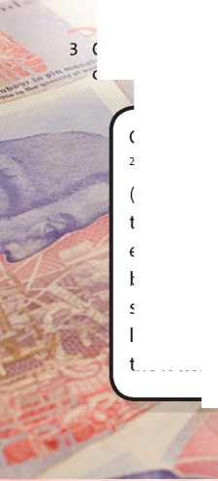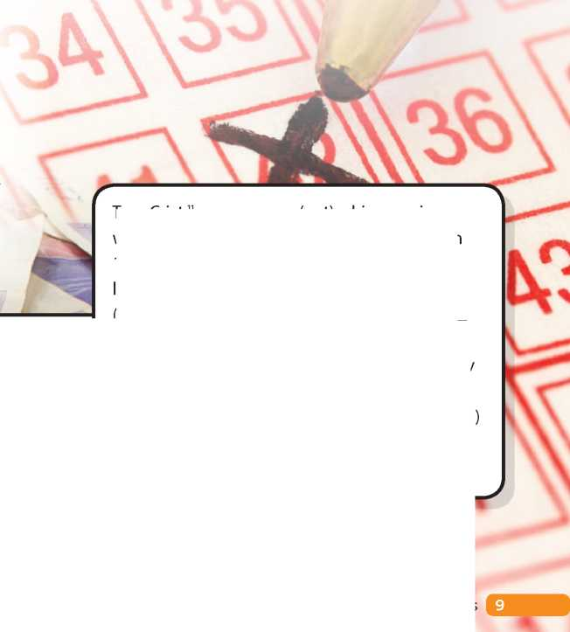

I Revision: Student Book page 13

1 Choose the correct verb.

1. We should **do** / **make** a plan for the weekend.
2. Can you **have** / **tell** a word with your sister?
3. You should **give** / **make** her a call and apologise.
4. Don't **keep** / **take** offence. It was only a joke!
5. I **made** / **took** an excuse and left the party early.
6. Is it always wrong to **make** / **tell** a lie?
7. I'm really tired. Can we **do** / **take** a break now?
8. I nearly always **give** / **tell** the truth.

Listening Strategy

You do not have to understand every word in a listening task. Focus on the general meaning and try not to be distracted by words you do not understand.

**Q1-03**

Read the Listening Strategy. Then listen to two

short dialogues. For each one, choose the best summary of the general meaning (a or b).

1. **Complete the advice with *should* or *shouldn’t* and the verbs below.**

**feel go invite listen look ~~op~~e~~n~~ spend tell**

1. ‘It's really hot in here.' ‘We should open a window.'
2. ‘My ears are hurting.' ‘You to

loud music so often.'

1. ‘I think we're lost.' ‘Yes. We

at a map.'

1. ‘I only got 68% in my exam.' ‘You

disappointed. That's a good mark!'

1. ‘I really like the girl next door.' ‘We

her to our party.'

1. ‘Do you like Reece's new shirt?' ‘No - but I don't think you him that.'
2. ‘My science project isn't very good.' ‘Maybe you more time on it.'
3. ‘I don't feel well.' ‘You to bed

early.'

1. Write advice for these problems. Use *I think 11 don’t think you should* ... and your own ideas.

**1** My best friend gave me a T-shirt for my birthday, but I hate it.

1. Ellie is upset because

**a** she can't take part in the school show. **b** she can't go to a family wedding.

1. Daisy is excited because

**a** she likes seeing her cousin.

**b** her cousin has got a present for her.

**Q1.04**

Listen to two dialogues (A and B). Match the

dialogues with sentences 1 - 3 below. There is one extra sentence.

The person with the problem:

1. asks for advice, but decides not to follow it. **I I**
2. gets angry when their friend gives advice. **I I**
3. does not get any advice from their friend. **I I**

**Q 1.04**

**Listen again. Complete the missing words in these**

**lines from the dialogues.**

Dialogue A

1. I what to do.
2. Oh dear, I problem.

Dialogue B

1. Can I something?
2. Just talk to him advice.



1. I want to go to the cinema this weekend, but I haven't got any money.

Grammar J

**ID**

Past simple (negative and interrogative), Question words

I can use the past simple to describe events.

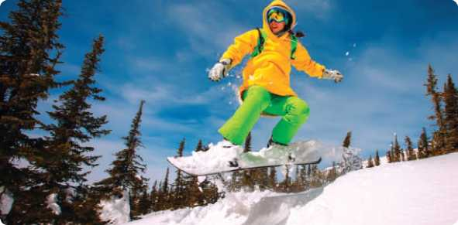

1. Complete the sentences with the correct negative past simple form of the verbs in brackets.
2. We (get) to the hotel in time for dinner.
3. Our team (win) the last match of the

season.

1. It was a long film, but I (feel) bored.
2. They (spend) all their money on holiday.
3. My aunt (be) at the family wedding last

weekend.

1. Our teacher (give) us a lot of

homework.

1. Complete the first part of each sentence with the correct past simple negative form.
2. I *didn't go* skiing last winter, I went snowboarding.
3. Einstein in 1965, he died in 1955.
4. The holidays yesterday, they began last

week.

1. My grandparents born in Russia, they

were born in Germany.

1. I ‘thirteen', I said ‘thirty'.
2. We the first half of the match, but we

saw the second half.

3 Make these sentences true for you. Use the past simple affirmative or negative form of the verbs in brackets.

|  |  |  |
| --- | --- | --- |
| **1** | I | _ (can) swim when I was five. |
| **2** | Last weekend, I _ | (do) a lot of homework. |
| **3** | Five years ago, I _ school. | (be) a student at this |
| **4** | Ten years ago, I | (live) in a different town. |
| **5** | I | _ (make) my own breakfast this morning. |
| **6** | I | _ (choose) the clothes I'm wearing now. |

1. Complete the dialogue with the question words below. how often what when where which who why

**Mia** Hi, Henry. 1 did you do at the

weekend?

**Henry** I went to the beach on Saturday.

**Mia** That's nice! *[13] [14] [15]* did you go with?

**Henry** Matt and Alex.

**Mia** Alex West? [16] do you see him?

**Henry** Only two or three times a year. He doesn't live near here any more.

**Mia** *[17]* does he live now?

**Henry** In London.

**Mia** Does he? [18] part of London?

**Henry** I'm not sure. North London, I think.

**Mia** [19] did he move?

**Henry** I think his mum got a new job. Anyway,

1. did you last see him?

**Mia** Oh, about two years ago.

1. Put the words in order to make questions. Then write answers that are true for you.
2. homework / how much / last / did / you / night / do / ?
3. with / travel / did / to / school / you / who / today / ?
4. best / meet / where / you / did / friend / your / ?
5. first / teacher / who / your / was / English / ?



Adjective endings

I can use different adjective endings.

1. **Circle the correct adjective.**
2. Playing volleyball is fun, but it's **tired** / **tiring**.
3. This new computer game is **amazed** / **amazing**!
4. I was **astonished** / **astonishing** that we won the dance competition.
5. ‘I fell off my chair in the middle of a lesson.' ‘How **embarrassed** / **embarrassing**!'
6. My grandma's stories are always **interested** / **interesting**.
7. I read a **shocked** / **shocking** report about smoking.
8. I wasn't **surprised** / **surprising** that he was late.
9. I was so **annoyed** / **annoying** about your comment!
10. **Complete the text with the correct *-ed* or *-ing* adjectives formed from the verbs in brackets.**

a *Long* WAY Home

Saroo was born in Madhya Pradesh in India. His family were very poor, so when Saroo was just five, he and his brother Guddu found work on trains as cleaners. The job was very **1**

(tire) and ONE DAY Saroo fell asleep at the station.

He was so **2** (exhaust) that he slept for

hours. When he woke up, Guddu was not there. Saroo was **3** (worry). He looked for his

brother, but couldn't find him. It was very 4 (frighten). After two weeks, the police

found Saroo, but he couldn't tell them where his home was **-** he was too **[20] [21]** (confuse).

In the end, the police had to place him with an adoption agency. An Australian family took him to their home and he grew up with them. As an adult, Saroo looked for his home town in India. It took months, but in the end, he found it. He was 6 (delight) and travelled there at

once. When he saw his mother again for the first time in 25 years, it was a very 7 (move)

experience.

Newspapers and TV stations became **8**

(interest) in Saroo's **9** (astonish) story

and Saroo himself wrote an **10** (excite)

book about it in 2012.

1. **Complete the sentences with *-ed* or *-ing* adjectives formed from the verbs below.**

**confuse disgust excite frighten move**

1. ‘This milk has got black bits in it.' ‘How !'
2. We all cried at the end of the film - it was so
3. I enjoyed the book, but I was about the

ending. It didn't make sense.

1. I love watching football, it's so !
2. I felt because it was dark in the house and
3. was alone.

**VOCAB BOOST!**

When you learn a new word, make a note of other related 's-| words at the same time. This will help you expand your vocabulary more quickly.

New word: disappoint (verb)

Related words: disappointed / disappointing (adjectives), disappointment (noun)

Try to add examples. These will help you to remember the meanings.

* I always try not to disappoint my pa rents.
* I was disappointed with my exam results.
* The film was very disappointing.
* I didn't like the present, but I tried to hide my disappointment.

1. **Read the *Vocab boost!* box. Choose ONE of the verbs below. Write down the related adjectives and noun, using a dictionary to help you. Then write example sentences. amuse depress entertain relax satisfy**
2. verb:

Exam ple:

1. *-ed* adjective:

Exam ple:

1. *-ing* adjective:

Exam ple:

**IF**

I Reading

A painless operation

I can understand a text about a medical operation.

**Revision: Student Book page 16 1 Complete the table.**

|  |  |
| --- | --- |
| **Accidents and injuries** | |
| **Noun / Phrase** | **Verb** |
| **1** blood |  |
| **2 a** | burn yourself |
| **3** a cut | your  finger |
| **4** a | sprain your ankle |
| **5** an injury | yourself |
| **6** a arm | break your arm |

Reading Strategy

When you do a matching task, follow these steps:

Read the text to get a general idea of the meaning.

Do not worry if you do not understand every word.

Read the task and all the options carefully.

Read the paragraphs of the text carefully one by one and match them to the correct option.

**4** Check that the extra options do not match any of the paragraphs.

**2 Complete the sentences with the words below. bruise fell over hurt hurts pain slipped 1**

I've got a big black my arm.

I've got a _

My finger

Joe

football.

My mum

where I banged

in my shoulder.

himself when he was playing

on the ice and

3 Read the text. Are the sentences true (T) or false (F)?

1. Lenkei took about half an hour to hypnotise himself. I I
2. Lenkei didn't speak during the operation. I I
3. All the operations were successful. I I

4 Read the Reading Strategy. Then match the questions below with paragraphs 1-3 of the text.

In which paragraph does the writer tell us ...

when the first operation happened? I I why Lenkei needed an operation on his arm? I I what Lenkei did just before the operation on his arm? I I on what part of his body the third operation was? I I when Doctor Llewellyn-Clerk realised that Lenkei was not in pain? I I

when Lenkei first hypnotised someone? I I

what happens to pain signals in his body while he is hypnotised? I I

when Lenkei had his second operation? I I how long the operation on his arm took? I I what the doctor did to Lenkei's arm during the operation? I I

**A B C D E**

**It didn’t hurt!**

**1**

10

In 2008, Alex Lenkei had a problem with the bone in his arm and he needed a serious operation. Normally, with an operation like that, the doctor gives the patient an anaesthetic so that he or she doesn't feel any pain. But Lenkei refused the anaesthetic. Instead, he hypnotised himself and simply told himself that he could not feel any pain. That took about thirty seconds. Then the operation started. According to Mr Lenkei, pain signals do not reach his brain when he is hypnotised.

25

The doctor, David Llewellyn-Clerk, was a bit worried. He had to take some bone from Lenkei's arm. He watched Lenkei carefully during the operation, as he wasn't sure that Lenkei could feel no pain. ‘I didn't think Mr Lenkei could hear us,' said Dr Llewellyn-Clerk, ‘but half way through the operation, he said “How's it going?”' That's when the doctor realised that Lenkei was not in pain. The operation lasted 83 minutes.

Mr Lenkei started hypnotising people when he was sixteen and is now an expert. It wasn't his first operation without anaesthetic. In 1996, a friend hypnotised him before a thirty-minute operation on his stomach. Both operations were successful, so Lenkei had a third operation without anaesthetic in 2013, this time on his ankle, which also went well.

35

**Unit 1** Feelings

**13**

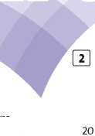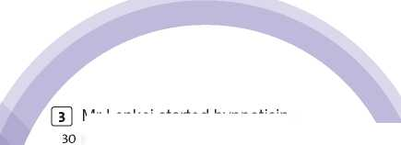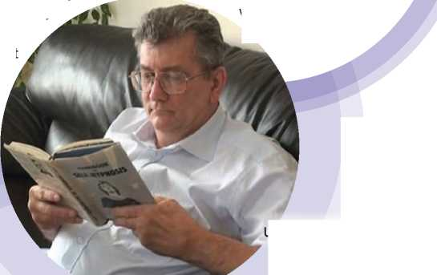

**1G**

**I Speaking I**

**Narrating events**

*I can relate and react to past events.*



1. Put the words and punctuation marks in the correct order to make phrases for reacting and showing interest.
2. envious / I'm / so / really / ? / !

Really? I’m so envious!

1. what / really / relief / a / ? / !
2. like / sounds / nightmare / a / that / !
3. what / oh / shame / no / a / ! / !
4. kidding / you're / !
5. that / like / sounds / fun / !
6. upsetting / how / !
7. **React to these sentences. Use phrases from exercise 1. More than one answer is possible for each sentence.**

1

I lost my mobile phone!

Speaking Strategy

Follow a simple structure for narrating events. For example:

1. Set the scene (Where? When? Who?).
2. Say what happened.
3. Say how you (and/or others) felt about it.
4. Read the Speaking Strategy and the task. Then write notes.

Tell the story of an event that happened in the school holidays.

1. Set the scene.

Who?

Where ?

When ?

1. What happened?

I went scuba diving when I was on holiday.

1. How did you (and/or other people) feel? Think of at least three adjectives.

I'm going to be on TV tonight!

I left my wallet in a shop, but they returned it to me.

**Now do the task using your notes from exercise 4.**

**littlehelen** It was the last day of the summer holidays and I was at my friend Alice's house. She said, 'Everyone is wearing fancy dress to school tomorrow to raise money for charity' So the next day, I went to school in fancy dress. But it was a joke! No one was wearing fancy dress! I had to go home and change, and I missed the first two lessons.

I was very embarrassed, but Alice thought it was really funny and couldn't stop laughing. The teacher was a bit cross with me and Alice!

I got 95% in my French exam.

1. Read the forum post about an event and complete the notes.
2. Set the scene.

Who? Helen, ...

Where?

When?

1. What happened?

Alice - said tomorrow - fancy d ress

1. How did people feel?

Alice - amused - laughed

Helen -

Teacher-



A description of an event

I can describe an event.

Preparation

1. **Rewrite the following sentences. Replace the underlined phrases with the verbs below. Use the correct tenses and any changes if necessary.**

**admit confuse excite apologise disappoint**

1. Maria felt sorry for playing a prank on Mark on his birthday.
2. Robert's reactions on the stage were difficult for us to understand.
3. We all hope for a picnic and the bad weather makes us really upset.
4. My little brother says that he himself put the plastic mouse into my schoolbag.
5. The magician's movements were really interesting to the young children.

Writing Guide

1. Read the task. Then make brief notes in the table below. Use one of the suggestions in the ideas box or your own idea.

You did something you feel bad about. Write a description of an event with the title ‘Confession!’

* Give a short description of what you did.
* Say how you felt at the time.
* Describe how other people reacted.
* Explain why you feel bad about it now.

Notes

What did you do?

How did you feel at the time? Why?

How did other people feel? How did they react?

Writing Strategy

When you write a description of an event, remember to say how you and other people felt at the time, and how you all reacted to the events. This will make your anecdote come to life and engage the reader's interest.

1. **Read the Writing Strategy. Then complete the description using the adjectives below to describe the people’s feelings. guilty proud scared upset**

6

**Confession!**

**Joanne**

1. once bought a big plastic insect at a joke shop and put it inside my brother’s lunch box in the morning. It looked disgusting! I told my friends about the prank - I was 1 of it! My brother didn’t

say anything about it after school. In fact, he didn’t mention it for ages. Then one morning I found the same insect in my bowl of cereal at breakfast. I wasn’t [22] [23] [24] at all - it was funny. But when

1. asked him how he felt when he found it in his lunch box, he didn’t smile. In fact he looked a bit
2. . ‘It was horrible,’ he said. ‘I screamed.

Then everybody laughed at me.’ When I heard that, I felt really [25] . I don’t play tricks on my

brother now!

How do you feel about it now? Why?

Ideas

You feel bad because you:

* borrowed something without asking and broke it.
* told somebody a secret your friend told you.
* copied some homework from the internet.
* told somebody about a surprise party and spoiled the surprise.

1. **Write your description. Use your notes from exercise 3.**



**A**

**Landscapes ^^1** *I can describe landscapes.*

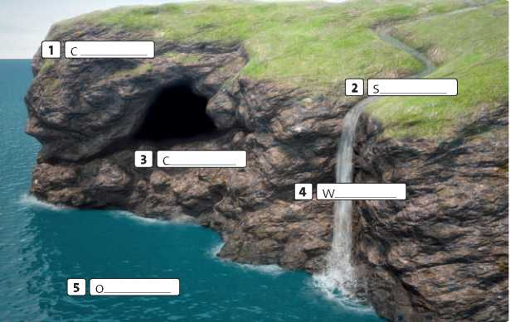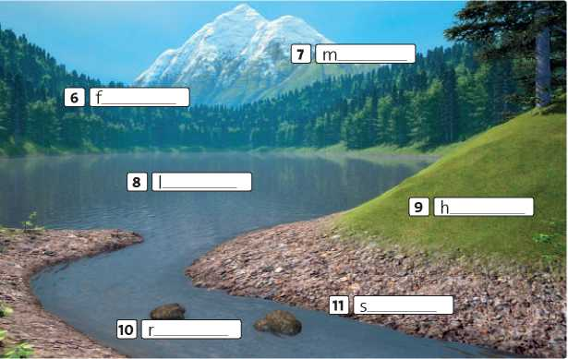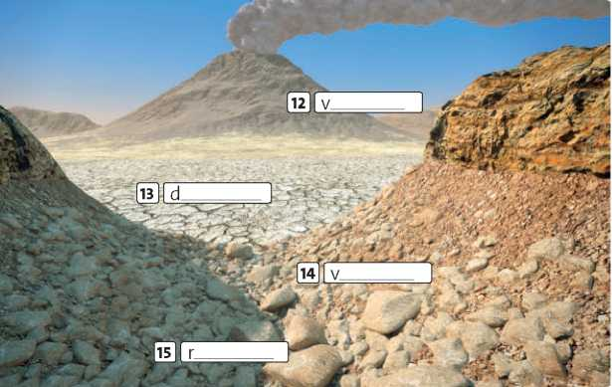

**1 Complete the labels.**

**3**

| **Landscape features** | |
| --- | --- |
| **Adjectives** | **Nouns** |
| **1** l a l t | **river** /^**mountain** |
| **2** c i y | **stream** / **desert** |
| **3** r o w r a n | **ocean** / **river** |
| **4** k a d r | **cave** / **shore** |
| **5** w h o l s a l | **lake** / **valley** |
| **6** o w l | **ocean** / **waterfall** |
| **7** c y k o r | **shore** / **forest** |
| **8** e d p e | **ocean** / **waterfall** |
| **9** d i w e | **river** / **hill** |
| **10** p e s t e | **volcano** / **waterfall** |

2 Put the letters in order to make adjectives that describe landscapes. Then circle the landscape feature that can go with each adjective. Sometimes both are possible.

Qi.qs

Listen and complete the quiz questions.

1. In which country is the highest in the

world?

1. What's the name of the to the east of

Africa?

1. What's the name of the that flows through

London?

1. In which country is Baikal?
2. What's the name of the that run along the

west coast of South America?

1. In which country is the Vesuvius?
2. What's the name of the in southern Africa?
3. In which two continents is the Great Rift ?
4. Which famous American city is on the of

Lake Michigan?

1. In which European country is the Black ?
2. **Answer the questions in exercise 3. Use the internet to help you.**






10. and

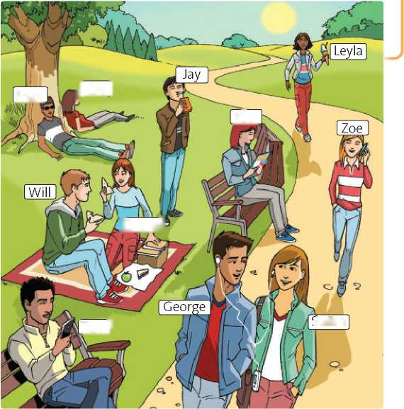

**2B**

il Eve I

Max

Kim

[Emmal

usan

Tom I

1. Grammar

Past continuous

I can use the past continuous.

Complete the sentences with the past continuous form of the verbs in brackets.

1. Yesterday at 6 p.m. we (have)

dinner.

1. Harry (not listen) so he didn't know

how to do the exercise.

1. Kate (lie) on the beach and Anna

(eat) an ice cream.

1. Sam and Ryan (smile) and Nancy

(take) a photo of them.

1. Why you and Zoe (argue)?
2. Hannah was annoyed because a man on the train (talk) loudly on his mobile.

Write sentences. Use the past continuous.

1. Jake / ride / his bike

Jake was *riding* his bike.

1. the sun / shine ?

**3** it / not rain

**4** where / he / go ?

**5** he / not wear / a helmet

**3 Complete the text with the past continuous form of the verbs below.**

**carry follow hurry leave rain stand wear not wear**

When I got off the coach in London, the weather was awful.

It 1 and there was a cold wind.

A short, fat man, who *2* a hat and

3 a small briefcase, got off after me.

It was five o'clock and lots of people *4*

work and 5 to catch the bus or

the Underground. I 6 a raincoat

so I went into a department store and bought a cheap umbrella. When I came out, the short, fat man from the bus 7 outside the department store.

8 he me?

1. **What was happening at the park yesterday afternoon? Complete the sentences, using the verbs and phrases below.**

**Use the past continuous.**

**eat an ice cream drink fruit juice have a picnic listen to music phone someone read a magazine sunbathe text**

1. Tom was texting.
2. Will and Emma .
3. Kim .
4. Max and Eve .
5. George and Susan .
6. Jay .
7. Leyla .
8. Zoe .
9. **Write questions with *you* in the past continuous. Then write true answers.**
10. **~~p.m. y~~e~~st~~e~~rday~~**

**on this day last year 3 a.m. this morning**

1. **p.m. yesterday 8.30 a.m. this morning**

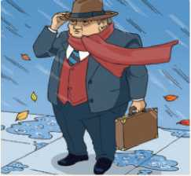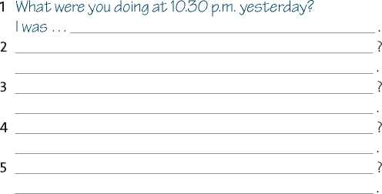

**2C**

I Listening

Adrenaline junkies

I can listen for key words and antonyms.

|  |  |  |  |  |  |  |
| --- | --- | --- | --- | --- | --- | --- |
| **1** | a | alike | b | like | c | similar |
| **2** | a | However | b | Otherwise | c | Instead |
| **3** | a | part | b | place | c | off |
| **4** | a | thanks | b | because | c | according |
| **5** | a | invented | b | decided | c | thought |

1 use of English Read the text about BASE jumping and choose the correct answers (a—c) to complete gaps 1-5.

Speaker I I

BASE jumping is an extreme sport. It is 1 to skydiving,

but there are important differences. Firstly, the jumps are much lower - usually no more than six hundred metres.

And secondly, there is no aircraft. *2* , participants jump

from some kind of bridge, building or cliff. The first BASE jump took 3 in 1912 in New York, when Frederick

Law jumped from the Statue of Liberty. In the 1960s and 70s, the sport became more popular, partly *4* to

filmmaker Carl Boenish. He made documentaries about BASE jumping and also 5 of the name. He died in 1984

while he was jumping in Norway. BASE jumping is a thrilling experience, but it is very risky too.

Listening Strategy

The information that you need to understand in the recorded text may be expressed differently in the task.

* Listen out for synonyms of key words in the task. Key words are content words such as adjectives, nouns and verbs.
* Also listen out for ways in which words with the opposite meaning, or negative verbs, correspond with key words in the task.

It's rather cold today. It isn't very warm today. We won the match. We didn't lose the match.

**A**

**B**

**C**

**3**

**Q1.07**

**Listen to three other people talking about the**

**extreme sports in the photos above. Match speakers 1-3**

**with photos A-C.**

**Q1.06**

Read the Listening Strategy. Then listen to Alex

talking about wingsuit flying. Write the words he uses

instead of the underlined words.

**1** He spent a long time trying to find the right sport.

1. He disliked team games when he was a teenager.
2. He thinks wingsuit flying is a great feeling.

**4** Unfortunately, it is expensive.

***Q* 1.07**

**Listen again. Are these sentences true (T) or false**

**(F)? To help you, listen for synonyms or antonyms of the**

**underlined words.**

Speaker 1

1. When he first saw the sport, he thought it looked impossible. I I
2. He thinks the sport feels worse when you're actually doing it. I I

**Speaker 2**

1. She wanted a sport that was physically difficult. I I
2. She often thinks about the risks involved in her sport. I I

**Speaker 3**

1. He was familiar with the sport before he went to Nicaragua. I I
2. He found the experience not very exciting. I I

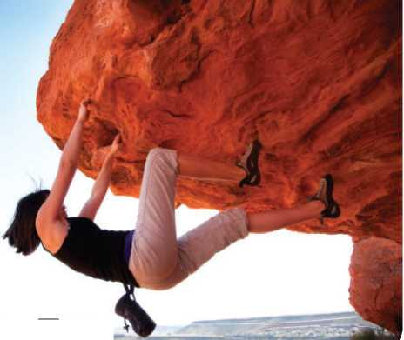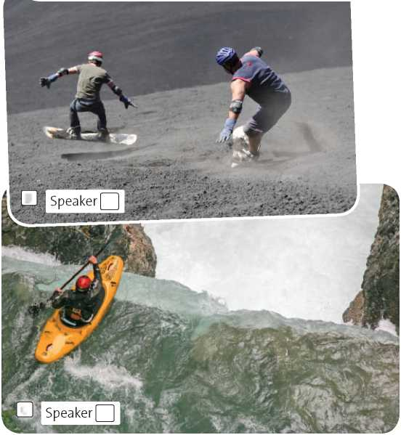

**2D**

Contrast: past simple and past continuous

I can distinguish the use of the past simple and the past continuous.

1. **Choose the correct tense to complete the sentences.**
2. Jake looked at the weather outside: it was grey, but it **didn't rain** / **wasn't raining**.
3. You didn't answer when I phoned you this morning. What **did you do** / **were you doing**?
4. Lucy switched off her computer, **put on** / **was putting on** her coat and **left** / **was leaving** the office.
5. She closed the window because some children **made** / **were making** a lot of noise outside.
6. When I told my friends about the robbery, they **didn't believe** / **weren't believing** me.
7. She didn't hear the doorbell because she **had** / **was having** a shower.
8. **Complete the sentences. Use the past simple form of one verb and the past continuous form of the other.**
9. I (see) Henry as I

(cycle) to the sports centre.

1. While we (prepare) the picnic, it

(start) to rain.

1. All my friends (leave) the party when I

(arrive).

1. As we (walk) by the river, we

(hear) a shout.

1. We (not eat) very much while we

(stay) in that hotel.

1. I (drink) my dad's coffee while he

(not look).

1. **Complete the second sentence so that it has a similar meaning to the first.**
2. I hurt my finger while I was playing the guitar.

I was playing the guitar when I hurt my finger.

1. I was walking home when it started to rain.

While I .

1. She broke her leg while she was learning to ski.

She was learning .

1. He was making lunch when he suddenly felt ill.

As he .

1. She was telling me about her party when she started to laugh loudly.

She started

1. I lost my wallet while I was shopping.

While I .

1. As the band were playing their first song, all the lights went out.

The band were playing

1. **Complete the sentences with your own ideas. Use the past simple or past continuous.**
2. As I was getting off the bus,
3. We were trying to find our hotel when
4. An amazing thing happened as

In January 2014, a doctor from New Zealand

1. had (have) a frightening experience with a

shark - but his calm reaction *2*

(make) him the star of news reports around

the world. James Grant [26] (fish)

Luckily, James 11 (carry) a knife so

he 12 (use) it to fight off the shark.

Then he 13 (get) out of the water

and 14 (look) at his leg. The bites

were 5 cm long and they 15



(happen).

**Unit 2 Adventure**

(clean) his

- (go)

with friends one Saturday when a shark attacked him. He [27] (not see)

anything, but he 5 (feel) a

sudden pain in his leg. At first, he thought that his friends 6 (play) a

prank on him. He 7 (turn)

around - but nobody 8 (be)

behind him. Then he 9 (realise) what 10

(bleed) a lot. James 16

leg. Then he and his friends 17_ to a nearby café! While they 18 (enjoy) a drink, somebody 19

(give) James a bandage because his leg  
20 (bleed). He 21

(go) to hospital for some treatment, but on Monday he was back at work.

I can understand parts of speech and dictionary entries.

**1 Write the noun form of these verbs. Some are the same as the verb.**

**3 Study the dictionary entries. Then answer the questions below.**

|  |  |
| --- | --- |
| **Verb** | **Noun** |
| **1** complete | completion |
| **2** achieve |  |
| **3** need |  |
| **4** dream |  |
| **5** argue |  |
| **6** fail |  |
| **7** imagine |  |
| **8** erupt |  |
| **9** rescue |  |

**explore** Zzk'sploiZ *verb* to travel around a place, etc. in order to learn about it: *They went on an expedition to explore the River Amazon.* ♦ (figurative) *We need to explore* (= look carefully at) *all the possibilities before we decide.* > **exploration** *noun* [U]

**explorer** Zzk'sploiroZ *noun* [C] a person who travels around a place in order to learn about it

**2 Complete the text with the noun form of the verbs in brackets. You may need the plural form.**

1. Which noun is countable?
2. Which noun is uncountable?
3. Which noun has no definition?

(Note: related nouns sometimes have no definition if the meaning is clear without one.)

1. Which entry has example sentences?
2. Why are there two examples, not one?



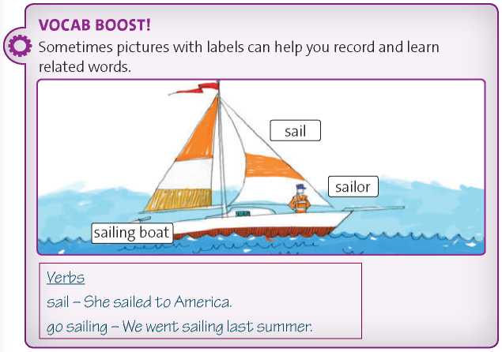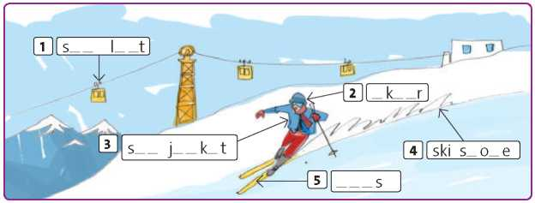

Which entry has no information about pronunciation?

**6**

**4 Read the *Vocab boost!* box. Then complete the labels and add any other words you can. Use a dictionary to help you.**

Last year, at the age of seventeen, Mike Perham became the youngest sailor to complete a 1 (circumnavigate) of

the world alone. But this year, two sixteen- year-old girls are beginning separate 2 (attempt) to beat his record. Last

year, a thirteen-year-old Dutch girl, Laura Dekker, was finishing her 3

(prepare) for the same journey when a children’s court stopped her. Now aged fourteen, she’s trying again. It seems that many teenagers today aren’t interested in the normal forms of 4 (entertain) and

1. (relax), like video games and

sports. They want *6* (experience)

that can really excite their 7

(imagine) and also help with the 8 (develop) of personal skills. So

they choose *9* (explore). Their

amazing 10 (accomplish) certainly

look good on their CVs when it’s time to find 11 (employ). But for most of them,

that probably isn’t the main 12

(motivate).

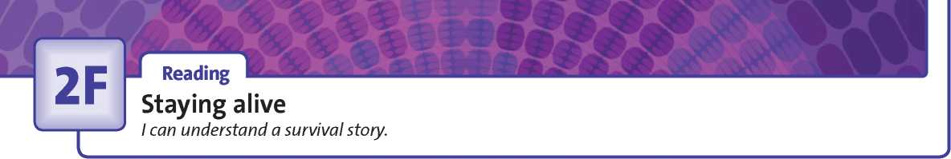



**Revision: Student Book page 28**

1. **Match the pairs of adjectives with similar meanings. Put them in the correct columns. ~~astonishing~~ bad big disgusting exhausted filthy good hungry sad stunning tasty terrifying tiny**

|  |  |
| --- | --- |
| **Simple adjective** | **Extreme adjective** |
| surprising | Astonishing |
| 2 | delicious |
| beautiful | 3 |
| 4 | awful |
| unpleasant | 5 |
| 6 | starving |
| small | 7 |
| 8 | brilliant |
| frightening | 9 |
| 10 | tragic |
| dirty | 11 |
| 12 | huge |
| tired | 13 |

1. **Read the text. Underline five extreme adjectives from exercise 1.**

*Alone at sea*

Reading Strategy

When you do a task with gapped sentences in a narrative text, look carefully at the sentence before each gap and think about what is likely to happen next. Then look at the options and see which of the sentences matches your ideas. Finally, check that the text reads smoothly with your chosen sentence in place.

1. Read the Reading Strategy. Match sentences A-G with gaps 1-5 in the text. There are two extra sentences.

**A** During this time, Steven saw nine ships.

**B** Water was coming in and the boat was sinking fast.

**C** But he couldn't swim back to the yacht.

**D** It contained lots of useful information about surviving at sea. **E** He was planning to sail to the Caribbean.

**F** Some men were fishing near Steven's raft.

**G** Alone in the life raft, Steven travelled slowly across the Atlantic Ocean.

1. **Read the text again, including the missing sentences.**

**Are the sentences true (T) or false (F)? Write the paragraph (A-E) which contains the answer.**

1. Steven wanted to sail to the Canary Islands. T or F? 22 Paragraph? 22
2. Steven's nightmare started four days into the trip. T or F? 1221 Paragraph? 221
3. Steven managed to get some useful things from the sinking yacht. T or F? I I Paragraph? 22
4. Steven ate birds and fish in order to survive. T or F? 22 Paragraph? 22
5. Steven didn't reach the Caribbean. T or F? 22 Paragraph? 22

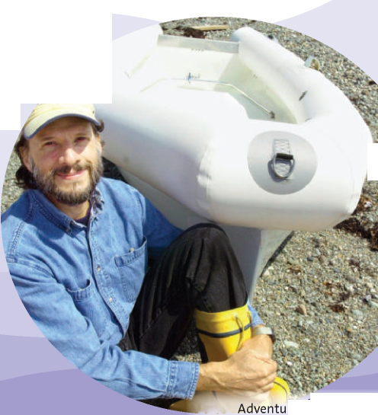

**D**

On 29 January 1982, Steven Callahan left the Canary Islands in a small yacht.

1. But a week later, during an awful storm, something (probably a whale) hit

the yacht and made a huge hole in it. 2 He had to act quickly!

Steven got into an inflatable life raft and just had time to get a sleeping bag, a first-aid kit, some food, maps, and a torch from the yacht before it sank. He also managed to get a copy of a book called *Sea Survival.*

1. But he couldn’t rescue the radio from the yacht.
2. His food ran out after a few days so he had to survive by catching

sea-birds, fish and flying fish. He drank rain water which he caught in the raft.

After about two months at sea, the raft was 3,300 km from the place where the yacht sank. 5 But unfortunately they didn’t

see him. He was starving, exhausted, weak and very thin.

Finally, after 76 days, some fishermen took Steven to the island of Guadeloupe. After his terrifying experience, he was finally in the Caribbean!

**1 Label pictures 1-9 with the words below.**

**boots dinghy helmet life jacket paddles poles rope rucksack safetyharness**

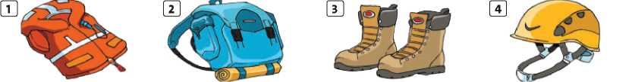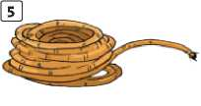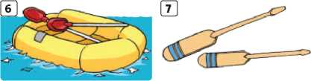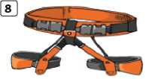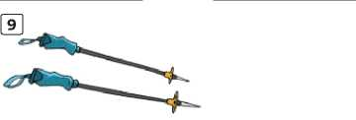

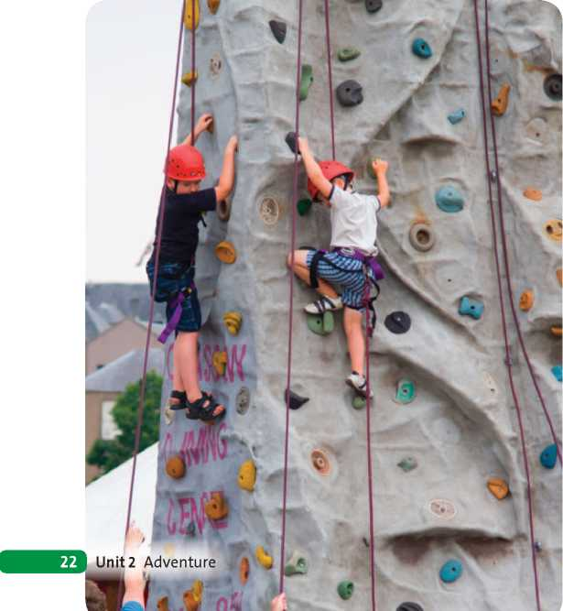

**1** (general description)

**2** (details x3)

**1**

**2**

1. **Which pieces of equipment from exercise 1 do you use for ...**
2. rock climbing?
3. kayaking?
4. walking / hiking?
5. **Choose the correct words to complete the sentences about the photo below.**
6. The photo **seems** / **shows** two children on a climbing wall.
7. They **look** / **look as if** quite young.
8. The boy **on** / **at** the left is looking down.
9. **At** / **In** the background, there are some buildings.
10. It looks **as** / **like** if the boys are having a good time.
11. **Read the Speaking Strategy. Then write five sentences to describe the photo below. Use phrases from exercise 3.**

**Speaking Strategy**

Make sure your photo description has a simple structure. Start by saying what the photo shows in general (Who?

What? Where?). Then mention interesting details. You can finish with a personal comment or some speculation.

1. (speculation / comment)
2. **Read the examiner’s questions in the task and make notes.** Describe the photo and answer the questions.
3. Why do some people enjoy doing risky sports?
4. Is doing risky sports the best way to see spectacular scenery, in your opinion? Why? / Why not?
5. **Now do the task using your notes from exercises 5.**

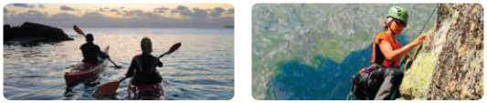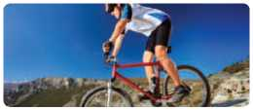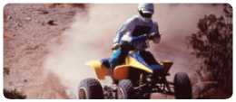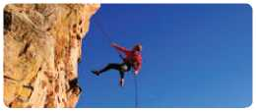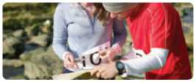

Preparation

**1 Label the photos with the words below.**

**abseilingjet-skiing kayaking kite surfing mountain biking orienteering quad biking**

**1**

**2**

**rock climbing**

**5**

**6**

**3**

**7**

**4**

**8**

Writing Strategy

In an informal text, you can use common abbreviations like *e.g.* and *etc.* You should use short forms like *I’m* and *don’t,* not full forms (*I am* and *do not).*

**Writing Guide**

**3**

Write an invitation to a party. Include these points:

* Give the reason, date, time and place of the party.
* Say what activities you are planning and what the person needs to bring, wear, etc.



II I Writing

An invitation

**1** I can write an invitation and a reply.

1. Read the Writing Strategy. Then complete the invitation and the reply with the abbreviations below.

[*andy@email.com*](mailto:andy@email.com)

before Friday, please!

Do not forget to bring some food!

Imagine you are Andy. Write a reply to Mike's invitation to meet up.

* Say why you cannot meet him.
* Suggest another activity at a later date.

**To:** [*mike@email.com*](mailto:mike@email.com)

Dear Mike,

Thanks for the invitation, but unfortunately I cannot make it. We're going away for the weekend on Saturday morning.

Are you around next week? It would be nice to meet up. We can chat, look at photos from the party, 5 .

See you soon!

Andy

**CHECK YOUR WORK**

**Have you ...**

^-1 [~~| covered all the points in exercise 3 and in exercise 4?

[~~| used short forms rather than full forms?

[~~| used an abbreviation from exercise 2?

[~~| checked your spelling and grammar?

**e.g. etc. p.m. PS RSVP**

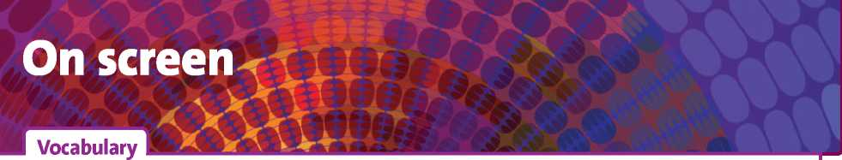

Films and TV programmes

I can talk about films and TV programmes.

**1 Find ten kinds of films or TV programmes in the word square and Circle them and write them below.**

|  |  |  |
| --- | --- | --- |
| **2** | d |  |
| **3** | r | c |
| **4** | r | s |
| **5** | p | d |
| **6** | a | f |
| **7** | c | s |
| **8** | t |  |
| **9** | s | o |

1 g s

**3 Which words from exercises 1 and 2 are TV programmes only, never films? Which could be either films or TV programmes?**

Only TV: chat show, , ,

**, ,**

TV or film: comedy, , ,

**4 Complete the adjectives for describing films. Use *a, e, i, o, u* and*y.* Tick (**^**) eight adjectives that usually have a positive meaning when describing film and cross (**\***) six that usually have a negative meaning.**

|  |  |  |  |  |  |  |  |  |  |  |  |  |  |
| --- | --- | --- | --- | --- | --- | --- | --- | --- | --- | --- | --- | --- | --- |
| W | M | P | P | E | R | I | O | D | D | R | A | M | A |
| O | D | R | K | H | U | T | G | Y | N | M | R | O | P |
| R | O | M | A | N | T | I | C | C | O | M | E | D | Y |
| F | C | I | C | H | A | T | S | H | O | W | A | U | H |
| L | U | B | T | R | L | T | H | R | I | L | L | E | R |
| I | M | T | I | E | C | G | F | R | L | C | I | G | F |
| M | E | S | O | A | P | O | P | E | R | A | T | F | D |
| F | N | S | N | B | A | D | E | O | M | R | Y | A | G |
| G | T | V | F | A | B | T | B | P | U | G | S | S | A |
| A | A | S | I | T | C | O | M | E | H | S | H | N | S |
| F | R | E | L | W | G | E | G | A | S | W | O | H | G |
| L | Y | I | M | G | A | M | E | S | H | O | W | M | L |

10 s

**2 Identify the kinds of TV programmes and films. Choose from the words below.**

**animation comedy fantasy film horror film musical news bulletin science fiction film western**

**1**b o r i ng I I

1. x^t ng □
2. t_nn □
3. gr_pp_ng □
4. c nf_s_ng □
5. c nv nc ng I I
6. mb rr ss ng I I
7. m g n t v I I
8. sp c t c l r I I
9. nr l st c □
10. sc r □
11. nt r st ng □
12. m v ng I I
13. v l nt □

**Q1.08**

**Listen to Anna and David discussing a film which they**

**watched. Choose the correct answer.**

This kind of film or TV programme:

1. usually has stories which take place in the future.
2. often has characters with magical or supernatural

powers.

1. often has cowboys and Native Americans.
2. Anna and David saw

**a** an action film.

**b** a war film.

**c** a thriller.

1. **a** Anna and David both liked the film. **b** One of them liked the film.

**c** Neither of them liked the film.

**Q 1.08**

|  | **Anna's opinion** | **David's opinion** |
| --- | --- | --- |
| characters | 1 | 2 |
| special effects | 3 | 4 |
| soundtrack | 5 | 6 |
| scenes | 7 | 8 |

exercise 4. (Sometimes the people have different opinions, and

sometimes their opinions are the same.)

1. often has frightening characters like vampires or

ghosts.

1. includes singing and dancing.
2. tells you about important events in the world.

**Listen again. Complete the table with adjectives from**

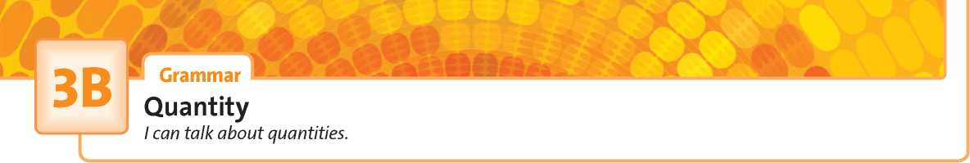

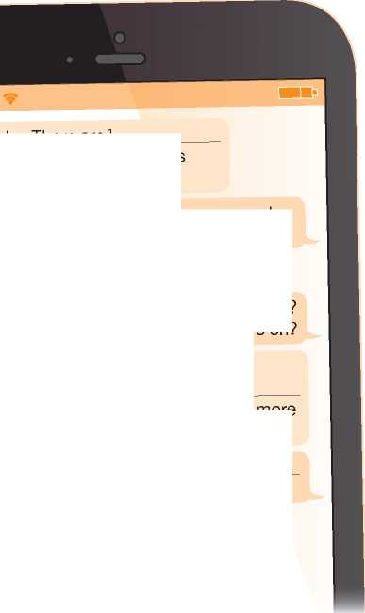

money!

more

money! _ clothes.

I haven’t got 2_ I spent it all on

No, but there’s a good action film: The

Amazing Spider-Man 2. It’s got6

great reviews. I’ll find out7

information about times.

Hey Becky. There are1

good films on at the cinema this weekend. Want to go?

Yes. Ryan wants to come - if he hasn’t got9 homework.

Cool. Are you inviting8 other people?

ooooo

I can lend you

1. Choose the correct words to complete the sentences.
2. I've got **some** / **any** homework to finish this evening.
3. Have you got **some** / **any** pets?
4. **Some** / **Any** people play video games every day.
5. Is there **some** / **any** ice on the road?
6. There weren't **some** / **any** special effects in the film.
7. Complete the text messages with *some* or *any.*

Thanks!!:) What do you want to see?

Are there5 thrillers on?

1. **Answer the questions in exercise 4.**




7. **Complete the video game review with the words and phrases below. Use each word or phrase only once.**

**a few a little any how many how much**

**many much some**

1. really enjoyed this game. The aim is to build a city, but there are a lot of problems to solve along the way.
2. houses, hotels, roads and factories can

you build? 2 money and energy do you

need to build them? Players use money called 'megabucks'. You start with just [28] megabucks, so you

must spend them carefully. It's difficult to build a city on your own, so [29] [30] players work together.

For example, if you have only got 5 energy,

you can borrow or buy 6 electricity from

a neighbour. But selfish and greedy players don't make 7 friends. If they haven't got 8

money or energy, no one helps them and they can't finish their city. So it's best to be friendly to the other players!



**3C**

I Listening

Advertising

I can predict what I’m going to hear.

*GET BACK THE*

4 *LIPSYOUWERE*

*BORN WITH*

**Now listen to the dialogues one at a time, and**

**01.10**

1. **Match slogans 1-6 with types of product A-F.**

1 What's in your wallet?

2 BEAUTIFUL KIT FOR THE BEAUTIFUL GAME

3 **Get in.**

**Get happy.**

5 The lighter way to enjoy chocolate.

1. **You are going to hear three dialogues. Read sentences A-D and match each one to a phrase (1- 4) you are likely to hear. Use the underlined words to help you.**

**A** The speakers start by agreeing, but then disagree. **B** One speaker is complaining about something he bought. **C** One speaker is giving directions to the nearest cinema.

**D** One speaker is narrating an amusing event that

happened.

1. Go straight on at the ... **I I**
2. I don't think you're right about ... **I** I
3. It's just not good enough ... **I I**
4. A few moments later, ... **I I match each one with one of the sentences A-D in exercise 5.**

**There is one extra sentence.**

**A** sports clothes I I

**B** cosmetics I I

**C** credit cards I I

**D** cars **0**

**E** sweets I I

**F** fast food I I

**Dialogue 1:** sentence

**Dialogue 2:** sentence

**Dialogue 3:** sentence

**Q 1.10**

**Listen again. Check your answers to exercise 6 by**

**listening for phrases 1-4 in exercise 5.**

**Listening Strategy**

In listening tasks, the instructions and questions usually give you some idea of the kind of topic and the type of language you are going to hear. Reading them carefully before you listen will help you to ‘tune in'.

1. **Write slogans to advertise these products.**

**A**

**B**

**C**

**Q1.09**

**01.09**

**you hear?**

1. **Read the Listening Strategy. You are going to hear adverts for three products. Circle the word (a-c) you are most likely to hear in each advert.**

**A sports clothes a** motorway **b** race **c** beach

**Ba car a** script **b** engine **c** station

**C fast food a** anxious **b** tired **c** hungry

**Now listen to the adverts and write the products.**

Advert 1 is for

Advert 2 is for

Advert 3 is for

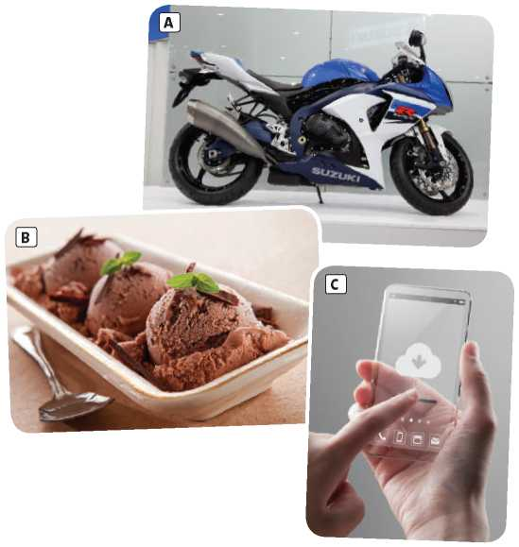**Listen again. Which words from exercise 2 did**

Grammar

***must, mustn’t* and *needn’t* / *don’t have to***

I can talk about prohibition and necessity.

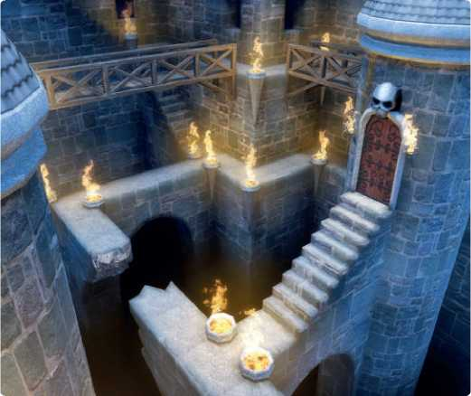

**1 Choose the correct verbs to complete the dialogue.**

**night!**

*r*

**theschool h**

1. **Look at the advert for the quiz night. Then complete the sentences with *must* / *have to, mustn’t* or *don’t have to* / *needn’t*. Sometimes more than one answer is possible.**

* **Take part on your own or with a team.**
* **Arrive before 6 p.m. to enter.**
* **£3 entry fee per person.**
* **School students only - no parents or friends.**
* **No smartphones allowed!**

1. You
2. You
3. You
4. You
5. You

**Alice** Is this your new video game?

**Ryan** Yes, it is. You 1**must** / **needn't** try it. It’s great!

**Alice** How do I play?

**Ryan** First, you 2**have to** / **mustn't** escape from the castle.

**Alice** How? Down the stairs?

**Ryan** Stop! You 3**don't have to** / **mustn't** open that door!

**Alice** Oh! Too late! Am I dead?

**Ryan** Yes. But you 4**don't have to** / **must** start again. Just press ‘B’ to continue.

**Alice** OK, thanks. What now?

**Ryan** You 5**have to** / **needn't** climb out of the window. But slowly! You [31] [32]**don't have to** / **must** be careful.

**Alice** Oh no. I’m dead again. I’m not very good at this.

**Ryan** Well, we [33]**have to** / **needn't** play this game. I’ve got lots of others ...

**Alice** No, no. I [34]**mustn't** / **needn't** give up. Do I press ‘B’ again?

1. Complete the sentences with *mustn’t* or *don’t* / *doesn’t have to.*
2. He’s a brilliant student - he work hard

to get good marks.

1. You can stay up late, but you make a lot

of noise and wake up your sister.

1. We forget the name of our hotel.
2. She always pays by credit card so that she carry a lot of money with her.
3. You tell Jack about the party - it’s a

secret!

1. The bus leaves at 9 a.m. exactly, so you

be late.

1. We wear uniforms to school, but we

wear jeans or trainers.

be part of a team. arrive after 6 o’clock.

pay £3 to enter the quiz. be a student at the school. use a smartphone during the quiz.

1. Make the active sentences passive. Use modal verbs.
2. You mustn’t eat those mushrooms.

Those mushrooms mustn’t be eaten.

1. They needn’t cancel the concert.
2. We mustn’t use mobile phones during lessons.
3. You have to write your name in capital letters.
4. We must hand in homework on time.
5. You have to wear school uniforms to school.



Negative adjective prefixes

I can form and use adjectives with negative prefixes.

1. **Write the opposite of the adjectives by adding a negative prefix: *dis-, il-, im-, in-* or *un-.***
2. satisfied
3. tidy
4. correct
5. legible
6. visible
7. kind
8. believable
9. polite
10. **Complete the text about illegal downloads. Use the adjectives in brackets with or without a negative prefix.**
11. **Complete the sentences with the adjectives below, with or without a negative prefix.**

**honest legal patient polite possible safe**

1. Police are investigating an file-sharing site

in the Philippines.

1. It was very of him to arrive an hour late for

dinner.

1. I get very if I have to wait more than a few

minutes for a download.

1. You don't have to pay before the excursion; it's

to pay at the end.

1. You mustn't climb on that wall; it's .
2. You can believe everything she tells you; she's always completely .

In the USA, around 200 million 1 illegal (legal) music downloads take place every year. In the UK, the figure is about 100 million - the second highest in the world. The music industry complains that these downloads are *2* (fair) to artists

because they stop them earning money from their work. It is 3 (possible) to know exactly

how much money artists and record companies are losing. However, one thing is *4*

(certain): overall, the industry is earning a lot less than it earned a few years ago.

Record companies pay for adverts telling people that downloading music without paying is as 5 (acceptable) and 6_

(honest) as stealing from a shop. But the adverts are *7* (likely) to work because people

see the music industry as rich and powerful compared to them. Most do not see sharing music online as 8 (responsible).

In fact, the number of illegal downloads is now going down, but that's not because of the warnings. For people who are 9

(patient) to hear the latest tracks, streaming services like Spotify now offer a simple and 10 (safe) way to enjoy them without

the need for downloads at all.

**Dictionary Skills Strategy**

You can often find synonyms (words with the same meaning) and antonyms (words with the opposite meaning) of adjectives in a learner's dictionary.

1. **Study the dictionary entries. Then answer the questions below.**

**caring** Z'keorit)/ *adj* showing that you care about other people: *I want to live in a caring society.* SYN **kind** OPP **uncaring**

**considerate** Zkon'sidorotZ *adj* **considerate (of sb) (to do sth)** careful not to upset people; thinking of others: *It was very considerate of you to offer me your coat.* SYN **thoughtful** OPP **inconsiderate**

What is a synonym for *caring?*

What is a synonym for *considerate?*

Do both adjectives have antonyms beginning with a

negative prefix?

Which dictionary entry has information about which preposition you use with the adjective?

5 Read the *Vocab boost!* box. Use a dictionary to find one synonym and one antonym of each adjective.

|  |  |  |  |
| --- | --- | --- | --- |
| **1** | **pleasant** | SYN | OPP |
| **2** | **fortunate** | SYN | OPP |
| **3** | **courteous** | SYN | OPP |
| **4** | **probable** | SYN | OPP _ |

I Reading

Disaster alert!

I can understand a text about a smartphone app.

**Revision: Student Book page 40**

**1 Complete the sentences with the correct form of the verbs below.**

**cause do express get have make provide take part in use**

**1**

online games like *Minecraft*

**Reading Strategy**

When you do a multiple-choice task, decide whether each question is about the whole text or a specific part. If it is about a specific part, find the relevant sentences in the text and underline them.

**3 Read the Reading Strategy. Then read the text again and choose the correct answers.**

According to the text, most people don't value apps very highly. don't know what the main benefits of apps are. use apps mainly for fun and social situations. think apps are useless in dangerous situations.

**a b c d**

The main purpose of the Safety Tips app is to prevent an earthquake like the one in 2011. warn people who are visiting Japan about earthquakes. warn Japanese people about earthquakes. warn business people about earthquakes.

**a b c d**

Jenny had problems

**a**

**b**

because no one told her what to do after an earthquake. because she couldn't understand the advice on Japanese media.

because there was no information for tourists about what to do in an earthquake.

because her Japanese colleagues didn't know what to do.



I often

with my friends.

Video games can many benefits,

such as improving memory and creativity.

The scientists a lot of research on the

topic and published the results yesterday.

I prefer to a smartphone rather than

a computer.

Video games can sometimes

positive effect on teenagers.

The amount of violence in video games can concern for a lot of parents. Newspapers sometimes claim that video games are bad for children, and parents often

the same opinion.

Playing computer games in groups can help you to work together with other people and to decisions more quickly.

Do you think playing computer games helps you to better grades?

**2 Read the text and answer the questions.**

**1**

**2**

**3**

is available in a number of languages.

is available at airports and tourist information centres. warns about earthquakes but not about tsunamis.

is in English, with Japanese phrases.

What does Jenny do?

Which country did she visit?

What kind of natural disaster did Jenny experience in 2011?

At the moment, the app

**a**

**b**

**c**

**d**

**STAYING SAFE**

10

15

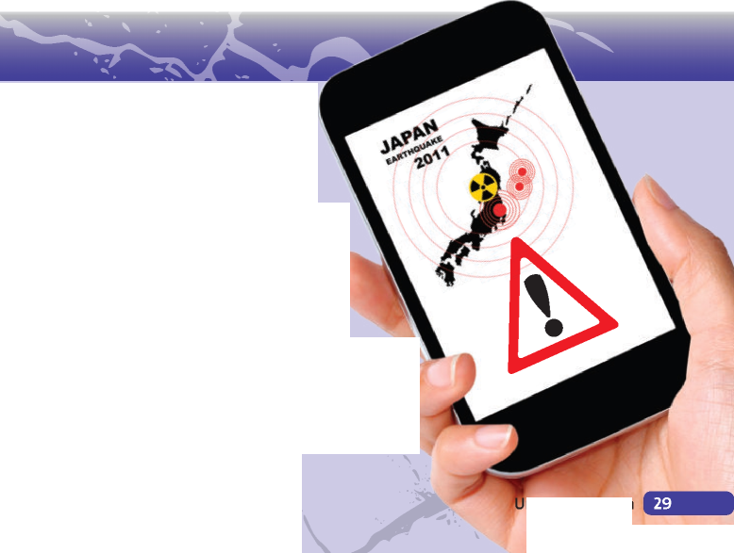Most people use the apps on their smartphone to play games, surf the net, keep in touch with people and organise social events. But Jenny Harlow, a scientist from London, has got an app that does something much more important: it warns her when she is in danger. The app is called Safety Tips and it gives users real-time earthquake and tsunami warnings. The Japan Tourist Agency had the idea for the app after the 2011 earthquake in

Japan, when many foreign tourists in the country were confused about what was happening. Jenny was on a business trip to Japan when the earthquake struck. ‘It was the first time I had experienced one. All the warnings and information on the internet, radio and TV were in Japanese. It was really confusing and I didn't know what to do.' She had to rely on Japanese colleagues to help her.

The Safety Tips app sends an alert to users when a major earthquake happens, and also tells them if a tsunami is likely. The app gives lots of tips about what to do, where to go and how to stay safe, as well as a list of useful Japanese phrases such as ‘Is this an earthquake?' and ‘Is it safe here?: Importantly, all the information is in English, and there are plans to add other languages. The Japan Tourist Agency plans to advertise the app at airports and tourist information centres in Japan. ‘I'm coming to Japan again next year and I will definitely watch out for alerts from the app,' says Jenny.



**3**

**_ỊỊỊ**

**Listen again. Tick (**^**) the phrases in exercise 1 that**

1. Write the phrases 1-10 in the correct groups (A—C) below.
2. I adore / I can't stand ... I I
3. That's agreed, then. I I
4. I think ...will be better / more fun, etc. I I
5. I'd rather / I'd prefer (to) ... I I
6. I'm / I'm not a big fan of ... I I
7. OK, I agree. I I
8. I'm / I'm not keen on ... I I
9. Let's / Shall we settle on ... I I
10. That's a great idea. I I
11. I quite fancy / I don't really fancy ... I I

**A Expressing likes and dislikes**

**B Expressing a preference**

**they use.**

**Speaking Strategy**

In the exam, you will have about one minute to read the task. Use this time to ‘think in English', identifying key words and phrases that you could use in the conversation.

1. Read the Speaking Strategy. Then do the task in exercise 2 using the video games below. Write notes.

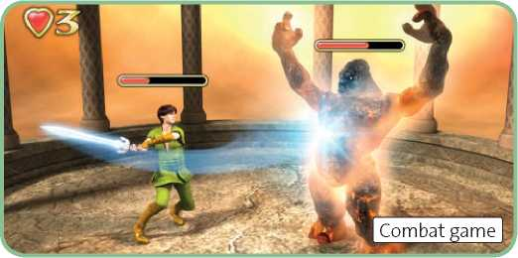

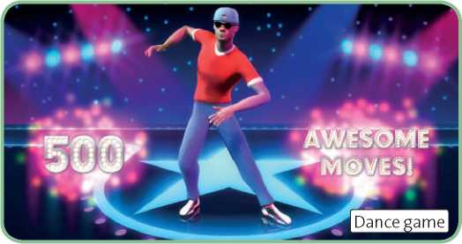

**C Reaching an agreement**

My choice:

Read the task below. Then listen to a student

**141**

doing the task. Which game did they choose?

You and a friend are deciding which video game to play aftei school. Decide together which game you will play, which house you will go to and if you will invite any other people.

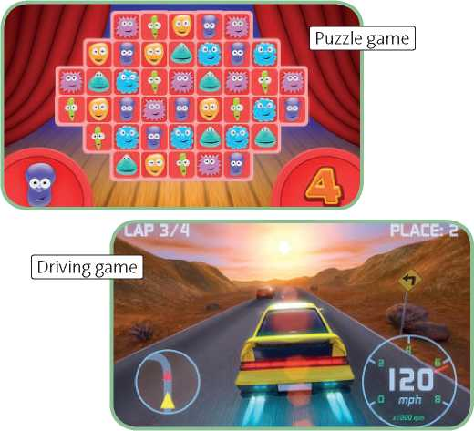

Why?

Play the game where? Why?

Invite other people? Why? / Why not?

1. **Now do the task in exercise 2, using your notes from exercise 4.**
2. LJ ■ Writing

An informal letter

**1** I can write an informal letter.

Preparation

1. **Complete the social activities with *a, e, i, o, u* and*y.***

|  |  |  |
| --- | --- | --- |
| **1** |  | _ for a b k r d |
| **2** |  | - sh_pp_ng |
| **3** | m | t fr nds n t wn |
| **4** | pl | b_sk_tb_ll |
| **5** | h | _v a c ff |
| **6** | l | st n to m s c |

7 pl t bl t nn s

1. **Complete the invitations by writing the first word of each phrase and adding a social activity from exercise 1. Use the infinitive without *to* or the *-ing* form.**

**Writing Strategy**

When you write a letter to a friend or relative:

* Start with: *Dear [Jake],.*
* Begin the main part of the letter with a short introduction. You can use phrases like: *How are you? Sorry I didn’t reply sooner. Thanks for your letter.*
* Write in paragraphs.
* Do not use very formal language in your letter.
* Use contractions (*it's*, *there’s,* etc.).
* Finish the main part of the letter with a short paragraph. You can use phrases like: *That’s all for now. Id better go now. Write again soon.*
* End the letter with *Love,* or *Best wishes,* and your first name.



1. don't we ?
2. you fancy ?
3. about ?
4. you like to ?
5. **Read the Writing Strategy opposite. Then write the missing words to complete the letter below.**

1 Lily,

Thanks for your letter. How 2 you? I had

a great weekend. Lauren came over and we watched the third Hobbit film on DVD. I saw the second film last year and I loved it.

I enjoyed the film, but I didn't think it was brilliant. There are some exciting scenes, but it's really long and I got a bit bored by the end.

Before the film, we made pizzas and popcorn. We ate them while we were watching the film. (The pizza was a bit burned!)

Would you like to go shopping next weekend? I need to buy a birthday present for my dad, but I want to find some clothes for me at the same time. How about meeting for lunch too?

Anyway, that's all for 3 . Write again

4

1. wishes,

Paige

1. **Circle the aspects of the film that Paige talks about. acting characters ending plot scenes script special effects length**
2. **Read the task below. Underline the parts of Paige’s letter which give extra information about each of the four points.**

You and a friend watched a film at your house recently. Write a letter to another friend in which you:

* say what film you watched.
* give your personal opinion of the film.
* mention something else you did on that occasion.
* suggest an activity to do with the friend you are writing to.

Writing Guide

1. **Write a letter for the task in exercise 5. Remember to include extra information for each point. Do not copy ideas from the model in exercise 3.**

(greeting) (introduction) (what film?)

(your opinion)

(another activity)

(an invitation)

(final paragraph)

(close the letter)

(sign your name)

**CHECK YOUR WORK**

**Have you ...**

[~~| included extra information for each point? [~~| followed the correct layout for a letter?

[~~| checked your spelling and grammar?

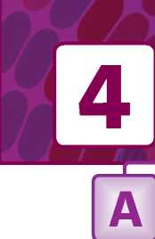

Weather

I can describe the weather.

**1 Complete the adjectives that describe the weather in the pictures.**

It's thundery and 2C . It's 3s and 4f *.* It's 5f and 6i

It's 7s and 8w

It's hot and 9s

It's cold and 10r

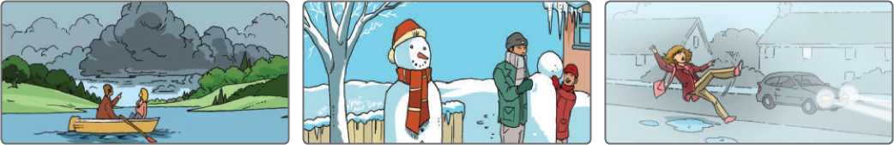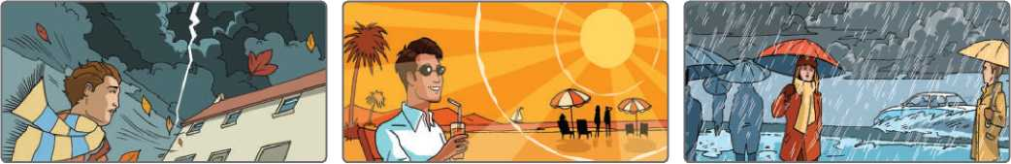

**5 Write the temperatures in words.**

1. **Write the nouns for the adjectives in exercise 1.**

**Listen to people describing the weather. Complete**

**01.12**

1. thunder **5 9**
2. **6 10**
3. **7**
4. **8**
5. **Complete the text with the words below.**

**blow claps flashes raindrops storm clouds sunshine thunderstorm**

There was a terrible [35] [36] yesterday evening.

We saw big, dark grey 2 in the distance.

Then a strong wind started to 3

and it began to rain heavily - huge 4

fell from the sky. We got incredibly wet! There were

5 of lightning and loud 6 of

thunder. It was quite scary. But then the storm passed and there was bright 7!

1. -5° It’s minus five.
2. 26°C It’s twenty-six degrees Celsius.
3. -15° _
4. 14°C
5. -7°C
6. 32°

**each sentence with one word from exercises 1, 2 or 3.**

1. **a** It was rainy all morning.

**b** It was in the afternoon.

1. **a** There was thick .

**b** There was on the road.

1. **a** Most of the day the sky was

**b** It was mild and .

1. **a** There was on the grass.

**b** In the afternoon it was and

1. **Write a paragraph describing the weather one day last week. Write 15-30 words.**

1 Complete the table with the comparative forms.

|  |  |
| --- | --- |
| **Adjective** | **Comparative** |
| **Short adjectives** | |
| tall | 1 |
| large | 2 |
| hot | 3 |
| early | 4 |
| **Long adjectives** | |
| powerful | 5 |
| spectacular | 6 |
| **Irregular adjectives** | |
| good | 7 |
| bad | 8 |
| far | 9 |
| **Quantifiers** | |
| few | 10 |
| much / many | 11 |
| little | 12 |

1. 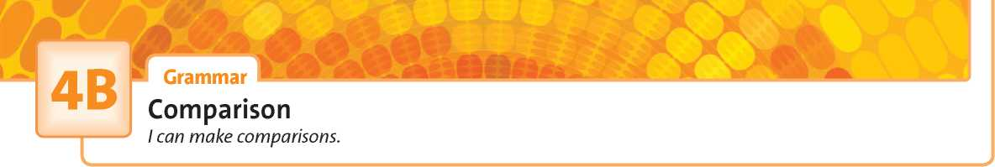**Compare the weather in the two cities. Write sentences with *as ... as* and *not as ... as.***

|  |  |
| --- | --- |
| **London** | **Edinburgh** |
| 41/ |  |
|  |  |
| 15°C | 15°C |
| *ẽ* |  |

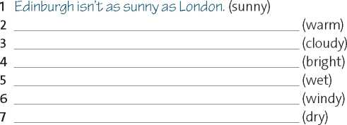

**4 Complete the sentences with *AS*, *more, much* or *than.***

1. Mist isn't as thick fog.
2. The weather today is wetter

yesterday.

1. ‘Is a hurricane powerful than a

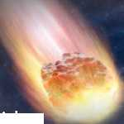thunderstorm?' ‘Yes, it's stronger.'

**FACT FILE:**

COMETS AND

The moon isn't bright the sun.

Are hurricanes more dangerous tornadoes?

‘I think maths is much interesting

geogra p hy.' ‘Do you? I don't think it's geography, but it's

interesting as more useful.'

ASTEROIDS

asteroid

Comets are made of ice and pieces of rock. Asteroids are made of rock and metal, and are 1 (heavy).

Most asteroids are much 2 *

(big) than most comets.

You can find asteroids 8 (close) to the sun than comets.

If comets get too close to the sun, they melt. So you can only find comets much *4* (far) from the sun, where it is 5

(cold) and ice doesn't melt.

Comets are 6 (bright) than asteroids because they have

long, white tails.

Comets are 7 (rare) than asteroids. There are hundreds

of millions of asteroids in our solar system, but far 8 (few)

comets - only about 4,000. For this reason, asteroids are 9

(dangerous), as one of them is 10 (likely) to hit the Earth.

**Revision: Student Book page 49**

**•. * 1 Match the words below with definitions 1-10.**

**avalanche drought earthquake epidemic famine flood forest fire mudslide tsunami volcanic eruption**

1. A(n) is when the ground shakes

and buildings collapse.

1. A(n) is when hot rocks, fire and

steam suddenly come out of the ground.

1. A(n) is when water covers the

ground in places which are usually dry.

1. A(n) is when snow and ice fall

quickly down a mountain.

1. A(n) is a long period of time

without enough food in a region.

1. A(n) is a very large and long wave

following an earthquake under the ocean.

1. A(n) is when there is no rain for a

long time.

1. A(n) is a fire that spreads quickly

through a large area of trees.

1. A(n) is when a serious disease

spreads to lots of people.

1. A(n) is when a large quantity of

wet earth suddenly falls down the side of a hill.

**2 Label photos A and B with the natural disaster words from exercise 1.**

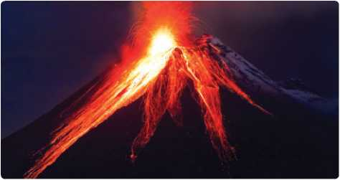

**A**

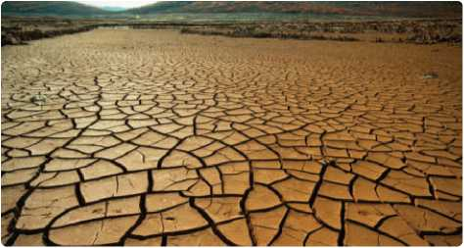

**B**

Listening Strategy

It is important to be able to identify the context of the listening, i.e. who is speaking, where and when they are speaking, and what the situation is. This is not always obvious, so listen carefully for clues to help you.

dialogues and answer the questions. Write the clues which

**Read the Listening Strategy. Then listen to two**

**1J3**

Dialogue 1

**gave you the answers.**

1. Where are they?

Clues:

1. What natural disaster caused the damage?

Clues:

**Dialogue 2**

1. What kind of natural disaster are they discussing?

**Q1.14**

**©1.14**



Superlative adjectives, *too* and *enough*

I can use different structures to make comparisons.

1. Complete the facts with the superlative form of the adjectives in brackets and the correct answer, a, b or c.
2. The (high) mountain in Europe is I I.

**a** Elbrus **b** Everest **c** Kilimanjaro

1. The (far) planet from the Sun is I I.

**a** Earth **b** Mercury **c** Neptune

1. The (deep) ocean is I I .

**a** the Arctic **b** the Atlantic **c** the Pacific

1. The (sunny) part of England is I I.

**a** the north **b** the s outh **c** the centre

1. The (polluted) city in the world is I I .

**a** New York **b** New Orleans **c** New Delhi

1. The (common) cause of a tsunami is I I.

**a** an earthquake **b** a volcanic eruption **c** a storm

1. The country with the (long) coast is I I.

**a** Russia **b** Spain **c** Canada

1. The (large) island in the world is I I .

**a** Great Britain **b** G reenland **c** Iceland

1. The (dry) continent in the world is I I .

**a** Antarctica **b** Aus tralia **c** Africa

1. Complete the sentences with the correct superlative form of the adjectives in brackets. Then circle *in* or *of.*
2. Birmingham is one of the (large) cities

**in** / **of** England.

1. Crocodiles are one of the (dangerous)

animals **in** / **of** the world.

1. The special effects are the (bad) part

**in** / **of** the film *Terminator 2.*

1. In Australia, the (hot) month **in** / **of** the

year is usually February.

1. The Dorchester is one of the (expensive)

hotels **in** / **of** London.

1. Rewrite the sentences using *too* or *enough* and the adjective in brackets. Do not change the meaning.
2. This game isn't easy enough for me. (difficult) This game is too difficult for me.
3. We're too young to go on holiday alone. (old)
4. This bed is too hard. (soft)
5. This film isn't interesting enough. (boring)
6. It isn't warm enough to go to the beach. (cold)
7. His family were too poor to go on holiday. (rich)



1. Complete the dialogue. Use *too* or *enough* with the adjective in brackets or the superlative form.

**Kate** Now we join Brett Simpson for the 1

(late) news about the wildfires. Brett, what's happening?

**Brett** Well, the police aren't allowing us to get

1. (close) to the fires, but I can feel

the heat from here.

**Kate** How are the people in the area reacting? It isn't one of the 3 (rich) parts of the country,

is it?

**Brett** No, it isn't. Some people are *4*

(lucky) to have relatives in other cities, so they're leaving. But many are 5 (old) or

1. (ill) to travel. They're waiting and

hoping.

**Kate** What's the 7 (good) thing other

people can do to help?

**Brett** Well, I asked the police that question. They said the

1. (helpful) thing is to stay away

from the area. Thousands of people are coming here just to have a look. This is one of the

1. (big) and 10

(spectacular) fires for decades. But these people are getting in the way of the emergency services and their work. And their job is 11

(difficult) without that!

**Kate** What is the 12 (likely) cause of the

fire?

**Brett** It's13 (early) to say. Sometimes

lightning can start a fire like this, if the trees are 14 (dry). But of course, humans are

the 15 (probable) cause.

1. **Complete the sentences with the particles below. You need to use three of them more than once. Are the sentences true (T) or false (F)?**

**Revision: Student Book page 51**

| **A**  climate fossil global greenhouse ice rain renewable sea surface | **B**  caps change energy forest fuels gases level temperature warming |
| --- | --- |
| **1** climate change |  |
| **2** |  |
| **3** |  |
| **4** |  |
| **5** |  |
| **6** |  |
| **7** |  |
| **8** |  |
| **9** |  |

1 Match words from box A with words from box B to make compound nouns. Write them below.

1. **Write the phrasal verbs which can replace the underlined words. Choose from the list below.**

**carry on come up with give up go up look after put off set off use up**

1. I need to think of a good excuse for not handing in my

homework.

1. I'm trying to stop eating junk food.
2. After running ten kilometres, she was too tired to

continue.

1. He left his job so he could take care of his sons.
2. Please don't finish all the milk - I need some for my

breakfast tomorrow.

1. The number of people with smartphones is continuing

to rise.

1. We should delay the meeting because nobody can come

that day.

1. Don't stay up late! We need to leave early tomorrow.

**down off on out up with**

1. Factories and power stations give greenhouse

gases. □

1. When we cut trees, we increase the amount of CO2

in the atmosphere. I I

1. The world's oceans are slowly heating . I I
2. The world's supply of gas is likely to run in the next

ten years. I I

1. The EU recently decided to close all the nuclear

power stations in Europe. I I

1. Solar energy works better in places where you can rely good weather. I I
2. Scientists recently came a car engine that

uses only CO2. I I

1. Many types of animals and plants are dying

because the Earth is getting warmer. I I

VOCAB BOOST!

There are hundreds of phrasal verbs in English and 's'-| many of them are very common. They are easier to

learn in small groups. Here are two options:

1. Learn phrasal verbs related to the same topic.

Travel

break *down =* (a car, a bus, etc.) stop working

go back = return

head for = travel in a certain direction

set off = leave

take off = (a plane) leave the ground, go up in the air

1. Learn phrasal verbs with the same base verb.

look

look after = take care of

look around = explore

look into = study, examine

look up = find in a dictionary or other reference work

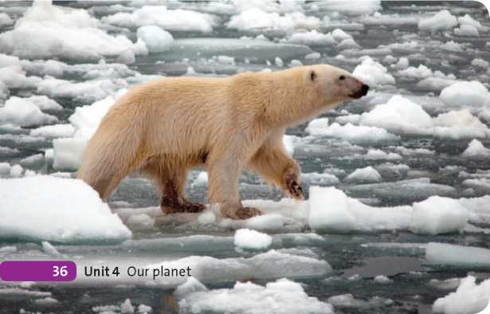

1. **Use a dictionary to find four phrasal verbs with the base verb *turn.* Include short definitions.**
2. **=**



Survival story

I can understand a survival story.

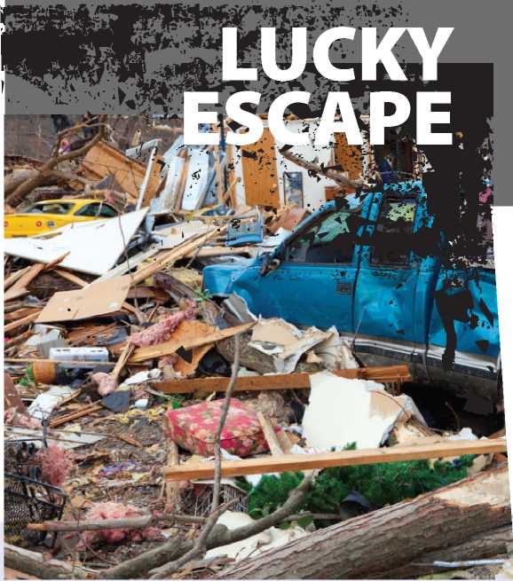

**Revision: Student Book page 52**

**1 Complete the sentences with the correct form of the verbs below.**

**approach head land reach spin take off 1**

, *so* we went

out of

A snow storm was

inside.

The plane from London at 9 a.m.

yesterday and in Paris an hour later.

It was very late when we Oxford.

The plane was towards Australia

when it disappeared.

The helicopter began to control.

1. Read the text, ignoring the gaps. Answer the questions.
2. What kind of natural disaster did Diana and Pete experience?
3. Where were they when they realised there was a problem?
4. Where was Monica?
5. In which room did Monica and Diana hide?
6. Where did Pete hide?
7. How many people died in the disaster?

One Monday afternoon in May 2013, Diana Palmore was at home with her husband, Pete, when they heard loud sirens 1 a tornado was approaching the town.

Diana's daughter Monica was at the local school and 5 Diana decided to go and [37] [38] before the tornado

reached the town. She ran as fast as she could to the school. In her classroom, Monica and her classmates were sitting under their desks, [39] on their heads.

Diana ran in and took Monica. But the tornado was 10 much closer now and it was too dangerous *[40]* . So

they hid in a bathroom. When the tornado hit, it ripped the roof from the school. Monica and Diana looked up and saw cars and trees [41] above the school. 'It was

very scary. The whole school was shaking,' said Monica.

15 When the storm passed, Monica and her mum [42] ,

but it was in ruins. They couldn't find Pete. But they could hear him shouting for help. Then they saw his hand and [43] - in a cupboard under the stairs. He

couldn't breathe, so they had to get him out quickly.

20 Moments after they pulled him out, the whole house collapsed. The family survived a terrifying experience with only small injuries. But other people in the town 8 as the Palmores.Twenty-four people died in

the tornado.

1. **Complete the phrases with the words below. Tick the phrases that are used for describing differences. both can contrast first obvious**

**photos second theme Unlike**

1. Both show ... I I
2. In to the first photo,

the second photo ... I I

1. In photos, there are ... I I
2. In the first photo ... , but in the photo, ... I I
3. One difference is (that) ... I I
4. The common in the photos is ... I ]
5. The photo shows ... , whereas the second

photo shows ... I I

1. the first photo, the second photo

shows ... I I

1. You see ... in both photos. I I
2. **Look at photos A and B and complete the description with the words below.**

**children country enjoying funjudgingjumping must see shows throwing wearing**

The first photo 1 two little girls. They are in the

1. walking on a path. It 3 be raining

because the path is very wet and muddy. In the second photo

1. can *[44]* a man and a woman. They are playing in

the snow.

Both photos show two people having 5 in bad

weather. In the first photo, the girls are 6 in

a puddle. In the second photo, the man is 7 a

snowball at the woman. You can see trees in both photos. In both photos, the people are 8 warm coats.

The obvious difference is that they are 9 in the

first photo, but adults in the second. 10 by their

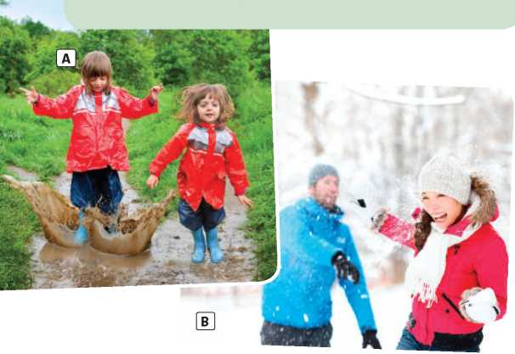expressions, Id say they are 11 themselves.

**ị Speaking Strategy**

: When you do a photo comparison task, follow these steps:

: 1 Describe each photo in general (e.g. mention the people,

* where they are, speculate about what is happening, etc.).

j 2 Describe any obvious differences or similarities between the photos.

1. Speculate about how the people in the photo are feeling,

* or what they are thinking or saying.

1. **Read the Speaking Strategy and the task. Then write notes for your answer.**

Describe and compare the two photos, C and D.

1. 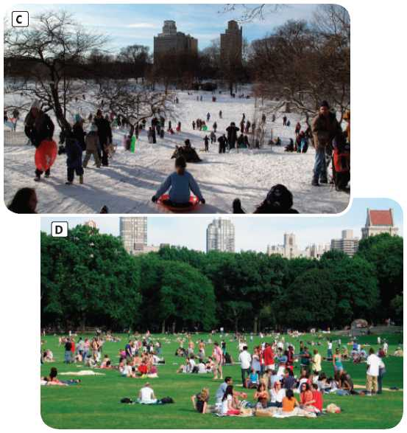Second photo: Description

First photo: Description

**1**

1. Obvious differences and similarities
2. How are the people feeling?

Preparation

1. Complete the zero conditional sentences with the correct form of the verbs in brackets.
2. If you (burn) coa l, it (give) off

greenhouse gases.

1. A rainbow often (appear) if the sun

(come) out when it's raining.

1. If an earthquake (happen) under the ocean,

it sometimes (cause) a tsunami.

1. If a hurricane (form) over the Indian Ocean,

they (call) it a typhoon.

1. Floods (happen) if it (rain) a

lot more than usual for a long time.

: Writing Strategy

: When you are expressing your opinions and the opinions

: of others, give your text a clear structure. For example:

: • In one paragraph, give your opinion with two or three

: arguments that support it.

: • In another paragraph, give the opposing view with

: one or two arguments supporting it. You can then say

: why you disagree with the opposing view (a counter­argument).

1. **Add two phrases below to each group (A-D). Then tick (✓) the phrases that are in the model text.**

**As I see it, ... Having said that, ... However, ...**

**In my opinion, ... Moreover, ... Nevertheless, ...**

**On the other hand, ... To be honest, ... What is more, ... A Expressing an opinion**

1. think / I don’t think that ...

B Presenting an opposing opinion

There are people who believe that ...

**C Presenting a counter-argument** In spite of this, .

**D Making an additional point** Furthermore, .

Writing Guide

□□□ □□□ □□□ □□□

1. Read the task and make a plan.
2. **Read the Writing Strategy. Then read the task below and the model text. Decide where the second paragraph should begin: A, B or C.**

The second paragraph should begin at I I .



**‘Young people are doing more to prevent global warming than older people.’ Do you agree?**

‘Individuals can do more to stop global warming than governments.' Do you agree?

Paragraph 1 (my opinion)

* Argument 1:
* Argument 2:

Paragraph 2 (opposing view)

* Argument 1:
* Argument 2:
* Counter-argument:



1. **Write an article like the one in exercise 2. Use your notes from exercise 4 and include phrases from exercise 3.**

**CHECK YOUR WORK**

**<®> Have you ...**

■ Q covered all the arguments in your plan?

Q used phrases from exercise 3?

Q checked your grammar and spelling?

**Ambition**

J Vocabulary

Jobs

I can talk about jobs and work.

1 Read the definitions and complete the puzzle.

This person:

1. helps people to look after their teeth.
2. writes computer software.
3. flies an aeroplane.
4. often looks after cows and other animals.
5. cuts people's hair.
6. helps people who are injured or ill in

an emergency. p

1. trains a person or team to make them

better at a sport.

1. deals with people who arrive at a hotel, an office, etc.
2. designs and builds roads, bridges, machines, etc.
3. helps people when they buy a house or have a legal problem.
4. designs buildings.
5. helps people to choose a holiday.
6. cleans people's offices, houses, etc.
7. brings food and drink to tables in a restaurant or café.

**What is the secret job?**

11

12

14

**2 Complete the work activities with the words below. Use each word or phrase only once.**

**alone children a computer customers your feet five hours indoors a lot a lot of money outdoors the phone phone calls the public a team a uniform**

1. travel
2. be on
3. serve
4. work

|  |  |  |  |  |
| --- | --- | --- | --- | --- |
| **1** | ch a ll e | ng i ng | **6** | str _ ssf _ l |
| **2** | b dL | - p d | **7** | t — r _ ng |
| **3** | cr | _ t v | **8** | v r d |
| **4** | r — p - | L t _ t _ v | **9** | w ll p d |
| **5** | r w _ | _ rd _ ng |  |  |

3 Complete the adjectives for describing jobs with *a, e, i, o, u* and *y.* Then use them to complete the table.

1. wear
2. deal with
3. be part of
4. work nine-to-
5. work long
6. make
7. answer
8. work with
9. earn
10. use

|  |  |
| --- | --- |
| **Positive 0** | **Negative 0** |
| challenging |  |
|  |  |
|  |  |
|  |  |
|  |  |

Q1.1S

Listen to three people talking about their jobs.

|  |  |  |  |
| --- | --- | --- | --- |
| **Job** | | **Adjective 1** | **Adjective 2** |
| **1** |  |  |  |
| **2** |  |  |  |
| **3** |  |  |  |

What are the jobs? Choose two adjectives from exercise 3

which you think best describe each job.

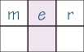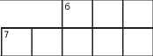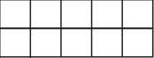

**5B**

Grammar *ầ*

*will, be going to* and the first conditional

I can make predictions, plans, offers and promises, and talk aboutfuture situations and

their consequences.

1. **Match sentences 1-5 with the decisions, offers and promises (a-e). Complete a-e with *will* or *won’t* and the verbs below. be carry have help lose**
2. This bag is very heavy. I I
3. See you at eight o'clock. I I
4. You can borrow my phone. I I
5. I can't do this maths calculation. I I
6. What would you like to drink? I I

**a** I it for you.

**b** OK. I late!

**c** Show it to me and I you.

**d** I lemonade, please.

**e** Thanks! I it.

1. Circle *will* or *be going to* to complete the predictions.
2. I don't think Chelsea **will** / **are going to** win the Champions League next year. Their team isn't strong enough.
3. Look at those clouds. It **’ll** / **'s going to** snow.
4. Kat hasn't done any revision. She **won’t** / **isn’t going to** pass her exams.
5. That car is going much too fast! It **’ll** / **’s going to** crash!
6. I **will** / **am going to** email you tonight - I promise!
7. Jack's holding a tennis racket. He **’ll** / **’s going to** play tennis!
8. Look at the pictures and complete the predictions with the affirmative or negative form of *be going to.*

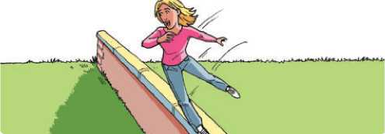

**1** She fall.

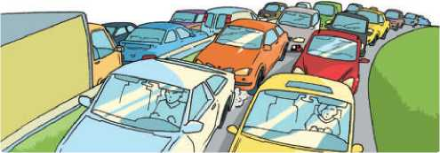

1. Order the words in a-e and then match them with 1-5 to make the first conditional sentences.
2. If you don't finish your homework in time, I I
3. He'll do an hour's revision in the morning I I
4. If she needs money over the summer, I I
5. If he decides to become an engineer, I I
6. If I pass all of my exams, I I

**a** at university / apply / a place / for / he'll

**b** teacher / happy / be / our / won't

**c** wakes / up / enough / if / early / he

**d** parents / give / will / me / my / a reward

**e** a / she'll / job / get / part-time

1. They arrive on time.



**5C**

I Listening

Changing jobs

I can use signpost phrases to predict what I’m going to hear next.

**Revision: Student Book page 61**

1. **Look at the jobs and answer the questions.**

**builder estate agent gardener journalist locksmith photographer pizza delivery man *I* woman police officer stunt performer surfing instructor video game developer**

Which job is connected with ...

1. flowers and pla nts?
2. selling houses?
3. a water sport?
4. fast food?
5. cameras?
6. copying keys?
7. fighting crime?
8. film and TV?
9. computers and entertainment?
10. construction?
11. writing for newspapers?
12. **Read the sentences and choose the correct ending, a or b.**
13. Being a sports coach isn't well paid. On the other hand, **a** it can be quite repetitive.

**b** it can be very rewarding.

1. Farm workers have a physically demanding job. In other words,

**a** it's often very tiring.

**b** it's often quite varied.

1. My uncle wanted to be an engineer. However,

**a** he worked hard and got the qualifications.

**b** he couldn't afford to get the qualifications.

1. My aunt paid for her degree by getting various part-time jobs; for example,

**a** she worked as a cleaner every evening.

**b** she studied hard and did well in her exams.

1. My grandfather worked as a police officer, a paramedic, a farm worker ... What I mean is,

**a** gardener was the job he liked best.

**b** he did a variety of different jobs during his life.

**Q1.16**

**Listen to an interview with a female lorry driver**

**Listening Strategy**

Some words and phrases can help you to predict what is coming next in a listening. For example, if you hear *however,* you know that it will be followed by a contrasting point. Listen out for ‘signposts' like these that help you to understand the structure of the listening.

**called Sally Stone. What did she do before she became a**

**lorry driver?**

**a** She went to college. **I I**

**b** She worked as a hairdresser. **I I**

**c** She worked at her dad's company. **I I**

**Q1.16**

**Read the sentences below. Then listen again.**

**Are the sentences true (T) or false (F)?**

1. **Read the Listening Strategy. Then choose the correct words and phrases to complete the sentences.**
2. Being a surfing instructor sounds great, but **as I see it** / **not only that**, it's quite repetitive.
3. Stunt performers have to do a lot of dangerous things, **moreover** / **such as** falling off buildings.
4. Photographers often travel around a lot, **although** / **for example** some of them work in a studio.
5. Gardeners are not well paid, but **as a result** / **in spite of this**, many of them love their job.
6. Estate agents do badly during recessions, and **nevertheless** / **that’s because** fewer people buy houses.
7. Being a builder is hard work. **However** / **What is more**, you're often on your feet all day.
8. Sally is a qualified hairdresser. I I
9. Sally decided to become a lorry driver because it is easier than hairdressing. I I
10. Sally and her father work in the same job sector. I I
11. Sally took the driving test only once. I I
12. Sally says most men are surprised to see a woman driving a lorry. I I
13. Sally thinks that female lorry drivers are safer than male lorry drivers. I I



**5D**

Grammar

Defining and non-defining relative clauses

I can use defining and non-defining relative clauses.



| **1** | That's the hospital | my dad works. |
| --- | --- | --- |
| **2** | He's someone | face is familiar, but I |
|  | can't remember his name. |  |
| **3** | Do you know a shop | I can buy |
|  | printer paper? |  |
| **4** | The essay | Tom wrote got top marks. |

1 Complete the sentences with *who, which, where,* or *whose.*

**5 Complete the text with the relative clauses (a-f).**

This multinational company is famous for providing fantastic working conditions for its employees, 1 . But what

qualities do you need to get a job here in California, *2* ? The answer may

surprise you. Laszlo Black, 3 , is in

charge of finding new employees for the company, 4 . He is not looking

for people who describe themselves as ‘intelligent and experienced’, 5 .

In Black’s opinion, people who describe themselves as intelligent think they know the answers already. This limits their curiosity and flexibility, 6 .

1. Join the two sentences with a relative pronoun *(who, which, where,* or *whose).*
2. I've lost the DVD. You gave it to me.

I’ve.*\ost the DVDwh\chyou gave me.*

1. Who is the boy? He helped you with your homework.
2. Do you know that man? He's looking at us.
3. I opened the cupboard. We keep the glasses there.
4. That's the girl. I saw you with her.
5. That's the boy. I borrowed his bicycle.
6. Complete questions 1-5 with clauses a-e. Add a relative pronoun only where necessary.
7. Is this the phone

you.used.to.text.me?

1. What's the name of the hotel
2. Is Jake the boy
3. This is the jacket
4. Do you like people

**a** ~~you us~~e~~d to t~~e~~xt m~~e~~?~~

**b** we stayed last summer?

**c** you introduced me to a few days ago?

**d** I wore to Beth's party.

**e** show lots of initiative?

1. Complete the sentences with the relative pronouns.
2. The company's US offices are in Seattle, is near the border with Canada.
3. I've applied for a job at the BBC, my

mum used to work.

1. At the job interview, she met Jack White, father started the company.
2. The company has three hundred employees, work in three different offices.

**a** which are two qualities that most other companies value highly

**b** where the company has its main headquarters

**c** which receives around 2.5 million CVs every year

**d** who enjoy free leisure facilities (gyms, swimming pools, video games, etc.) and free meals

**e** which makes them unsuitable for a company like this **f** whose job title is ‘senior vice-president for people'

Prefixes

**1**

**2**

**3**

**4**

**5**

**6**

**7**

dentist

fruit-picker

farm worker

indoors

**5E**

**Word Skills**

I can use and understand a range of prefixes.

**COLLEGE**

**drop-out**

James Cameron is one of Hollywood's most successful directors. His 1 -award winning films include *The*

*Terminator, Titanic* and *Avatar.* When he isn't directing, he works as a scientist and explores the deepest parts of the ocean in a *[45]* marine. But he [46] achieved

as a physics student, leaving university without a degree. After working as a lorry driver, he then worked in special effects before becoming a director. Some [47]

-colleagues describe him as a difficult person to work with. However, others say that he is just a perfectionist who tries to [48] manage every aspect of his films and

sometimes [49] [50] reacts when things go wrong.

1. **Complete the second sentence so that it means the same as the first. Use one word only, beginning with a prefix from exercise 1 or 2.**

You cooked this meat for too long.

You *overcooked* this meat.

Our team did not perform well enough last season. Our team last season.

1. met a former school friend in a café in town.

I met an in a café in town.

She's an expert in history after World War II.

She's an expert in history.

I'm sorry, I typed your name incorrectly.

I'm sorry, I your name.

They bought the house, but sold it again a year later. They bought the house, but

it a year later.

Ben Stiller wrote *Zoolander* with two other writers.

Ben Stiller and two other writers  *Zoolander.*

VOCAB BOOST!

**0^** You can use mind maps for groups of words that are

'<-i connected. Mind maps are particularly useful for people who have a visual memory.

solicitor

outdoors

architect

sports coach

**Complete the text with the prefixes below. ex micro multi over sub under**

**re semi**

-retired - he still works two or three

rewarding

activities

stressful

creative

be on your feet

describing

deal with the work nine-to-five public

1. **Read the *Vocab boost!* box. Add these words and phrases to the mind-map for jobs.**

**answer the phone badly-paid gardener hairdresser lorry driver paramedic programmer receptionist repetitive serve customers tiring well-paid**



The worst jobs in the world?

I can understand a text about difficult jobs.

**Revision: Student Book page 64**

1. **Complete the collocations in the sentences. Use the words below.**

**an advertisement an application the day a degree a job a job the job a team**

1. My brother has left school and is looking for . He'd like to work in a hotel.
2. I noticed for an interesting job in the

newspaper.

1. I sent in for a holiday job at a

fast-food restaurant.

1. They offered my mum in a

department store, but she decided not to take it.

1. My sister joined of programmers who

work on video games.

1. My brother has in engineering from

Cambridge University.

1. During the summer holidays I worked at a theme

park and had of selling ice cream.

1. Joe took off work so that he could

visit his mum, who is ill.

Reading Strategy

When you complete gap-fill sentences about a text, the words you need to write are in the text. However, the words immediately before or after the gap may be different. Think carefully about the meaning and look for synonyms and paraphrases.

1. Read the Reading Strategy. Then complete the sentences with information from the text.
2. Jeff Haslam's job is to keep the clear in

London. [1 word]

1. Jeff has a on his helmet because he works

in the dark. (1 word)

1. Charlie Radley spends a week at a time on his . (2 words)
2. Charlie wants to get a different in the next

year or two. (1 word)

1. Sandy Smith first found out about her job on . (2 words)
2. Lumberjacks have to work

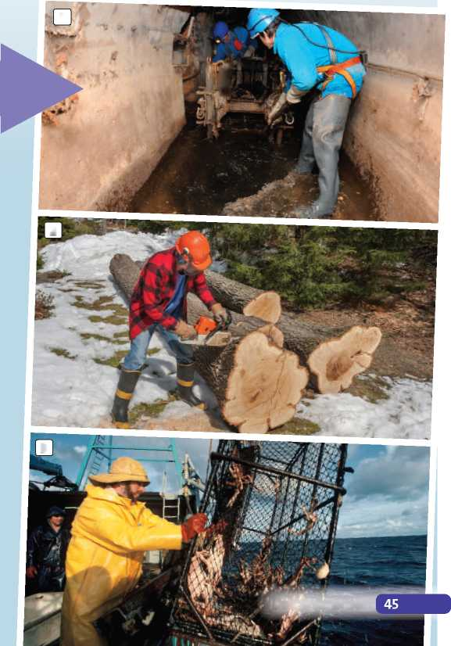but do not earn a lot of money. (2 words)

1. **Look quickly at texts A-C. Match each text with the correct photo (1-3).**

***WOULD YOU WANT TO DO THIS?***

[A Jeff Haslam spends a lot of his time underground. He works in London's sewers - the tunnels under the roads that carry away waste water. His job is to keep the sewers clear. 'We work in teams of six,' says Jeff. 'It's very dirty work. And of course we 5 work in the dark.' He has to wear special clothes, a mask and a helmet with a light. 'The most difficult thing is clearing the fat and oil from the sewers under the Chinese and Indian restaurants,' he says. 'Last month we removed 1,000 tonnes of fat!'

**E**

10

15

Many people like to work outdoors, but few would like Charlie Radley's job. Charlie lives in Alaska and works on a fishing boat. Each fishing trip lasts about a week. 'It's extremely cold and often stormy,' says Charlie, 'so we wear warm, waterproof clothes.' Charlie can earn a lot of money if they catch a lot of fish, but if they don't, he earns very little. 'I'll do this job for a year or two more,' says Charlie, 'then I'm going to look for something warmer and drier!'

IA Sandy Smith is a lumberjack - somebody who cuts down trees. Sandy noticed an advertisement for lumberjacks on the internet. Lumberjacks work long hours and are not very well paid, but as 20 Sandy likes to work outdoors, she decided to apply for the job. 'It's a very dangerous job,' says Sandy. 'We work with big, dangerous machines, so I'm always very careful!'

**1**

**2**

**3**

' j

1. Which qualities from exercise 1 do you think you have? Write three.

**»1.17**

**Read the Speaking Strategy. Then listen again and**

|  | *r*  **Revision: Student Book page 66** | |
| --- | --- | --- |
| 1 • | **1 Complete the definitions with the words below.** | |
|  | **enthusiastic flexible** | **friendly** |
|  | **good at communicating physically fit reliable** | **honest patient** |
|  | **1** If you’re  have to wait. | , you don't get cross if you |
|  | **2** If you’re | , you talk clearly and |
|  | people find you easy to understand. | |
|  | **3** If you’re | , you don't get tired easily. |
|  | **4** If you’re | , you tell the truth. |
|  | **5** If you’re people. | , you get on well with |
|  | **6** If you’re  attitude to work. | , you have a very positive |
|  | **7** If you’re  different things. | , you’re able to do lots of |
|  | **8** If you’re  do things. | , people can trust you to |
|  | **<** |  |

4

Read the task below. Then listen to a candidate

I think I'm , and

**Q1.17**

doing the task and tick the job he chooses.

You want a part-time job in order to earn some money while you’re at school. Discuss the two job advertisements with a member of staff at the job agency. Decide which jot you will apply for and why.



**Part-time waiter** needed to work in our **-irsave job**

popular city-centre café. Hours: 6 - 10 p.m. Mon -

Fri. £6.50 an hour plus tips. I I

**Gardener** needed to work part-time at Highfleet **\*savejob** Hall. Hours: 8 a.m. to 3 p.m.

Sat and Sun. £6.50 an hour. I I

**complete the sentences with the words below.**

**although even though however nevertheless**

1. I know it's only four hours a day. , it's at the

end of the day when I am already tired.

1. I enjoy working outside the weather is

often bad.

1. the hours are quite long, they’re all at the

weekend.

1. The money is slightly better too. , I’m sure

the other job is right for me.

1. 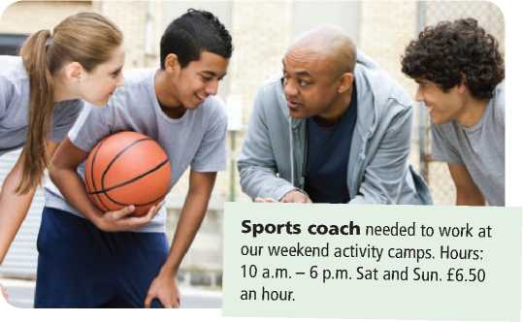**You are going to do the task in exercise 3. Look at the two jobs below and make notes.**

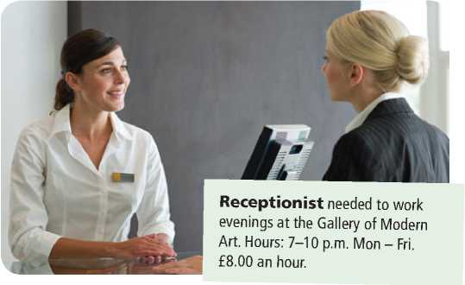

Which job do you prefer?

Why this job?

Speaking Strategy

When you discuss a topic and give reasons for your opinions, try to include some complex sentences. For example, use words like *although* / *even though, nevertheless* and *however* to make contrasts.

Why not the other job?

**6 Now do the task in exercise 3, using your notes from exercise 5.**

Preparation

1. Put elements 1- 7 in the correct places (A- G) in the letter.
2. the email address the email is going to
3. the writer's name
4. the writer's address
5. the date
6. the writer's signature
7. the person the letter is going to
8. the subject line

**From:** Alex Davies <[AlexRDavies@hotmail.com](mailto:AlexRDavies@hotmail.com)>

**Sent:** Saturday, November 03, 10:06 am

**E To:** [coachsarah@netballau.com](mailto:coachsarah@netballau.com)

**FBI Subject:** Application for volunteer netball

team leadei

**0** 20 Crown Road

Mill I

IA2 3NN

CD 3rd November, 2019

**E** Den Mi s C „iicv.

1. 1 in the leisure centre for a volunteer netball team

leader, and I [51] the role.

1. am captain of my school netball team, and would love to help out with your netball team.
2. [52] playing lots of sports at school, including

hockey, table tennis and badminton. I love playing team games. I [53] be a great team leader because

1. am sociable and responsible.
2. can come to training every Wednesday after school and am available for Saturday games.
3. look forward to hearing from you soon.

Yours [54]

IE Alex Davies

***Atex Davies***

IE Alex Davies, Ryton School

1. Complete the summary of the email.

The writer is applying for the voluntary role of

1

He saw the advert 2 . He thinks that his

1. will be useful for the job. He has

experience of playing 4 . He thinks he is

1. and [55] . He can
2. every week and is available for

Writing Guide

: Writing Strategy

: When you write a formal letter:

* Start with: *Dear (Mrs White),* if you know the name of the person, or *Dear Sir or Madam,* if you do not.
* Include a subject line at the top of the email.

: • Write in paragraphs. One-sentence paragraphs are fine

: for opening or closing an application letter.

* • Do not use colloquial language or short forms *(I’m,*

*: there’s,* etc.).

: • Finish with *Yours sincerely,* if you used the person's name

* at the start, or *Yours faithfully,* if you did not.

1. **Read the Writing Strategy above and the volunteering advertisement below. Write an email applying for the volunteering role. Follow the paragraph plan below.**

Looking for energetic and  
organised volunteers!

We are holding two charity swimming competitions on Friday and Saturday, December 16 and 17 at Alton Leisure Centre. We need help with collecting money, timekeeping, prize giving and photos! Please email to apply.

Paragraph plan

**A** what the volunteering role is and how you found out about it

**B** why you are interested in the role

**C** why you are the right person for the role

**D** which days you can attend

**E** what you would like to happen next

|  |  |  |
| --- | --- | --- |
|  | **CHECK YOUR WORK** |  |
| **(<® Have you ...** | |  |
|  | 1 1 laid out the letter correctly?  1 1 used appropriate language? |  |
|  | 1 1 checked your grammar and spelling? |  |

**Money**

Vocabulary

**Q1.18**

Spending power

I can talk about different shops and services.

**Listen and write the numbers. Use the correct**

**symbols: £, €, $ and ¥.**

**3 Where can you do these things? Complete the answers with the words below.**

**a** €1,000,000

**b**

**c**

**d**

**e**

**f**

**g**

**h**

**bank charity shop deli (delicatessen) estate agent's launderette DIY store optician's takeaway**

**2 Where can you buy these things? Complete the names of the shops with the correct words.**

**1 D**

s

Where can you ...

1. buy cold meat, cheese, olives, etc.?
2. buy a hot meal to eat at home?
3. keep your money?
4. get glasses for your eyes?
5. buy cheap second-hand things?
6. find houses and flats for sale?
7. wash your clothes?
8. buy things to decorate your house?

**Q1.19**

**Listen to four dialogues one at a time, pausing**

**after each one. Which shops are the people in?**

3 g

**4** b

**5 c**

**6 c**



**Complete the dialogues with the words below.**

**1 bargain discount price tag sale**

**Emma** Are those jeans new?

**Kelly** Yes, I bought them in a 1 .

**Emma** How much were they?

**Kelly** Well, I looked at the *2* and it said

£45. But when I got to the till, the sales assistant gave me a £20 3 , so they were

only £25.

**Emma** That was a *4* !

s

**7 g**

s

**8 p**

o

c

**9 s**

**10 s**

**2 coupon receipt refund special offer**

**Fred** I'd like to buy this scarf, please. Can I use

this 5 ? It says I can have

a £5 discount.

**Sales assistant** No, I'm afraid you can only use it on

full-price items. This scarf is already on

6

**Fred** OK. I'll buy it anyway. Actually, it's a

present. If my friend doesn't like it, can she bring it back and get a 7 ?

**Sales assistant** Yes, if you give her the 8 .

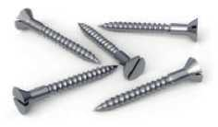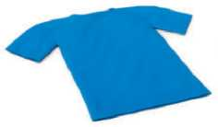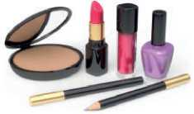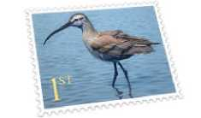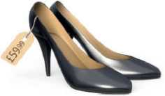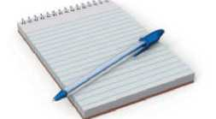



**3 Complete the second conditional questions in the quiz**

READERSBW

***top tips!***

If we only needed, we

1. **Complete the second conditional sentences with the correct form of the verbs below.**

**be can feel have help not stay up not take win**

1. If you had a problem, I you.
2. If I more time, I'd see more of my friends.
3. I the bus to school if I had a bike.
4. If you so late, you wouldn't be so tired in

the morning.

1. How you if Sam didn't

invite you to his party?

1. My parents cross if I didn't revise for my

exams.

1. You afford a new mobile if you didn't

waste your money on DVDs and games.

1. If I the lottery, I'd buy my mum a new car.
2. **Complete the money-saving tips with the correct form of the verbs in brackets.**

*We* asked readers what they would do if they needed to save money. Here are their ideas!

If we (drive) more slowly, we

(not use) so much petrol.

(buy) the food we

(not throw) so

much food away.

If we (borrow) books and DVDs

from libraries, we (not have to)

buy them.

**below with the correct form of the verbs in brackets. Then do the quiz.**

What would you do if ...

you (see) a road accident?

**I I** film it on my mobile

**I I** call the police

**I I** help the people in the accident

your friend (give) you a present that you

(not like)?

**I I** throw it away

**I I** ask your friend to change it

**I I** keep it and say nothing

you (can) speak perfect English?

**I I** move to Britain or the USA

**I I** become an interpreter

**I I** learn more languages

1. you (know) that a classmate was cheating

in an exam?

**I I** tell the teacher

**I I** talk to the classmate about it

**I I** do nothing

1. you (break) your friend's mobile?

**I I** give him / her your mobile

**I I** buy a new one

**I I** say that you didn't break it



you (find) €100 in school?

**I** ] keep it

**I** ] give it to a teacher

**I** ] give it to a charity

1. Now write your answers to the quiz in exercise 3 as conditional sentences.

If we (drink) water from the tap

rather than bottled water, we

(save) a lot of money.

If everyone (wear) an extra jumper

1. or two in the winter, they (can)

turn down their heating and save money.

If degree courses (be) shorter,

students (spend) less on

tuition fees and accommodation.

If we (turn off) the lights every

***y*** time we left a room, we (not

use) so much electricity.

1. If I saw a road accident, I'd

**Revision: Student Book page 73**

**\*• .• 1 Circle the correct verbs to complete the sentences.**

1. The restaurant **charges** / **costs** $3 for water.
2. We **saved** / **saved up** a lot of money by booking the flights online.
3. If you **buy** / **spend** the cinema tickets, I'll **owe** / **pay for** the drinks and popcorn.
4. Don't worry - if you can't **afford** / **spend** to buy lunch, I can **borrow / lend** you some money.
5. He's always short of money because he **loses** / **wastes** about €5 a day on drinks and snacks.
6. I **borrow** / **owe** my parents €50 from last summer.
7. If I **charge** / **run out of** money, I'll **borrow** / **lend** some from my parents.
8. We can **buy** / **charge** three books because they only **cost** / **pay for** €4 each.
9. The information needed is
10. The information needed is
11. The information needed is
12. The information needed is
13. The information needed is
14. The information needed is **complete the gaps in the summary in exercise 3. Use**

**Listen again and write the correct words to**

**Q1.20**



**between 1 and 3 words for each gap.**



**Read the questions and think about the kind of information you need for the answers to the questions.**

**Ọ1.20**

**Listen to the true story of a student in Australia.**

**Which is the best title? Tick a, b or c.**

**a** An honest student gets a reward **I** I **b** Crime doesn't pay I I

**c** How to find a job in TV I I

1. Where is the apartment that speaker 1 mentions?
2. How much did speaker 2 spend on cosmetics?
3. How long has speaker 3 had his job?
4. What is speaker 4's hobby?

**Q 2.21**

**Listen to four different speakers and answer the**

**questions in exercise 5.**

**Listening Strategy**

Before you listen, carefully read the summary and think about what you need to fill each gap. Think about the part of speech (noun, adjective, verb, etc.) and the kind of information (a time or date, number, age, place, an adjective that describes a feeling, etc.) that should go in each gap.



**Listen again and match speakers 1-4 with**

***Q* 2.21**

**Read the Listening Strategy and the summary below. What kind of information do you need for each answer? Choose from the alternatives below.**

**an adjective to describe a feeling a country a job**

**a number a period of time a room**

Mr Amarsinghe was short of money so he took a part-time job as 1 . He was working in 2 on the ground floor

of a TV company, when he found some money. At first, Mr Amarsinghe, who was born in 3 , thought it was a trick

and decided not to take the money. The police arrived and found more than *[56]* dollars. No one claimed the money

but the police phoned Amarsinghe after 5 and told him

that most of the money was now his. A judge decided that he deserved the money for his honesty. Amarsinghe was of course 6 when he heard this, but he wasn't sure how he

would spend the money.

**sentences A-E. There is one extra sentence.**

This speaker:

**A** asked for a pay rise at work, but did not get it. I I **B** borrowed money for a holiday, but did not go. I I **C** receives gifts of money, but never spends it. I I **D** tried to raise money for charity, but did not get much. I I

**E** tried to get a refund in a shop, but failed. I I

The extra sentence is I I .



I can talk about events happening at different times in the past.

1. Read the example of the past perfect. Then look at the timeline and answer the question below.
2. Rewrite the following sentences using one past perfect verb and one past simple verb.

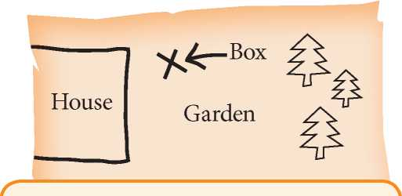

I got home

B C

now future

IOOO <

When I got home, somebody had tidied my room.

A

^4-

past

When did somebody tidy my room? A I I B I I C I I

1. Complete the sentences with the past perfect form of the verbs in brackets.
2. Tom (take) his bike apart and was trying to

fix it.

1. She took out a letter which she (keep) in a

drawer for years.

1. When I clicked ‘buy', the price (increase).
2. I was cross when the computer suddenly switched off,

because I (not save) my document.

1. He couldn't move back to London because he (sell) his flat there.
2. Complete the text with the past perfect form of the verbs in brackets.

A family in Wales has tried, without success, to get their hands on £5,000 which belongs to them. Six months ago, Richard Williams found a note inside a book. It was from his father, Allan Jones, who 1 (die) two

years earlier. The note told Richard about a metal box with £5,000 inside - money that his father 2

(save up) during his lifetime. Before he died, his father 2 (bury) the box in the garden, near the house.

Then he *4* (write) a note for the family.

He 5 (draw) a small map too, showing the

exact location of the money.

Unfortunately, since Allan’s death, the Williams family 6 (do) some building work. They 7

(add) two rooms to the back of house - directly on top of the buried money! ‘If we tried to get the money now, we’d cause too much damage. It would cost more than £5,000 to repair it,’ says Richard, who 8 (not

know) anything about his father’s money until he found the note.



1. I bought a ticket, then I checked the numbers.

After I’d bought a ticket, I checked the numbers.

1. We bought some chicken, then we made dinner.

When

1. My parents went out, then I got home.

When

1. The sun came out, then we arrived at the beach.

After .

1. I took my bike apart, then I cleaned every piece.

After . _

1. It got dark, then we arrived at the hotel.

When

1. I spoke to my dad, then I applied for the job.

After _

1. She read the letter, then she began to laugh.

When

1. **Look at the updates showing what Callum did yesterday. Then write more sentences like the example. Use the past perfect and the past simple.**

**@callum19**

**9:30** Just got up. It’s late - but it’s the weekend!

**10:30** No milk! Toast for breakfast.

**11:11** Shopping in town, looking for a new skateboard.

**12:10** I’ve found a great skateboard! I’m buying it.

**12:52** Meeting friends for lunch in town. I’m early!

**15:45** Finished my homework. Phew!

**17:29** Practising the guitar. Concert tomorrow!

**19:04** Great! Pasta for dinner!

**21:25** Watching a DVD - but it’s boring.

1. **22:15** Reading a magazine about extreme sports.
2. get up / have breakfast

After he’d got up, he had breakfast.

1. have breakfast / go shopping
2. buy a skateboard / meet friends for lunch
3. finish his homework / practise the guitar
4. have dinner / watch a DVD
5. read a magazine / go to bed
6. **Circle the correct verb form in these sentences.**

**Tick the box if both forms are correct.**

1. *My* friends agreed **paying** / **to pay** for my ticket. I I
2. I don't mind **cycling** / **to cycle** in the rain. I I
3. I've started **learning** / **to learn** the saxophone. [ I
4. Two men have admitted **stealing** / **to steal** the painting.
5. We ended up **staying** / **to stay** at the hotel for a week instead of two nights. I I
6. Do you like **going** / **to go** for walks on the beach? I I
7. I hate **seeing** / **to see** animals in pain. I I
8. I don't expect **passing** / **to pass** all my exams. I I
9. She offered **phoning** / **to phone** me later. I I
10. **Complete the text with the infinitive or *-ing* form of the verbs in brackets. Sometimes both are correct.**



At the end of a long journey, most people prefer

1 to get (get) home and relax as soon as possible.

They don't fancy 2 (shop), but they don't

want [57] (arrive) home with nothing to eat.

Now, travellers who pass through Gatwick Airport in

London can avoid *[58]* (return) home to an

empty fridge by choosing 5 (visit) a virtual

shop. There are no real products in the shop, only images on ten large screens. When you decide 6

(buy) something, you use your smartphone to scan it.

You keep 7 (scan) items until you've found

everything you need, then you pay. After that, you can spend a week or two 8 (enjoy) your holiday.

Let the shop 9 (deliver) your shopping soon

after you get home. According to the retailer, the virtual shop is a perfect combination of traditional and online shopping. People enjoy 10 (look) around

shops, but they also love 11 (shop) online

because it's so convenient.

1. **Study the dictionary entries and answer the questions.**

**1** How many meanings are there for each verb?

1. Which verb takes an infinitive?
2. Which verb takes an *-ing*form?

**□ 4** Which verb takes a bare form?

**fail** *I* fell *I verb* **1** [I, T] to not be successful in sth: *She failed her driving test. • I feel that I’ve failed. - I’m 25 and I still haven’t got a job.* ***2*** [I] **fail to do sth** to not do sth *She failed to notice that the front door was open.*

**risk** *I* risk *I verb* [T] **1** to put sth or yourself in a dangerous position: *The man risked his life to save the little boy.* ***2* risk doing something** to take the chance of sth unpleasant happening: *If you don’t work hard now, you risk failing your exams.*

**make** Imeikl verb **1** to create or prepare something by combining materials or putting parts together: *She makes her own clothes.* **2 make somebody/something do something** to cause somebody/something to do something: *She always makes me laugh.*

**VOCAB BOOST!**

When you learn new verbs, it is a good idea to learn the verb pattern at the same time, if there is one.

You can write it like this:

suggest doing something

refuse to do something

make somebody do something

Writing an example is a good way to learn the pattern. An example that is true for you might make it easier to remember:

My brother always suggests playing video games.

My sister refuses to help me with my homework.

Nothing can make me change my mind.

**\>**

1. **Write example sentences to show the verb patterns for these verbs.**

**1** hope

1. fancy

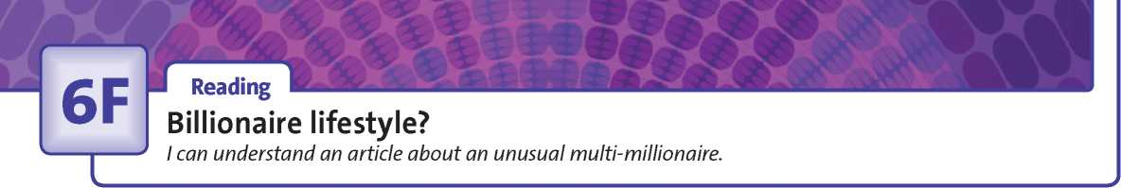**Revision: Student Book page 76**

1. **Circle the correct words (a or b) to complete the text.**

My uncle is the 1 of a small company that

makes mobile phone batteries. His company has

1. with one of the biggest mobile phone

companies in the world. It generates a lot of

1. for my uncle's company.

My sister is *4* . She has started a number of

businesses, and taken quite a lot of risks. She is always asking for 5 , but it is difficult

to find 6 who want to lend her money.

Although her companies make quite big 7 ,

she doesn't pay herself a very big 8 .

b entrepreneur

1. a CEO
2. a a contract
3. a salary
4. a an investor
5. a profits
6. a CEOs
7. a profits
8. a funding

b a funding

b income

b an entrepreneur

b funding

b investors

b investors

b salary

**: Reading Strategy :**

When you do a task with gapped sentences, : study the sentence after each gap and look for any connections with the missing sentence. For example, if it begins with *but,* there is a contrast. Other words suggest other types of connection:

: • similarity: *too :*

. • cause / result: *so .*

**•** a different option: *or*

1. **Read the Reading Strategy. Then match sentences A-G with gaps 1-5 in the text. There are two extra sentences.**

**A** He doesn't plan to give his children very much money when he dies.

**B** By the age of twenty he had made and saved $9,800 (about $100,000 in today's money).

**C** However, he became the richest man in the world.

**D** As a teenager, he worked in his grandfather's shop and delivered newspapers.

**E** Although he is rich, he isn't very happy.

**F** Only his clothes are expensive, but he says they look cheap when he puts them on!

**G** He still lives in Omaha, in the house he bought more than fifty years ago.

**2 Read the text about Warren Buffet, ignoring the gaps. Which sentence is true: a, b or c?**

**4 Read the text again, including the missing sentences in exercise 3. Are the sentences true (T) or false (F)?**

**a** Warren Buffet is a billionaire who enjoys spending money. **b** Warren Buffet made billions, but has given all his money away.

**c** Warren Buffet is a billionaire and leads a modest lifestyle.

1. Buffet is over 80 years old. I I
2. He started earning money when he was a teenager. I I
3. He has recently moved into a very expensive new house. I I
4. The food he eats now is the same as the food he ate when he was young. I I

He plans to give a lot of money to his children. I I

**Warren Buffet**

Warren Buffet is the most successful investor of the 20th century and one of the richest men in the world. Buffet was born in Omaha, Nebraska in 1930. He first became an investor at the age of eleven. 1 He also

bought chewing gum, Coca-Cola and magazines from him and sold them to

5 neighbours. *2* By his early thirties, he had become a millionaire,

and by 1990 he was a billionaire.

But although he is very rich, his lifestyle isn't particularly extravagant.

3 It only cost him $31,500! He doesn't carry a mobile phone and

he doesn't have a computer on his desk. Buffet says he eats the same things he has 10 always eaten: burgers, fries and Coke. 4 Not only is he very modest,

but he is also very generous. He has already given billions of dollars to charities and says that he will eventually give away 99% of his money. 5 He once

said, ‘I want to give my kids just enough so that they would feel that they could do anything, but not so much that they would feel like doing nothing.'





■ Speaking

Photo comparison and presentation

1 ' I can compare ideas for spending money on schools and justify my opinion.

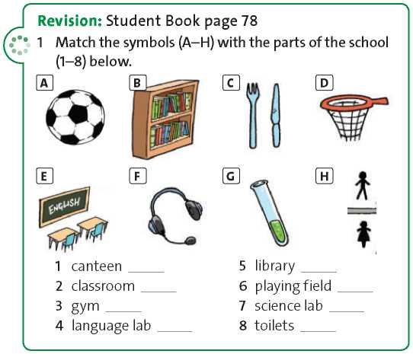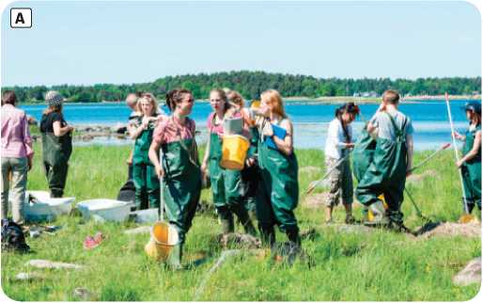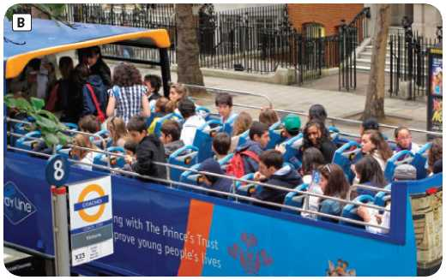

**4**

**Q1-22**

**Which of the phrases in exercise 2 does the student use?**

**5 Now prepare to do the task below. Make notes.**

1. **Match the phrases below with categories A-D.**

**A** Structuring your speech

**B** Ordering points or opinions

**C** Justifying your opinions

**D** Summing up your opinion

**All in all, *... D***

**First, ... Second, ... Finally, ... I I**

**First of all, we need to decide *I* examine *I* look at *I***

**ask ourselves ... I I**

**I'd like to start by saying *I* looking at ... I I**

**Just to summarise the main points ... I I**

**Now I'd like to move on to ... I I**

**Now let's look at *I* move on to (the question of) ... I I**

**The main reason I feel this way is ... I I**

**There are a number of reasons why I believe this. First, ... I I**

**I'll begin with ... I I**

**This leads to my next point. I I**

**The reason I say that is ... I I**

**I'll tell you why I think that. I I**

**To sum up, ... In conclusion, ... I I**

**Read the Speaking Strategy. Then listen again.**

1. Describe one of the photos.
2. Compare it with the other.
3. ‘Only schools with a lot of money have good

extracurricular activities.' Do you agree? Why? / Why not?

Describe one photo

Compare it with the other

**Q1-22**

**task below.**

**Listen to a student presenting her answer to the**

The government does not spend enough money on schools. Do you agree? Why? / Why not?

**: Speaking Strategy**

When you are giving a short presentation, use the phrases to give opinions and justify them, and to structure your speech.

Answer to the question

1. **Now do the task from exercise 5 using your notes.**



Preparation

1. Read the task and the essay. Are the sentences true (T) or false (F)?
2. Sarah wants a sound system because she hasn't got anything for listening to music. I I
3. Her brother loves football. I I
4. She'd give money to an organisation that helps homeless people. I I
5. She'd spend most of the money. I I

If you won €1 million in the lottery, what would you do with it? Write an essay and include your ideas. Give reason! for your choices.

1. Read the Writing Strategy. Then underline the following in the essay:
2. one concession clause (starting with *Even though, Although,* etc.)
3. three second conditional sentences (with an *if* clause and a main clause)
4. one phrase for introducing an opinion
5. four phrases for listing four points
6. one phrase for introducing an additional point
7. Read the task in exercise 1 again. Make notes for your answer.

Introduction:

If I won €1 million, there are a lot of things I would like to do with the money. It would be nice to buy myself something, but it would also be good to help others.

First of all, I would buy myself a docking station with fantastic speakers. Although I have got an MP3 player and some speakers, they are not very good.

Secondly, I would buy a new car for my mum. Her car is really old. I would buy my brother a Liverpool kit and a scarf. He is a really big Liverpool fan!

Thirdly, there are a lot of homeless people in my city.

I would donate money to the local hostel. If I gave them €5,000, they could buy a lot of meals for homeless people.

Finally, I would save at least half of the money. In my opinion, it would be silly to spend it all now. What is more, if I invested the money, it would grow, and I would have more to spend in the future.

To sum up, I would buy something nice for myself and other members of my family, support local charities, and also save some money for the future.

First idea:

Reasons:

Second idea:

Reasons:

Third idea:

Reasons:

Fourth idea:

Reasons:

Conclusion:

Writing Strategy

In your writing, avoid starting too many sentences with the same words. Remember that you can:

* use a variety of phrases for introducing opinions

*(It seems to me*..., *In my opinion*..., etc.) and for making additional points *(Moreover*..., *Furthermore* ..., etc.).

* start conditional sentences with the *if* clause or the main clause.
* use concession clauses *(Although.., Even though* ...) at the beginning or end of a sentence.

Writing Guide

1. **Use your notes from exercise 3 to write an essay. Include an introduction and a conclusion.**

**CHECK YOUR WORK**

**<®> Have you ...**

■ I I used a variety of different ways to begin sentences? I I checked your spelling and grammar?

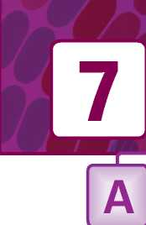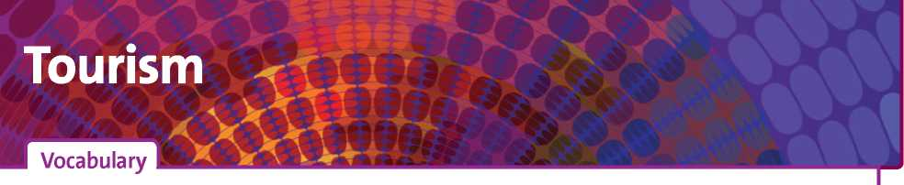

Worth a visit

I can describe visitor attractions.

**2 Answer the questions with the words below.**

**1 Complete the visitor attractions.**

**1 f 2 a**

**aquarium botanical gardens museum palace theme park tower national park**

Where can you ...

1. enjoy nature and see exotic plants?
2. learn about interesting old objects?
3. see where members of the royal family live?

**3 m**

**3**

1. go on exciting rides?
2. get a great view of a city?
3. see fish and sharks?
4. see unusual trees, plants and flowers?

**Ọ2-02**

**Listen to three tourists booking excursions. Which**

**type of attraction from exercises 1 and 2 does each tourist**

**decide to visit?**

**Tourist 1**

**Tourist 2**

**5 h 6 c**

**4**

**Tourist 3 Time:**

**Q2.02**

**Listen again. Complete the sentences with the**

**adjectives below. There are four extra adjectives.**

**atmospheric beautiful busy crowded disappointing impressive peaceful remote romantic spectacular**

**7** c

**8** s

1. **a** I imagine it's quite .

**b** The ruins are far more at night.

1. **a** The market looks .

**b** The market isn't as on Fridays.

1. **a** The evening excursion is much less .

**b** And it's more , in my opinion.

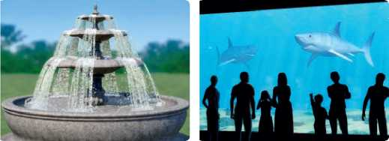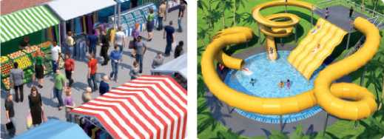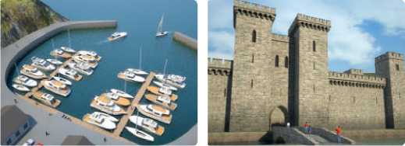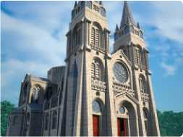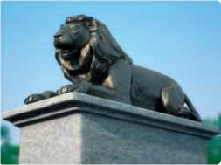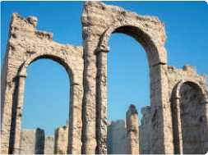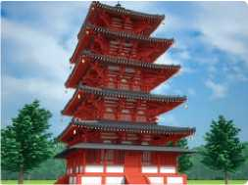

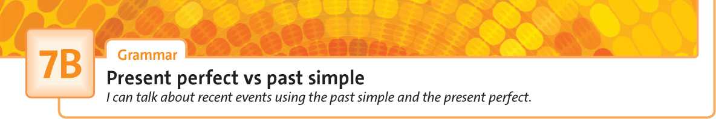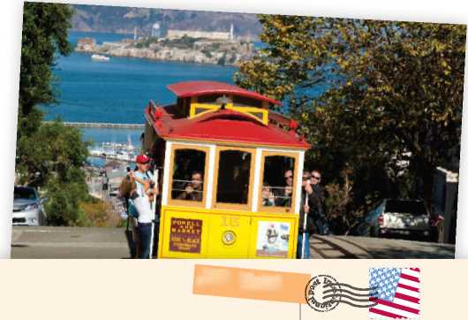

**be be buy go not go not rain take visit**

**AIR** mail

Amy White

20 Oxford Road

Abingdon

UK

**3 Hannah is on holiday in Greece. Write questions and answers about the things she has and has not done.**

1. **Complete the sentences with the verbs in brackets. Use the present perfect.**
2. Poor Jeff. He (break) his arm.
3. Look! The sun (come out).
4. John (not visit) Italy.
5. Oh dear. I (lose) my dictionary.
6. We (not finish) our homework.
7. Harry (not read) the *Hunger Games*

books, but he'd like to.

1. **Complete the postcard with the present perfect form of the verbs below.**

Dear Amy,

We 1 in the USA for

two weeks. The weather [59] [60]

fantastic - it [61] once!

We *[62] [63] [64]* two cities - San

Diego and Los Angeles. Now we’re in San Francisco. It’s a great city. We

1. shopping, and I
2. some clothes.
3. 7 lots of photos, which

I’ll upload to my blog later. We

1. to Alcatraz island

yet - we’re going there tomorrow. I’m really looking forward to it!

Love, Rose

1. Has she visited Athens? No, she hasn't.
2. **:** ?
3. ?
4. ?
5. ?
6. ?
7. **Complete the sentences with *has* / *have been, has* / *have gone* or *went.***
8. Lucy isn't at home. She’s gone to the sports centre.
9. We haven't had a holiday this year, but last year we to Brazil.
10. We've got plenty of food - I to the

supermarket yesterday.

1. She knows Madrid very well. She there

lots of times since she moved to Spain.

1. I love water sports. I surfing in lots of

different countries.

1. I hope Toby is enjoying the summer. He

to Italy for six weeks.

**Complete the mini-dialogues. Use the correct present perfect or past simple form of the verbs in brackets.**

1. **A** ever (you / have) a

holiday in Turkey?

**B** Yes, I . I (spend) two

weeks there last year.

**A** Which cities (you / visit)?

**B** Only two. We (start) in Istanbul and

then (travel) to Izmir.

1. **A** ever (you / try) an

extreme sport?

**B** No, I . But I (learn) to ski

last winter.

**A** Really? (you / enjoy) it?

**B** Yes, I . In fact, yesterday I

(book) my next skiing holiday!

1. **A** ever (you / go) on a

coach tour?

**B** Yes, we . We (go) across

the USA by coach last July.

**A** How long (it / take)?

**B** Three weeks. We (stop) at lots of

interesting places on the way.

1. **A** ever (you / eat) insects?

**B** Yes, I . I (buy) a bag of

insects as a snack in Thailand. But I (not

enjoy) them very much.

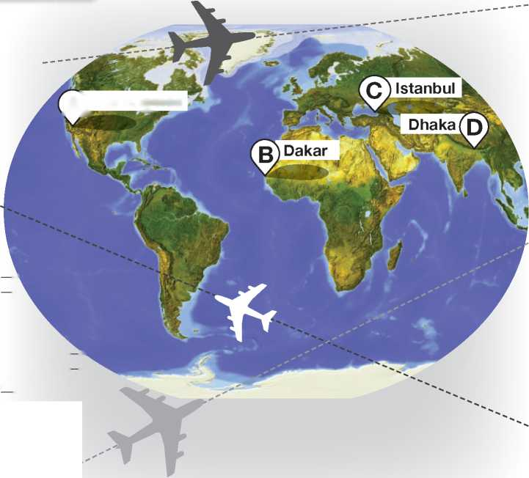■ Listening

Check your ticket!

**—I '** I can understand and use emphatic stress.

Listening Strategy

Notice the way that speakers emphasise certain words to stress an alternative or to correct what someone has said:

‘Would you like a double room or a single room?'

‘A double room, please.'

‘Does the plane arrive at nine?' ‘No, it arrives at five.' ‘Dave's in Paris.' ‘No, he isn't. He's in Rome.'

**I Read the Listening Strategy. Then listen and underline the stressed word in the sentences below.**

**Q 2.03**

**1**

**2**

**3**

**4**

**5**

Actually, I ordered the chicken pasta.

I need two seats near the front of the plane. No, there's a bus to the cathedral.

I'd rather go to the castle first.

The market is very touristy.

**I Listen again. Decide which sentence came before each sentence in exercise 1: a or b. Only one option makes sense with the stressed words.**

**1**

**Q 2.03**

**G 2.04**

**02.05**

**Listen and check your answers to exercise 3.**

Listen to a true story. Look at the map and identify

the route Sandy Valdivieso and her husband flew. Is it 1, 2, 3

or 4?

1. They flew from A to B to C to D.
2. They flew from A to C to D to B.
3. They flew from A to C to D to C to B.
4. They flew from A to C to D to C to A.

**A) Los Angeles**

Here's your chicken curry, madam. I I Here's your vegetable pasta, madam. I I Actually, I ordered the chicken pasta. I've booked you two seats near the middle of the plane. I I

I've booked you a seat near the front of the plane. I I I need two seats near the front of the plane.

Do we have to walk to the cathedral? I I

Is there a bus to the palace? I I No, there's a bus to the cathedral. Let's go to the castle later. I I Let's go to the museum first. I I

I'd rather go to the castle first.

**5 a** The market is a good place to visit, isn't it? I I  
**b** The whole city is really touristy, isn't it? I I

The market is very touristy.

**o 2.05**

Listen again. Are the sentences true (T) or false (F)?

Read the mini-dialogues and underline the word you need to stress in each of B’s lines.

1. **A** Did you get a new smartphone for your birthday?

**B** No, I got a new camera for my birthday.

1. **A** Did you have a good time in Egypt last month?

**B** We went to Morocco last month.

1. **A** Did you book a double room for three nights?

**B** No, I booked a single room for three nights.

1. **A** Shall we go by taxi or by bus?

**B** Let's go by taxi.

1. **A** I think the zoo is closed in December.

**B** No, I checked - it's open in December.

1. Sandy Valdivieso and her husband wanted to visit Africa, not Asia. I I
2. Their journey went wrong because an employee made a mistake at the airport in Istanbul. I I
3. They realised something was wrong as soon as the plane left Istanbul. I I
4. They saw the location of the plane on a map while they were flying. [ I
5. They were in Bangladesh for more than twelve hours. [ I
6. They never managed to get to Senegal. I I



Reported speech

I can use reported speech.

**Reported speech**

1. **How do these tenses / modal verbs change in reported speech?**

**Direct speech**

1. present simple
2. present continuous
3. past simple
4. present perfect
5. past perfect
6. *can I can’t*
7. *will I won’t*
8. *might*
9. *should*
10. **Circle the correct words.**

Last weekend

1. **Rewrite the sentences as reported speech. If necessary, change the pronouns, possessive adjectives and references to time and place.**
2. John to Sue: ‘I left a message for you yesterday.'

John told

1. Mark: ‘I'll top up my phone this evening.'
2. Jenny to Dave: ‘I can't hear you.'
3. Ann: ‘I've checked my balance three times this week.'
4. Jo to Si: ‘You should turn off data roaming.'
5. John said he ill.

a is b was

**6** Kate: ‘I had already texted Harry at the weekend.

1. Maisie said that she buy a new phone.

a would b will

1. Nathan said he looking forward to summer.

**7** Fran to Fred: ‘I called Tom two days ago.'

a is b was

1. Harry said that Kay gone to Italy.

a has b had

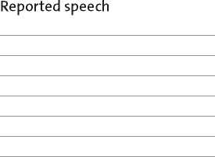

1. Emma told me that she find her phone.

a couldn't b can't

1. Pete told me he go to the party.

a had to b might have

1. **Read the reported conversation between two identical twins. Write the direct speech below.**

Imo was walking down the road when she slipped and fell. Her twin sister Zoe phoned just afterwards. Zoe told Imo that she had fallen over a few moments before. Imo told her that was an amazing coincidence because she had just done the same! Zoe said her leg was hurting so much that she couldn’t walk. Imo told Zoe that her own leg was OK and that she could easily walk home. But Imo told Zoe that if she couldn’t walk, she should call an ambulance. Zoe said that wouldn’t be necessary and that she could phone their parents.

1. **Complete the text with *said* or *told****.*

Dan 1 Bev that he had bought her a new phone.

She looked at it and 2 him that it was too big.

He [65] her that they were all that big nowadays.

She *[66] [67]* she wanted him to change it. He

1. that he couldn't change it and [68]

her that it had cost a lot of money. She [69] she

didn't care and 8 him she wouldn't use it.

1. Zoe:
2. Imo:

because

1. Zoe:
2. Imo:
3. Imo: But
4. Zoe:

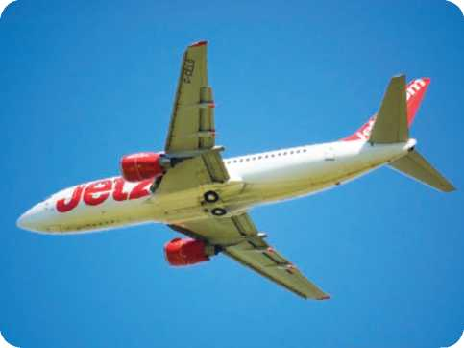

**7E**

I Word Skills ■

Compounds

News) **Jet2.com**

At Manchester Airport, an eleven-year-old boy has managed to walk through all the security 1 and fly to Rome. He did not

have a passport or a boarding [70] .

According to news reports, Liam Corcoran was with his mother in a nearby shopping 2 when he decided to go off on his

own. He went to Manchester Airport, where he succeeded in reaching the departure *[71] [72]* without having a ticket or any other

kind of document. Because it was high [73] , the airport

was extremely crowded and nobody noticed him. He boarded a Jet2 flight to Rome and the plane took off. During the flight, a few other passengers in economy [74] became suspicious

about the boy and told the cabin [75] . The captain then

radioed the airport and confirmed that they had an extra passenger!

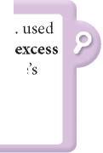

1. **Complete the text with the words below.**

**centre checks class crew lounge pass season**

1. Match the two halves of the compounds.

|  |  |  |  |
| --- | --- | --- | --- |
| **1** | flight | **a** | belt |
| **2** | low | **b** | room |
| **3** | passport | **c** | attendant |
| **4** | first | **d** | season |
| **5** | flight | **e** | number |
| **6** | online | **f** | check-in |
| **7** | seat | **g** | control |
| **8** | hand | **h** | class |
| **9** | baggage | **i** | luggage |
| **10** | single | **j** | carousel |

**VOCAB BOOST!**

**Ci** When you record new nouns, look for compounds ^-1 which include those nouns. You can sometimes find

these compounds under the same dictionary entry, but sometimes they have their own entries.

1. **Read the *Vocab boost!* box. Study the dictionary extract below and answer the questions.**
2. How many compounds are there in total?
3. How many separate entries are there?

**baggage** Z'bsgidgZ *noun* [U] bags, suitcases, etc for carrying sb's clothes and things on a journey: **baggage** (= baggage weighing more than the airline allowed limit) ♦ *I went to wait for my suitcase at baggage reclaim.* SYN **luggage**

**baggage room (US)** = left-luggage office

1. **Use a dictionary to find compounds that include these words.**
2. bus:
3. Using can save you time at

the airport.

1. Hotels are a lot cheaper during
2. You must wear your when

the plane is taking off and landing.

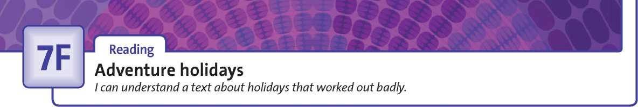



**Revision: Student Book page 88**

1. **Complete the holiday-related compound nouns.**

**Use the words below. Which of them are written as one word?**

|  |  |  |  |
| --- | --- | --- | --- |
| **back camp pen sun sun** | | | **sun travel travel** |
| **1** | guide | **5** | pack |
| **2** | burn | **6** | glasses |
| **3** | friend | **7** | site |
| **4** | cream | **8** | programme |

1. Read the texts. Are the sentences true (T) or false (F)?
2. Read the Reading Strategy. For questions 1-4, choose the correct option (a-d).
3. When Sam's brother was twelve, he and his cousin

**a** did not enjoy their trip together.

**b** had a terrible holiday, but got over it quickly.

**c** went camping near the River Thames.

**d** went canoeing with his parents.

1. On Sam's first holiday without his parents, he

**a** walked all the way to the Lake District.

**b** had to hitch-hike across some mountains.

**c** kept warm, but couldn't keep dry.

**d** ate less food than he wanted to eat.

**1**

**2**

**3**

**4**

Harriet

**a b c d**

The holiday taught Harriet

**a**

Sam's parents chose his holiday. I I

Sam had a frightening experience. I I

The weather was good during Harriet's holiday. I I Harriet's holiday was shorter than she expected. I I

Reading Strategy

Do not assume that because a multiple-choice option contains words from the text, it is correct. Focus on meaning, not on individual words.

Treat each option as a true or false task in order to find the option that is true.

went on holiday with six friends.

has been on one holiday without her mum and dad. arranged accommodation before the holiday. had a miserable time from the start of the holiday.

that it's best to take a map with you when you go backpacking.

never to go backpacking in Britain.

why backpacking in Britain in March isn't popular. to check the weather forecast before a holiday.

**What have been your worst holidays? Sam and Harriet tell us about theirs ...**

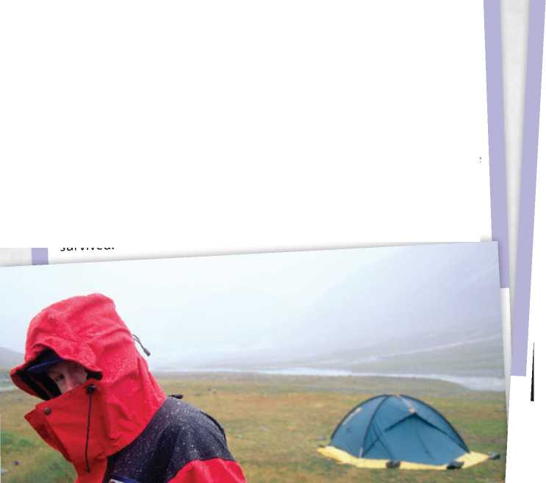SAM

My parents have always believed that we shouldI learrỊ to look after ourselves from an early age. That included holidays. I'^member my poor brother went on a canoeing trip with a cousir’when they were both just twelve ’/ears olcI. They had a miserable time'and have never realfy recovered from the experience. When ^^ided

1. was old enough to go on holiday with just my best fhend-YooTe going to h tch-hike to the Lake District with a tent and a backpack;

still alive - you're going to hitch-hike back again; So.we hitch,-h ked for hundreds of kilometres'we camped, we got cold and wet and scared, and couldn't afford to buy enough food. But, somehow we survived.

**HARRIET**

^hlnlT.Seyenteen'somefriendsand I scĩeĩ^^ in Wa,es during the

Bui at wav' *t*

2 A, ?pourin.9 with rain andItwas getting knoS ca™ to a farmhouse and

,e do°" We we°e 50 dirty and wet ỉnĩLS idnt let us nt0 toe house. We had homi 2n2h,e 9ĩrT' But th"y,et us phone the ?r/',the hotel manager kindly sent a ne*day it ™s«n raining so z id i°take toe train home. I've learned bac, ,9 0 Britain in

Mỵto * ?ins non‘st°p and the fields are covered in deep mud.

I ve never had such a miserable time! ■■ilMI

**■ Speaking Ỉ**

**Planning a holiday**

 *■ ' I can discuss and plan a holiday trip.*

**Q2.06**

**Choose the correct answers.**

1. **Complete the tourist attractions with *a, e, i, o* and *u.***
2. m n m nt
3. s f r p rk
4. c rn v l
5. sq r
6. r st r nt
7. sh pp ng d str ct
8. p r h s
9. **Put the phrases into the correct groups.**

**Do you fancy ... ? Either suggestion is fine by me.**

1. **don't mind. I don't think that's a great idea. I'd rather not. I'm not sure about that.**

**I'm not very keen on that idea. Let's do that. That's a really good plan.**

**They're both good ideas. We could always ... Let's ... What a good idea!**

**Making suggestions**



**Accepting a suggestion**



**Declining a suggestion**



**Expressing no preference**

4. **Complete the sentences with the words below. about buy nice park repeat**

**say town walk worth**

1. The nicest restaurant is in the centre.
2. What the hotel near the station?
3. There's a little hotel in the Old Town.
4. It's near the cathedral, which is also a

visit.

1. Sorry, did you ‘Indian restaurant'?
2. Could you that, please?
3. The cathedral near the is very historic

and atmospheric.

1. We can or we can take the tram.
2. We could always a travel card.

**Listen to two people discussing a trip to a city.**

1. They choose the **more expensive** / **cheaper** hotel.
2. There are a number of restaurants that serve **local** / **foreign** food.
3. They decide **to buy** / **not to buy** a travel card.
4. **Read the Speaking Strategy and the task below. Then make notes on each of the four points.**
5. Are there any good places to stay? How much do they

cost? Where are they?

1. What interesting buildings or monuments are there to

see?

1. What's the best way to get around?
2. Are there any good places to eat? Type of food? Where?

First recommendation:

Second recommendation:

**Speaking Strategy**

If you don't understand something someone has said, don't panic! Ask for clarification. You can use these phrases:

Sorry, did you say ... ? Could you repeat that, please? Pardon? Sorry, what does ‘tourist attraction’ mean?

1. **Now do the task from exercise 5 using your notes.**

You are planning a trip with a friend to a famous town in your country. Discuss the trip with your friend and agree on:

* places to stay. **•** ways to travel around.
* interesting buildings, **•** good restaurants. monuments, etc.

**Preparation**

1. Complete the collocations with the verbs below.

go (x2) hire visit

1. for a walk / for a bike ride / on a boat trip
2. a castle / a mosque / a museum
3. a car / a kayak / a bike
4. abseiling / mountain biking / surfing /

shopping / kayaking

1. Read the blog post. Find two more activities you can add to 1-4 in exercise 1.
2. **Read the Writing Strategy. Then find these sentences in the blog post. What word or words did the writer omit from the start?**
3. having a great time on our cycling tour ...
4. staying in a castle tonight ...
5. looking forward to it!
6. Read the sentences below. Cross out the words which could be omitted to make them more informal.
7. I wish I could stay here longer!
8. I'm taking lots of photos to show you.
9. I'll see you soon!
10. Read the task. Then prepare to write your blog post by inventing answers to questions 1-5 below.

You are on holiday with a friend, touring around a country.

Write a blog entry with information about:

* where you are touring and how you are travelling
* the weather
* some places you have stayed
* something you plan to do in the next few days.

1. Where are you touring?
2. How are you travelling?
3. What is the weather like?
4. Where have you stayed?
5. What are your plans?

**Writing Guide**

1. **Write your blog post using your notes from exercise 5.**

Writing Strategy

In informal style (e.g. in emails, blogs and postcards) we can omit sentence subjects *I* and *we.*

*Must go now! Wish you were here!*

With the present continuous, we can also omit the auxiliaries *am* and *are*.

*Having a great time in Italy!*

However, only do this once or twice in a text. Do not omit every instance of *I* and *we*.

CHECK YOUR WORK

o> Have you -

[~~| included all the information in your plan?

[~~| omitted the first word(s) from one or two sentences to make the style more informal?

[~~| checked your spelling and grammar?

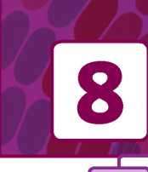

**A**

**Science**

Vocabulary

Gadgets

I can describe gadgets and talk about their use.

**1 Complete the list of materials using *a, e, i, o* and *u.***

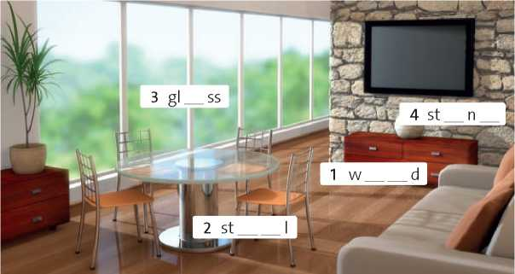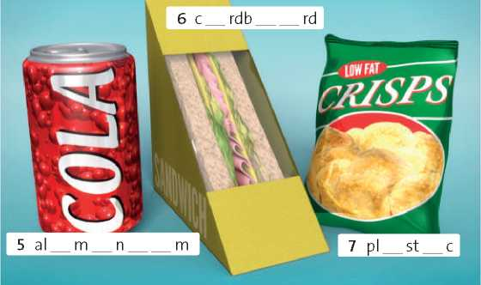

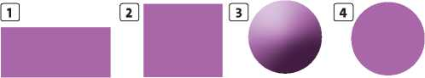

**Listen to the sentences and match the objects to**

1. Complete the sentences with the correct materials.
2. Shoes are often made of I .
3. Expensive rings are often made of g .
4. Car tyres are made of r .
5. Cups and plates are often c but

sometimes they are made of c .

1. Books are made of p .
2. Pavements are often made of c .
3. Gates and fences are sometimes made of
4. .
5. Tents and backpacks are usually made of

n .

1. In the past, coins were often made of c
2. Answer the questions with the material words from exercises 1 and 2. Use each word only once.
3. Which of the materials come from trees?

paper

1. Which of the materials are metals?
2. Which material is made from part of an animal?
3. **Match the words below with the diagrams. circular curved rectangular spherical square straight triangular**

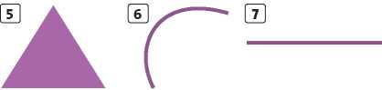

**1 5**

1. **6**
2. **7**

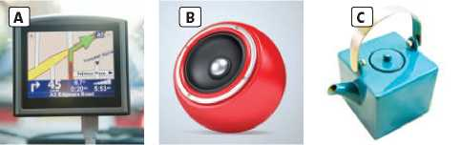

**02.07**

**the descriptions. Write the correct letter: A, B or C.**

1. Which man-made materials do we make from oil?
2. Which materials do we make from other materials which we find in the ground?
3. **2**
4. **4**
5. **6**



**8B**

**I Grammar J**

**The passive (present simple and past simple)**

*I can use the present and past passive to talk about technology.*

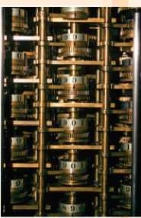

1. **Complete the sentences below with the present simple passive form of the verbs in brackets.**
2. Millions of mobile phones every year.

(sell)

1. American football very much in the UK.

(not play)

1. tablets in your school?

(use)

1. Most crimes in big cities. (commit)
2. Rubber trees in cold countries. (not grow)
3. Samsung televisions in

Korea? (make)

1. **Make the active sentences passive. Include the word *by.***
2. Millions of people watched the 2014 World Cup Final on TV.

The 2014 World Cup Final was watched by millions of people on TV

1. Alexander Fleming discovered penicillin.
2. Rafa Nadal didn't win the match.
3. **Complete the fact file below with the past simple passive form of the verbs in brackets.**

**COMPUTERS:**

**a short history**

* The first computer 1

(invent) by Charles Babbage in the early 19th century. It 2

(not power) by electricity - it was mechanical.

* The first electronic digital computer

1. (build) in 1943 in

Britain. It 4 (call)

‘Colossus’ and it [76]

(use) for decoding enemy messages in the war.

1. Robots made that car.
2. Did Suzanne Collins write the *Hunger Games* books?

■ Businesses began to use computers in the

1950s, but computers 6 (not sell)

in shops until the early 1970s.

■ The first desktop computers 7

(develop) in the late 1970s.

Internet access via a modem

1. (add) in the

1990s, but wireless access

1. (not add)

to most computers until about 2000.

1. Peter Jackson directed the *Hobbit* films.
2. **Put the words below in the correct order. (Remember where to put the adverb.)**
3. satnavs. / are / Phones / used as / sometimes
4. Was / Bob Dylan? / *Make you feel my love* / first / by / sung
5. invented / The wheel / about 5,000 years ago. / probably / was
6. quickly / was / The suspect / arrested.

■ For the first time, in 2015, more tablets and smartphones 10

(sell) than laptops and desktops. Will computers eventually disappear from our homes and schools?



**Revision: Student Book page 97**

**•. .* 1 Complete the sentences with the verbs below.**

**Remember to use the correct form of the verb. browse come up with get lose prescribe run**

1. He 10 kg during his trip to

Antarctica.

1. Yesterday, my friend a great idea

for how to raise money for our club.

1. My mum's got a new car and it

on biofuel.

1. If you've got a smartphone, you can the internet wherever you are.
2. My sister always a good deal

when she goes shopping for clothes.

1. Last month, a doctor some

medicine for my headaches.

Listening Strategy

You will sometimes have to identify the intentions of the speaker (e.g. to persuade, to warn, to inform, etc.). Listen for phrases such as *I thinkyou should, be careful to, I’m going to tell you about ...* that give you a clue to the speaker's intentions.

**Q2.08**

**Read the Listening Strategy. Then listen to**

four speakers. What are their intentions? Complete the

sentences with the *-ing* form of verbs from exercise 2.

1. Speaker 1 is a group of tourists.
2. Speaker 2 is to a friend.
3. Speaker 3 is about a museum.
4. Speaker 4 is a friend.

**Q 2.09**

**Read the questions below. Then listen to four**

speakers one at a time. Pause after each one and answer

the relevant question.



1. **Complete the definitions using the verbs below.**

**apologise challenge comfort complain encourage enquire entertain inform persuade recommend warn welcome**

1. If you somebody (about something),

you tell them about a danger.

1. If you to somebody (about something),

you tell them why you are unhappy about it.

1. If you (for something), you say that you

are sorry.

1. If you about something, you ask

questions about it.

1. If you something (to somebody), you

say why it is good.

1. If you somebody (to do something),

you make them feel more confident about it.

1. If you somebody or something, you say

you are happy about their arrival.

1. If you somebody (about something),

you tell them facts about it.

1. If you somebody, you invite them to

compete with you.

1. If you somebody, you try to make them

feel better when they're sad.

1. If you somebody (to do something),

you say things which make them want to do it.

1. If you somebody, you keep them

amused and interested.

1. The speaker's main aim is to

**a** welcome people to a special event.

**b** complain about problems with a new car.

**c** enquire about a new model of car.

1. The speaker's main aim is to

**a** inform somebody about a new laptop.

**b** recommend buying a new laptop.

**c** apologise for damaging somebody's laptop.

1. The speaker's main aim is to

**a** persuade people to invest money.

**b** challenge people to invent a better product.

**c** thank people for helping to develop a fantastic product.

1. The speaker's main aim is to

**a** describe a machine to her students.

**b** warn her students to be careful.

**c** challenge her students to do better than her.

**8D**

I Grammar

The passive (present perfect, future and modal verbs)

I can use different forms of the passive.

1. **Complete the sentences below with the present perfect passive form of the verbs in brackets.**
2. Our car (stea l).
3. Two important new drugs

(develop) this year.

1. The bus stop (damage) again.
2. The boat (not see) for two days.
3. All our money (spend).
4. I hope that painting (not sell).
5. **Look at the pictures, then complete the sentences with the present perfect passive form of the verbs below.**

**build not change not finish paint replace sett**

1. **Complete the questions using the present perfect passive form and *ever.* Then answer the questions with information that is true for you.**
2. (you / bite / by a mosquito)

Have you ever been bitten by a mosquito?

1. (your home / burgle)
2. (you / chase / by a dog)
3. (your phone / steal)

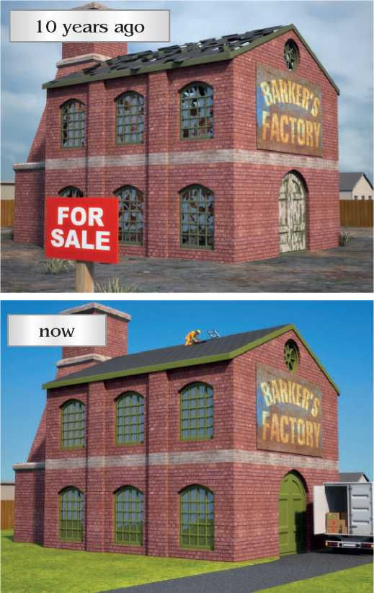

1. **Rewrite these sentences to make them passive. Include *by* ... to say who or what carries out the action.**

In the house of the future:

1. your fridge will order your food online.

your food will be ordered online by your fridge.

1. the sun will provide most of your electricity.
2. robots will clean all the rooms.
3. machines will prepare all of your food.
4. **Complete the dialogue using the present perfect passive and future form of the verbs in brackets.**

**Presenter** Can you give us the latest news on this exciting project to build a hotel on the moon?

**Scientist** The plans for the new hotel 1

(complete) and a location [77] [78]

(choose).

**Presenter** So when [79] (it / build)?

**Scientist** Well, the exact date [80] (not

decide) until next month at the United Nations meeting. The plans [81] [82] (approve)

at that meeting too.

**Presenter** And after that?

**Scientist** After that, the first parts of the hotel

1. (send) to the moon before

the end of the year.

1. **Complete the following sentences about a new software, using the correct passive voice.**
2. Possible replies to email (can suggest) for

your convenience.

1. Attachments (can store) for ever.
2. Automatic replies (may send) when new

mails arrive.

1. Updates (can access) at no extra cost.
2. Certain features (may personalise) for

businesses.

1. 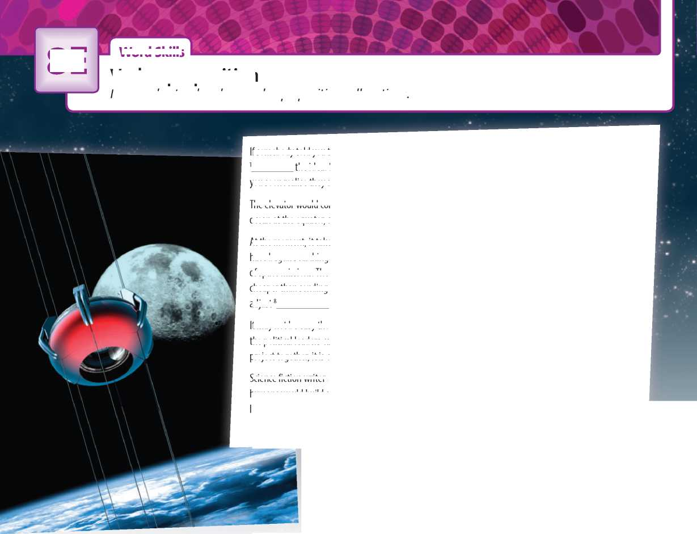**VOCAB BOOST!**

**Word Ski s**

**8E**

**1**

I

adjust 8

Verb + preposition

I can understand and use verb + preposition collocations.

If somebody told you they were building a lift to take people into space, you would probably laugh the idea. But in fact, if you listen 2 scientists and engineers talking about the plan,

you soon realise they are being completely serious.

The elevator would consist 3 a carbon fibre ribbon 100,000 km long. One end would be in the

ocean at the equator, and the other end would be in space.

At the moment, it takes months or years to prepare *4* a trip into space by rocket. Space agencies

have begun searching 5 a better option - partly because they worry 6 7 8 the cost

of space missions. The idea of a space elevator appeals 1 governments because it would be far

cheaper than sending rockets into space. It would be slower, but that would give passengers more time to the different conditions as they left the earth.

It may not be easy though: countries might argue 9 the exact location of the elevator. But if

the political leaders can cope 10 * these problems and manage to take part 11 the

project together, it is certainly possible.

Science fiction writer Arthur C. Clarke wrote a novel 12 the idea in 1979. He said in a speech that

humans would build a space elevator ten years after they stopped laughing at the idea. Well, they've stopped laughing now.

**Complete the text with these prepositions: *about, at, for, in, of, to,* and *with.* You will have to use some prepositions more than once.**

**Circle the correct prepositions to complete the sentences.**

**1**

You should apologise **for** / **to** that comment!

**charge** / tjoidg / *verb* **1** [T, I] **charge (sb/sth) for sth** to ask sb to pay a particular amount of money: *We charge £75 a night for a single room.* ♦ *They forgot to charge us for the drinks.* **2** [T, I] **charge sb (with sth)** to accuse sb officially of doing sth which is against the law: *Three men have been charged with robbery.*

**inform** / zn'foim / *verb* [T] **inform sb (of/about sth)** to give sb information (about sth), especially in an official way: *You should inform the police of the accident.*

♦ *Do keep me informed of any changes.*

**(O** Dictionaries often use *something* or *somebody (sth* or *sb)*

**^-1** in their definitions, but when you record verbs it is a good idea to include words which often go with those verbs.

to complain about sth / sb to complain about the weather / the noise / your hotel / your neighbours / your doctor

**\ 2**

1. **Read the *Vocab boost!* box. Write some words that often**

**go with these verbs.**

1. to care for sth / sb to care for
2. to learn about sth to learn about
3. to write to sb to write to

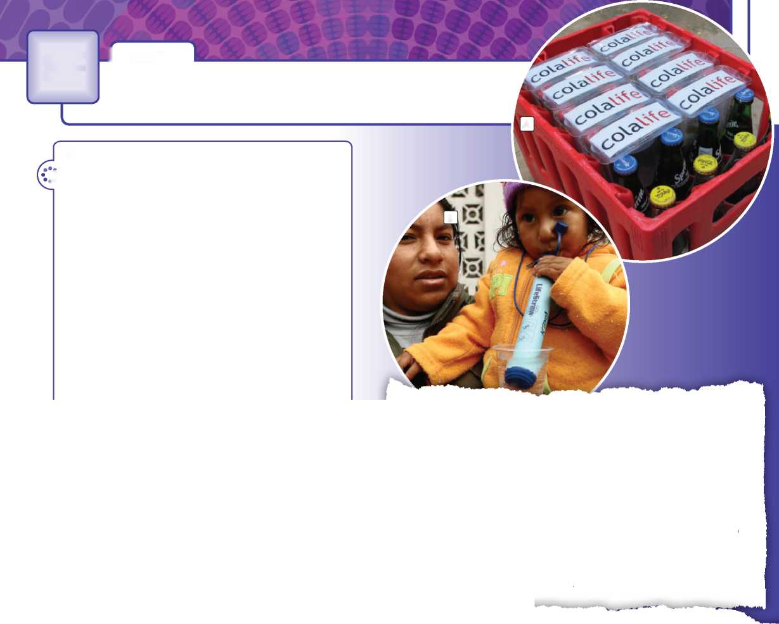

**8F**

I Reading

Inventions that save lives

I can understand a text about inventions.

10

**Revision: Student Book page 100**

*Í* **1 Complete the sentences with nouns formed from the verbs and adjectives below in brackets.**

1. The Hubble telescope can measure the (move) of distant galaxies.
2. The city centre was destroyed in the war. The (reconstruct) took many years.
3. Hard disk recorders allow us to make (record) of TV programmes.
4. Many men hope doctors will invent a cure for (bald).
5. The aeroplane is a wonderful

(invent).

1. That's a lovely flower (arrange).
2. Beethoven suffered from (deaf)

during the last 25 years of his life.

1. Before the (discover) of America

in 1492, many people thought the Earth was flat.

**2 Read the texts and match two of the inventions with the photos (A-B).**

**Reading Strategy**

Sometimes, true / false tasks include a third option: the text does not say. Choose the third option if the text does not contain enough information to clearly say if the sentence is true or false. Do not use your own knowledge (or guesswork) to fill any information gaps!

1. **Read the Reading Strategy. Then decide if the sentences below are true (T), false (F) or ‘does not say' (DNS).**

**Hippo-Roller, photo**

Many women and children in Africa spend up to nine hours a day carrying water to their homes. They use 20-litre plastic buckets, which they carry on their heads. The buckets are very heavy and often cause back and neck injuries. So engineers Pettie Petzer and Johan Jonker designed a ‘rolling wheel' which can carry ninety litres of water and is much easier to move. 33,000 ‘Hippo-Rollers' have been delivered to remote villages in Africa. The results are good: women have more time to look after their families, the children can go to school, and there are fewer injuries.

**E LifeStraw, photo**

**There are 780 million people in the world who don't have clean safe drinking water. This fact led the Swiss company Vestergaard to invent a special kind of straw that allows people to drink dirty water without getting ill. The LifeStraw**

**1**

**2**

**3**

**4**

**5**

**6**

Carrying water on your head can cause neck injuries. With the Hippo-Roller people can carry more water than with a normal bucket.

The LifeStraw is made from natural materials.

The LifeStraw never stops working.

A fizzy drinks company worked with Simon Berry to design the AidPod.

The AidPod is used successfully in many different countries.

15 **is a long thin tube that cleans the water as you drink. LifeStraw is very light and can clean up to 1,000 litres of water before you need to replace it. LifeStraw was used to help people after the Haiti earthquake, and floods in Pakistan and Thailand.**

**IE AidPod, photo "**

20 **When Simon Berry was travelling in Zambia, he noticed that he could buy fizzy drinks in the remotest villages. But the people had no medicines, and one in five children were dying before their fifth birthday. He had an idea. ‘Why don't they bring**

**medicines when they deliver the fizzy drinks?' So he invented the**

25 **AidPod, a triangular packet of medicines that fits between the**

**bottles in a crate. Berry is testing his ideas in Zambia. If his plan works, he hopes to do the same thing in other African countries.**



**3**

**Q2.10**

**Listen to a customer complaining in a shop. Then**

**Revision: Student Book page 102**

**1 Label the gadgets with the words below.**

**answer the questions.**

**digital camera digital radio DVD player**

**1** Which gadget from exercise 1 is faulty?

**e-book reader games console**

**headphones**

**mobile MP3 player tablet**

**2** Which three parts of the gadget are mentioned? (Choose from the parts in exercise 2.)

1 2 3

**Q2.10**

**Listen again and complete the sentences with the**

**words below. Circle the correct speaker (C - customer or**

**SA - shop assistant) for each sentence.**

|  |  |
| --- | --- |
| **1** What's | with it? **C** / **SA** |
| **2** There's | wrong with the volume control. **C** / |
| **SA** |  |
| **3** Can I have my | back? **C** / **SA** |
| **4** We don't give | **,** I'm afraid. **C** / **SA** |
| **5** I'm not | about that. **C** / **SA** |
| **6** I can give you a | note. **C** / **SA** |
| **7** Have you got the _ | with you? **C** / **SA** |

credit happy money receipt refunds something wrong

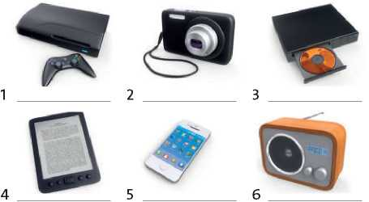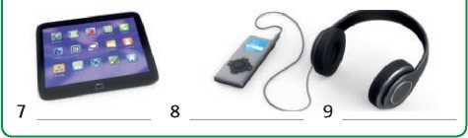

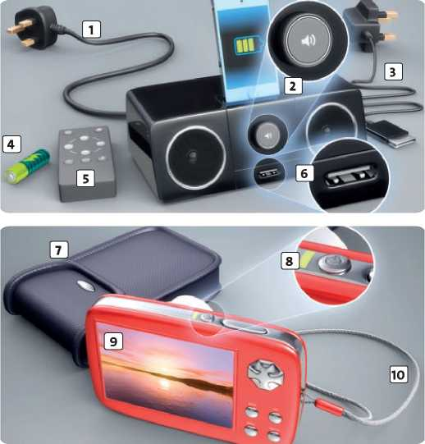

**5**

**2 Match the parts of the gadgets (1-10) with the words below (a-j).**

Speaking Strategy

When you are doing a speaking task, make sure you refer to all of the points in the task. It is also important that you react and respond properly to what is said during the conversation.

Read the Speaking Strategy. Then read the speaking task and write answers to all the questions below.

You are returning a gadget to a shop because one part of it is faulty. Discuss these four issues during your conversation with the shop assistant:

* What the gadget is and how much you paid for it.
* Which part of the gadget has a problem.
* When the problem started.
* What you want the shop to do.

1. What type of gadget did you buy?

**2** How much did you pay for it?

1. Which part of the gadget has stopped working?
2. When did the problem start?



**a** battery

**b** remote control

**c** case

**d** screen

**e** on/off button

| **f** USB port | □ |
| --- | --- |
| **g** power lead | □ |
| **h** volume control **1** 1 | |
| **i** strap | □ |
| **j** charger |  |

1. Do you want to exchange it or do you want a refund?
2. **Now do the task using your notes from exercise 5.**



OU ■ Writing

A formal letter

**1** I can write a formal letter of complaint.



does not allow for teachers and students’ rest. does not make use of teachers and students’ time. **c** does not encourage teachers and students.

**4**

During the pandemic, all your classes are now online and you have six periods every morning. Write a letter of complaint about this problem.

Dear Sir or Madam,

**1**

**2**

**3**

**4**

**5**

Preparation

1. **Read the task and the letter. What is the writer's main reason for complaining? Choose a, b or c.**

The writer thinks the schedule

**a b**

**Read the Writing Strategy. Then complete the formal letter in exercise 1 with some of the conjunctions below. however if or since so unless rather than**

**Complete the phrases for summing up using the words below. Underline the phrase that the writer uses in the letter in exercise 1.**

**all balance conclusion opinion reasons**

All in , I believe ...

On , I think ...

Overall, ... in my .

In , ...

For these , I strongly believe that ...

**Read the task below. Then think about the problem and make notes.**

Your school has just launched a new official website which most students find quite confusing and hard to use. Write a letter of complaint about it.

I am writing to report unreasonable class schedule in my school. (1) all classes in my school have gone

online because of the pandemic, the schedule has also been changed accordingly and at present, we are having 6 periods in the morning.

The main problem is that there is only a five-minute break between the periods. In those five minutes, students have to log in and out of their classes as well as get prepared for the new class. Hardly do they have time to relax or to take their eyes off the screens. My concern is that in the long run, this practice may seriously affect students' eyes and vision in particular and their well-being in general.

I understand that the school council wants to make the best use of online time and that teachers and students do not need long breaks to move from class to class as in offline classes. (2) , I believe after 45 minutes

concentrating on lessons, teachers and students should be allowed decent time to recharge and to prepare better for the next class, (3) having 10-minute breaks is

probably a better option.

In conclusion, I find this problem irritating. (4)

there is a change in the schedule, both teachers and students will feel exhausted by the end of the day.

Yours faithfully,

Pham Minh

Explain the problem clearly and why it is an issue for you.

Give more details about the problems.

Give reasons why you think the problem needs to be solved.

State what you want to happen in the future.

Writing Guide

**5 Use your notes to write a formal letter of complaint.**

**CHECK YOUR WORK**

**<®> Have you ...**

] |~| used some conjunctions and a phrase for summing up?

|~| checked your spelling and grammar?

**Writing Strategy**

Make sure you use a variety of different structures in your writing. You can form complex sentences by joining two clauses together with a conjunction *(although, because, if, or,* etc.). Use different conjunctions depending on the meaning of the clauses they introduce.



Cumulative Review 1 (Units I—1)

Listening

**02.11**

**Listen to four speakers talking about a past**

**situation. Write adjectives to describe how the situation made all four speakers feel.**



**02.11**

Listen again. Match speakers 1-4 with

**sentences A-E. There is one extra sentence.**

**A** He / She said the wrong thing. I I

**B** He / She needed a change of clothes. I I

**C** He / She had an accident. I I

**D** He / She spoiled a surprise. I I

**E** He / She didn't know what to say. I I

Speaking

**3 Work in pairs. You are going to take turns to tell your partner about a situation when you felt embarrassed. React appropriately when your partner is narrating. Use these ideas to help you:**

* set the scene
* say what happened
* say how you felt

**A**

Reading

1. Read the text and choose the best summary.

**a** How therapy can help people with phobias.

**b** The top five phobias and how to deal with them. **c** How phobias can affect our lives.

1. Read the text again. Match paragraphs A-E of the text with the questions below.

In which paragraph does the writer tell us ...

1. what caused Christine's phobia? I I
2. what happened when Christine saw

a spider in her car? I I

1. what Christine hopes for the future? I I
2. what other kinds of phobias exist? I I
3. what therapists can do to help? I I

Australian Christine Schipp was in the car with her husband one day when she noticed a spider on the back window. She opened the door of the moving car and jumped out. Unfortunately, Christine was the driver of the car, and her husband couldn’t drive! Luckily, the car stopped and her husband wasn’t seriously hurt.

B

Christine reacted in this way because she has a phobia, called arachnophobia - an extreme fear of spiders. Other animals can have a similar effect on some people, including dogs, fish, birds and even frogs. There are also other types of phobia, such as environmental phobias (like fear of flying) and medical phobias, for example, when people are terrified of going to the dentist.

C

Like many phobias, Christine’s fear of spiders comes from an event in the past. When she was four years old, her mother left her alone in the living room. While she was away, Christine saw a huge spider coming towards her. She was terrified, and climbed onto the sofa, covering her eyes. She was really upset.





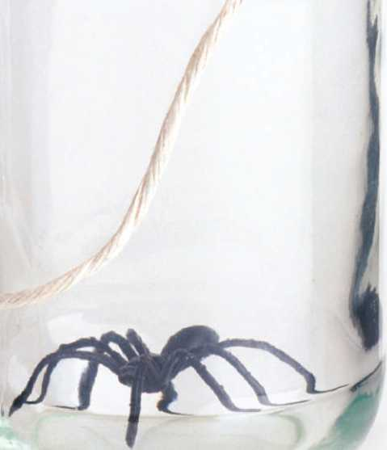

\ Cumulative Review 1 (Units I-1)

Grammar and vocabulary

1. **Choose the best options to fill in the blanks.**

TOUR BOAT DISASTER

Last night, twenty tourists 1 on a boat in the Indian

Ocean when it started filling with water. The boat turned over, but some of the passengers, including two British women, 2 with it during the night. Twenty-one-year-old

Katherine Ostojic and her younger sister, nineteen-year-old Alice, *3* on the part of the boat that was above the

water for ten hours. When they 4 any other boats,

they decided that they 5 to an island that they could

see on the horizon. But the island 6 as near as they

thought, and it took them over eight hours to get there. The journey was very 7 . When they reached the island,

they saw that it had an active volcano. Fortunately, some fishermen found the sisters and rescued them. Katherine and Alice were very 8 , and now they are safe in Bali.

At the moment, they *9* emails to their parents so that

they 10 that their daughters are alive. Because of their

adventure, the two girls have changed their travel plans and they are returning to the UK next weekend.

D

The good news is that there is a cure for these phobias. Psychologists use a technique called exposure therapy. First, they show the patient pictures of the thing they are scared of, and then they put a plastic model of it on the table. Finally, they bring the patient into contact with the real thing until they feel safe enough to be in the room alone.

E

After just three hours of therapy, Christine Schipp could hold a glass jar containing a large spider. But her treatment isn't finished. She has to continue looking at plastic spiders and pictures of spiders regularly. She hopes that if there is ever a spider in the car again, she won't put her own life, or anyone else's, in danger.

|  |  |  |  |  |  |  |
| --- | --- | --- | --- | --- | --- | --- |
| **1** | a | are | b | was | c | were |
| **2** | a | stay | b | stayed | c | stays |
| **3** | a | sat | b | sit | c | sits |
| **4** | a | didn't see | b | don't see | c | didn't saw |
| **5** | a | swam | b | should swim | c | swim |
| **6** | a | isn't | b | wasn't | c | weren't |
| **7** | a | retired | b | tired | c | tiring |
| **8** | a | cross | b | relieved | c | proud |
| **9** | a | are writing | b | write | c | wrote |
| **10** | a | are knowing | b | knew | c | know |

Writing

1. **Write a post about a frightening situation for an internet forum called *What a fright!* Include this information:**

* where you were
* what happened
* how you felt
* how you feel about the event now.



**Reading**

Listening



**Read the sentences and underline the key words.**

**Q2.12**

**Film**

| **Guardians of the Galaxy** | **action** | **122 mins** | **E4n** |
| --- | --- | --- | --- |
| **Frozen** | **animation** | **108 mins** | **£3.50** |
| **Anchorman 2** | **comedy** | **143 mins** | **£4.50** |

Genre Length Price

**Then listen to the information about the London Cinema**

**Museum. Are the sentences true (T) or false (F)?**

1. The London Cinema Museum isn't very well-known. I I
2. The actor Charlie Chaplin once visited the museum. I I
3. You needn't go on a guided tour if you want to visit the collection. I I
4. You don't have to buy a ticket to see a film before the day of the showing. I I
5. The museum is difficult to get to. I I

Speaking

1. **Work in pairs. You are at home with a friend and there is nothing you want to watch on TV. You are looking at the films available on the pay-per-view channel. Express your opinions about the films below. Which film will you pay to see, and why? Why are you rejecting the other options?**
2. Read the text and choose the best answers. Underline

the sentences in the text that helped you decide.

1. What is Mike Owen doing today?

**a** He is playing computer games.

**b** He is watching a TV series from start to finish.

**c** He is running a difficult race.

**d** He is watching an interesting documentary on TV.

1. According to the text, waiting for the next episode of a TV series can make viewers feel

**a** anxious.

**b** bored.

**c** delighted.

**d** frightened.

1. How much does it cost to use an online streaming service? **a** Nothing - it's free.

**b** It depends on the film.

**c** The same every month.

**d** Users pay by the hour.

1. Viewers who stream programmes

**a** can leave the room during the adverts.

**b** needn't receive phone calls.

**c** mustn't get up in the middle of a film.

**d** don't have to watch at particular times.

1. What makes Mike choose to watch *House of Cards* today?

**a** It only has thirteen episodes.

**b** Many TV channels show it at the same time.

**c** It was highly recognised as a huge success.

**d** There is just one episode each week.





**Grammar and vocabulary**

**4 Choose the best options to fill in the blanks.**

F w

**CINEMA  
ETIQUETTE**

«■11

ARE YOU

**watching?**

It's dark outside, but eighteen-year-old Mike Owen doesn't notice the time passing. Today, he's only doing one thing: sitting in front of his computer screen, watching all thirteen episodes of a TV drama.

Binge-viewing - watching several episodes of a TV series in one sitting - is getting more and more popular. And it isn't hard to see why. In the past, viewers had to wait nervously between episodes of their favourite TV series, because they were usually broadcast only once a week. Each episode finished with a moment of suspense called a 'cliffhanger', and fans were often left for seven whole days wondering what would happen next. But all of this has changed with the technology of streaming. For a monthly subscription, viewers can choose films or programmes from an online streaming service, which they can view on their TV, laptop, tablet or mobile phone.

This system has a number of advantages. Firstly, users can watch what they want when they want. Secondly, they can pause the film or programme so they can get a snack or answer the phone without missing the action. Thirdly, and most importantly for some, their viewing is not constantly interrupted by advertisements.

Mike is watching a series called *House of Cards,* a political thriller starring Kevin Spacey and Robin Wright. Instead of introducing one episode a week, all thirteen chapters were streamed online at the same time. The series was extremely popular and won a number of awards. TV executives should take note of the show's success because the future of their own channels may be in danger.

Going to the cinema is supposed to be fun, but sometimes, this is not the case. For example, how 1 times have you heard

a mobile phone ring while you *2* a film? This is one of the

most 3 things that can happen in the cinema. We are always

reminded to turn off our mobiles before the film starts, so there really aren’t 4 excuses. And if you forget, you 5 answer

your phone, because the person can leave a message on your voicemail.

Sitting next to a baby can also be a pain. Unfortunately, small children don’t understand that they *6* be noisy in the

cinema. 7 parents may not have anybody to leave their

children with, but they don’t 8 to go to the cinema to see a

film. Instead, they could watch one online or rent a DVD.

Finally, there is the issue of people talking. Most of us whisper when we want to say something, but a *9* people don’t seem to

know how. I’m afraid I don’t have 10 patience with these rude

people, and I usually tell them to be quiet!

|  |  |  |  |  |  |  |
| --- | --- | --- | --- | --- | --- | --- |
| **1** | a | many | b | much | c | some |
| **2** | a | watch | b | were watching | c | watched |
| **3** | a | annoyed | b | cross | c | annoying |
| **4** | a | a lot | b | any | c | some |
| **5** | a | mustn't | b | needn't | c | don't |
| **6** | a | needn't | b | don't | c | mustn't |
| **7** | a | Some | b | Any | c | A |
| **8** | a | have | b | must | c | needn't |
| **9** | a | little | b | lot | c | few |
| **10** | a | many | b | much | c | some |

Writing

1. **You and a friend watched the first season of a TV series last weekend. Write a letter to another friend in which you:**

* say which series you watched and who you watched it with.
* give your personal opinion of the series.
* mention what you did after you finished watching the series.
* invite your friend to watch the next season of the series with you soon.



**Reading**

**Listening**

**02.13**

**02.13**

**Listen and match conversations 1-4 with**

**contexts a-d.**

**a** a job interview I I

**b** a talk I I

**c** a job advert I I

**d** an informal conversation Q

**Listen again and choose the best answers.**

1. **Read the article about a job at a chocolate company. Match sentences A-F with gaps 1-5 in the article. There is one extra sentence.**

**A** Applicants need an excellent sense of taste and smell.

**B** The closing date for applications is 16 December.

**C** If candidates are successful, they will go on to do a blind taste test.

include on a CV?

Dream job for

**chocolate**

Which information should you always **a** Your date of birth **b** Your phone number **c** Your place of birth

What does Paul like about his job?

**a** It's challenging. **b** He loves travelling.

**c** It's very varied.

What do applicants need for the job?

**a** Communication skills

**b** Experience **c** Special qualifications Why did Annabel apply for the job?

**a** She wants to do something more challenging. **b** She wants to earn more money.

**c** She wants to work with some friends.

**lovers**

**Speaking**

1. **Work in pairs. Look at the photo and answer the questions.**
2. How do you think the people are feeling?
3. Which would you prefer: a face-to-face job interview or an interview by phone?
4. How would you describe the last time you had to make a good impression?

Are you out of work? Do you love chocolate?

Then you might be interested in an advertisement that appeared last week in cinemas all over the country. 1

The successful candidate will have to travel abroad regularly to look for the best ingredients for the company's products. 2 The best part of the job will be testing

the new products, which will be done, of course, by the Taste Assistant.

No formal qualifications are needed for the job, but there is one rather special requirement. 3 The company

is looking for someone with ‘a good nose'. They have no preference over men or women for the job, and age is not important. According to experts, however, women are usually more sensitive to taste than men. They also say that we lose our sense of taste as we get older. For this reason, the successful applicant is likely to be young and female.

The first stage in the selection process will be an interview.



J Cumulative Review 3 (Units I-5)

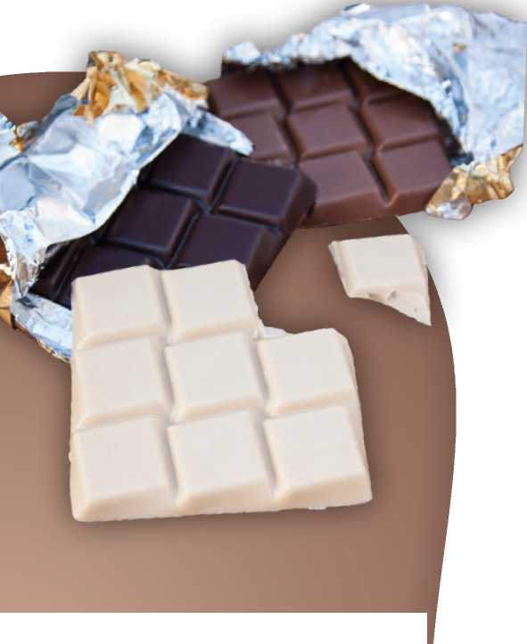

| **1** | a | badly-paid | b | creative | c | rewarding |
| --- | --- | --- | --- | --- | --- | --- |
| **2** | A | the best | b | better | c | best |
| **3** | a | I'm getting | b | I'll get | c | I got |
| **4** | a | stood | b | stands | c | standing |
| **5** | a | bit | b | few | c | lot |
| **6** | a | do | b | had done | c | was doing |
| **7** | a | confused | b | delighted | c | disappointed |
| **8** | a | would have | b | have | c | 's going to have |
| **9** | a | get | b | will get | c | gets |
| **10** | a | had to | b | 'll have to | c | have to |

**D** A major chocolate company is looking for a new Taste Assistant for their UK office.

Many people eat too quickly to pay attention to what they are eating.

The rest of the time will be spent at the company's headquarters experimenting with different flavours.

Grammar and vocabulary

1. **Choose the best options to fill in the blanks.**

**How TO GET YOURSELF NOTICED**

Marketing graduate Alfred Ajani, aged 22, applied unsuccessfully for over three hundred positions when he finished university. It seemed that the only posts available were for 1 temporary jobs. Alfred wanted something

2 , so he decided to try a different approach. ‘If I give

people my CV in person, perhaps 3 a job,' he thought. He

went to London's Waterloo Station and [83] at the entrance

with a pile of CVs and a card advertising his services. At first, commuters were a 5 suspicious, but then they started

going up to him to ask what he 6 . During the day, he

met some very interesting people. When he got home, Alfred received a phone call about a marketing job in Barcelona. He was 7 because his plan had worked. He 8 an

interview for the job next week. If he 9 the job, he'll be

able to work using his studies. Of course, he 10 learn a new

language too.

Writing

1. Write an application letter for the job in exercise 4. Include this information:

* what the job is and how you found out about it
* why you are interested in the job
* why you are the right person for the job
* what you are sending with the letter and when you can start work
* what you would like to happen next.

**Listening**

**shopping habits. Match speakers 1-4 with the item below that they are most likely to buy.**

**Listen to four speakers talking about their**

**Q2.14**

**an album an electronic device earrings a guitar an e-book some potatoes a dress**

Speaker 1:

Speaker 2:

Speaker 3:

Speaker 4:

**sentences A-E. There is one extra sentence.**

**Listen again. Match speakers 1-4 with**

**02.14**

**A** Speaker buys something which is not often

used today.

**B** Speaker spends money online.

**C** Speaker only saves money by buying a lot of

something.

**D** Speaker pays for things with somebody else's

money.

**E** Speaker is running out of space for all the

things he / she buys.

**Speaking**

1. **Work in pairs. There are plans to open new businesses in your town. Which one of the shops and services below would be most successful and why? Why are you rejecting the other options? Write notes below. baker’s charity shop clothes shop estate agent’s jeweller’s takeaway**

**Choices:**

**Reasons for rejecting other options:**

**Reading**

1. **Read the three texts. For each text, choose the correct answer (a, b or c).**
2. **Look back at questions 1-3 in exercise 4. Explain in your own words why the other options are not correct.**

**Best tv**

*moments*

The highlight of last night's television was the first episode of a reality show Secret Millionaire. The idea behind the show is for a millionaire to take on a new identity and go into poor areas of their city to find three charities to give some of their money to. They spend a week working with the organisations, revealing their true identity at the end of the programme. At this point, they give each of the charities a cheque for tens of thousands of pounds. Last night's show had more drama than usual - you'll have to watch to find out why - but finished with millionaire music producer David King donating £50,000 to the charities he had

worked with.



**1** The author of the text wants to

**a** give advice to millionaires on what to do with their money. **b** give an opinion of a TV programme.

**c** explain how reality shows can be good for society.

**What's in a sofa?**

When three students bought a sofa from a charity shop, they got more than they paid for. When they brought the sofa home, they discovered an envelope full of $20 notes hidden under the cushions. They continued to look and found more envelopes! By the time they finished, they had over $40,000. At first, the students began to talk about what they would do with the money. One said he would buy his mum a new car. But when they found a woman's name on one of the envelopes, they knew that they had to give it back. They called the woman who was so delighted to hear from them that she gave them $1,000 for returning her money.

**2** What was the students' first idea when they realised they had $40,000?

**a** To split up the money and spend it

**b** To find the person who it belonged to

**c** To call the charity shop about the sofa

**Cumulative Review 4 (Units I-7)**

Grammar and vocabulary

Calling all  
students!

**6 Choose the best options to fill in the blanks.**

Are you over seventeen years and six months old and in full-time education? Then why not open an account with us? With our Student Account, you get all the usual offers: free online banking and access to your money twenty-four hours a day, seven days a week. But on top of that, we won't charge you for going over your limit (up to £1,400). We also have a new banking app that you can use to manage your money more easily. If you want a flexible way to look after your money, our Student Account is the one for you. To open an account, fill in the application form on our website, or call your nearest branch for more information.

**3** The text gives readers

**a**

some information about different kinds of bank accounts

tips on how to manage your money as a student a number of reasons why they should open one particular account

**SHOPPING  
revolution**

Do you often go shopping? If so, how do you usually

1 the items you buy? Some people still use

cash, because it s easier to know2 money you

have spent. But if you're 2 of money when you

reach the supermarket check-out, it can be very embarrassing, other people pay by card, so that they4 carry a lot of money around with them.

Unfortunately, credit cards often make you spend more money5 you had planned. And it isn't until

the end of the month that you realise that you 6 the bank a lot of money. To carry cash or cards, you need a wallet and a bag - or quite a big pocket! But wouldn t it be great if you 7 your wallet at home?

If you 3 o smartphone, it seems that you will soon

be able to do that. The company Vocalink

1. a new app called Zapp which will allow people

to pay by phone in the future. Zapp will completely change the way we shop - and our mobile phones

1. even more necessary than they already are.

|  |  |  |  |  |  |  |
| --- | --- | --- | --- | --- | --- | --- |
| **1** | a | buy for | b | pay | c | pay for |
| **2** | a | how much | b | how | c | how many |
| **3** | a | few | b | short | c | little |
| **4** | a | don't have to | b | must | c | mustn't |
| **5** | a | as | b | than | c | that |
| **6** | a | borrow | b | owe | c | lend |
| **7** | a | would leave | b | will leave | c | could leave |
| **8** | a | have | b | will have | c | would have |
| **9** | a | develops | b | is developing | c | had developed |
| **10** | a | become | b | will become | c | would become |

Writing



**Cumulative Review 5 (Units I—8)**

Listening

Reading

**1 K~2.15| Listen to four conversations about gadgets and choose the best answers.**

**1**

**2.15**

Listen to an answerphone message. What is the speaker's intention?

**a** To apologise to her friend

**b** To tell her friend about her holiday

**c** To thank her friend

Listen to a conversation at the police station. What colour is the tablet?

**a** Black

**b** Purple **c** White

Listen to a radio announcement. What is the speaker's intention?

**a** To challenge the listeners

**b** To persuade the listeners to do something **c** To describe something to the listeners Listen to a conversation between a mother and her son. What does she give him for his birthday?

**a** A computer

**b** A games console

**c** A television

3 Match texts A-D with questions 1-6 below. Some questions match with more than one text.

Which invention(s) ...

1

was / were discovered during the scientist's free time?

Speaking

was / were made when scientists were working on something else?

was / were previously used for something different?

resulted from something getting too hot? _ is / are used for joining two things together?

took the longest to be developed?

**INVENTED BY**

**ACCIDENT**



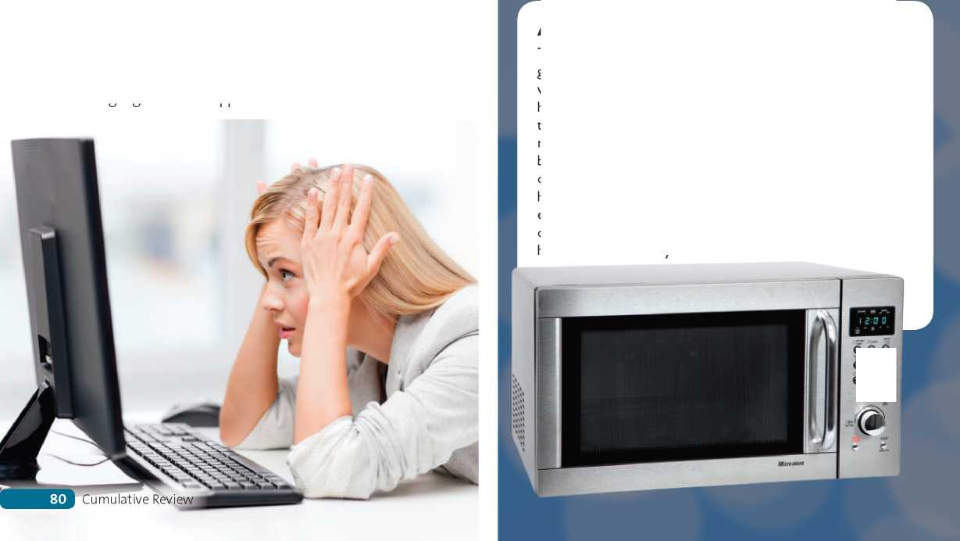

**3**

How do you think the person is feeling?

Which is worse in your opinion, a broken computer or a broken mobile phone?

When was the last time you had a problem with a gadget? What happened?

**2 Work in pairs. Look at the photo and answer the questions.**

**1**

**2**

**A MICROWAVE OVEN**

This useful kitchen device was invented by an electronics genius called Percy Spencer. Spencer had been in the Navy, where he had taught himself how to be an engineer. When he left, he got a job at Raytheon, an important company in the arms industry. In 1945, Spencer was experimenting with radar when something strange happened. He noticed that a bar of chocolate in his pocket had melted. Spencer worked out that it was the microwaves from the radar that had heated the chocolate. Spencer continued investigating the effects of microwaves on food and developed the microwave oven. The first machine was sold just a year after Spencer had made his discovery.

**e e e** *é e ẹ* **e é** *é*

**ĩ**

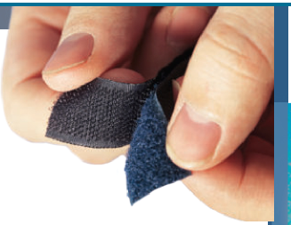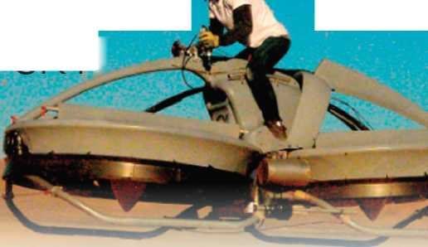

Cumulative Review 5 (Units I—8)

**4 Choose the best options to fill in the blanks.**

started life as a cleaning product. It

wallpaper cleaner did not sell very

money. That is, until the company

REACH FOR THE SKY!

| **1** | a | are | b | was | c | would |
| --- | --- | --- | --- | --- | --- | --- |
| **2** | a | was done | b | was doing | c | has done |
| **3** | a | allows | b | lets | c | prevents |
| **4** | a | is developed | b | developed | c | was developed |
| **5** | a | said | b | told | c | told to |
| **6** | a | is changed | b | was changed | c | has been changed |
| **7** | a | enough | b | too | c | too much |
| **8** | a | needn’t | b | mustn’t | c | can’t |
| **9** | a | costs | b | pays | c | charges |
| **10** | a | wanted | b | want | c | will want |

**B VELCRO**

**5**

**Grammar and vocabulary**

**Writing**

**C PLAY-DOH**

called Kutol Products and it was

Velcro was invented by a Swiss engineer called George de Mestral. In 1948, Mestral was out walking with his dog when he noticed that the dog was covered in small green balls. The balls were the seeds of a plant which was common in the area. Mestral wanted to know what made these balls stick to his dog's fur, so he looked at one of them under his microscope. He saw that it had a lot of tiny hooks. Mestral realised that this technique could be used to make two strips of material stick together. He experimented with a variety of materials for years until the invention of nylon, which was perfect for his idea. The first Velcro was finally produced in 1955.

The children s toy Play-Doh actually was made by an American company used to clean wallpaper. Sadly, the well, so Kutol Products began losing realised that its product was being used for a different purpose. Children had started using it to make Christmas ornaments in the shape of people and animals. Kutol Products adapted their product almost overnight by taking out the cleaning ingredient and adding colours and a nice smell. They also gave it a new name. Play-Doh went on to become one of the best-selling children's toys ever.

**D SUPERGLUE**

In 1942, Dr Harry Coover of Eastman-Kodak Laboratories was trying to find a new material to use for making part of a gun. He was disappointed to see that his latest effort, a substance called cyanoacrylate, was a complete failure because it stuck to everything it touched. Coover threw it away and forgot about it. Six years later, he came across cyanoacrylate once more when his company was developing a new design for part of a plane. Again, the substance stuck to everything in sight. But this time, Coover realised that the substance might be useful, because it didn't need heat to make it stick. Coover carried on experimenting with cyanoacrylate in his lab, and it appeared in DIY stores as superglue sixteen years after he had first used it.

It is incredible what inventors can come up with these days. In the past, people said that it 1 impossible to make a flying

motorbike, but a California-based company called Aerofex 2 just that. The Aero X hoverbike runs on normal petrol and

it 3 two people to ride up to three metres above the ground

at a speed of 70 km/h. The first model *4* back in 2012, but

experts 5 the company that it looked very ugly. Since then,

the design 6 so that now it looks like something out of the

film Star Wars. It has taken so long to produce because this kind of vehicle has always been considered 7 dangerous. You

1. have a pilot's licence to use the hoverbike, but all riders

will have to do a training course before they buy one. The Aero X 9 around $85,000 and can be reserved on the company's

website for $5,000. But if you 10 one, you'll have to be quick,

because they are sure to be very popular.

1. Imagine you have just returned home from a visit to a science museum. Write an email to a friend in which you:

* describe the journey to the museum.
* describe the science museum.
* tell the story of one of the exhibits.
* suggest an activity to do together when your friend visits.

**Talking about likes and dislikes**

I can't stand ... (1A)

I don't mind ... (1A)

I hate ... (1A)

I love ... (1A)

I quite like ... (1A)

I'm really keen on ... (1A)

... isn't bad. (1A)

... is great. (1A)

... is terrible. (1A)

**Making suggestions**

Shall we ... ? (2H)

Let's ... (2H)

Do you fancy ... ? (2H)

How / What about ... ? (2H) It would be nice to ... (2H) We could always ... (2H)

Why don't we ...? (7G)



**Expressing likes and dislikes**

**Reacting and showing interest**

You're joking / kidding! (1G)

How boring / funny / frustrating / exciting / upsetting / awful! (1G)

That's amazing / exciting / worrying / shocking! (1G)

That sounds great / terrible / annoying / terrifying! (1G)

What a cool thing to do! (1G)

Really? I'm so envious! (1G)

Really? What a relief! (1G)

That sounds like a nightmare! (1G)

Oh no! What a disaster / shame! (1G)

|  |
| --- |
| **Describing a photo** |
| The photo shows ... (2G) |
| in the foreground / background (2G) |
| in the top left corner / bottom right corner (2G) |
| at the top / bottom (2G) |
| on the left / right (2G) |
| in the centre (2G) |
| It looks like a ... (2G) |
| It looks as if they're ... (2G) |
| She seems to be ... (2G) |
| **Speculating about a photo** |
| She's probably feeling ... and ... (2G) |
| I expect they're feeling ... , but maybe a bit ... (2G) |
| Judging by ... , I'd say ... (2G) |
| To me, they look as if they're feeling ... (2G) |
| It can't be ... because ... (4G) |
| It must be ... because ... (4G) |

I quite fancy. / I don't really fancy (3G) I'm / I'm not a big fan of ... (3G)

I'm / I'm not keen on ... (3G)

I adore ... / I can't stand ... (3G)

**Expressing a preference**

I'd rather ... (3G)

I'd prefer (to) ... (3G)

I think ... will be better / more fun, etc. (3G)

**Reaching an agreement**

Shall we settle on ... ? (3G)

OK, I agree. (3G)

That's agreed, then. (3G)

That's a great idea. (3G)

**Comparing and contrasting: similarities**

The common theme in the photos is ... (4G)

You can see ... in both photos. (4G)

Both photos show ... (4G)

In both photos there are ... (4G)

**Comparing and contrasting: differences**

The first photo shows ... , whereas the second photo shows ... (4G)

In the first photo ... , but in the second photo ... (4G)

One obvious difference is (that) ... (4G)

Unlike the first photo, the second photo shows ... (4G)

In contrast to the first photo, the second photo ... (4G)

**82**

Functions Bank

**Expressing opinions**

**Accepting a suggestion**

I think / I don't think that ... (4H)

In my opinion, ... (4H)

I believe / don't believe that ... (4H)

It seems to me that ... (4H)

To be honest, ... (4H)

As I see it, ... (4H)

**Making contrasts**

I'm sure I'll enjoy it even though ... (5G)

Although it's ... , it will be very ... (5G)

The job is quite ... . However, I really don't want to work in a ... (5G)

The ... isn't very good. Nevertheless, I'm choosing this job because I'm interested in ... (5G)

**Structuring your speech**

I'd like to start by saying / looking at ... (6G)

First of all, we need to decide / examine / look at / ask ourselves ... (6G)

I'll begin with . (6G)

Now I'd like to move on to . (6G)

This leads to my next point. (6G)

Now let's look at / move on to (the question of ...) (6G)

That sounds like a great idea. (7G) What a good idea! (7G)

I like that idea. (7G)

That's a really good plan.

Yes. Why not? (7G)

Let's do that. (7G)

**Declining a suggestion**

I'm not sure about that. (7G)

I don't think that's a great idea. (7G)

I'm not very keen on that idea. (7G) I'd rather not. (7G)

**Expressing no preference**

I don't mind. (7G)

Either suggestion is fine by me. (7G)

They're both good ideas. (7G)

**Agreeing and disagreeing**

I don't agree that ... (8D)

I agree that ... (8D)

I'm not sure that ... (8D)

I wouldn't say that ... (8D)

**Ordering points or opinions**

First, ... Second, ... Finally, ... (6G)

**Justifying your opinions**

There are a number of reasons why I believe this. First, ... (6G) I'll tell you why I think that. (6G)

The reason I say that is ... (6G)

The main reason I feel this way is ... (6G)

**Making a complaint**

There's a problem / something wrong with ... (8G) It's broken. (8G)

It doesn't work. / It has stopped working. (8G)

Can I have my money back, please? (8G)

Can you exchange / repair it? (8G)

Can I see / speak to the manager, please? (8G)

**Summing up your opinion**

To sum up, ... / In conclusion, ... / All in all, ... (6G)

Just to summarise the main points ... (6G)

Functions Bank

**83**

This edition of Solutions is published by arrangement with Oxford University Press, Great Clarendon Street, Oxford for sale in Vietnam only and not for export therefrom.

© Oxford University Press 2022

The moral rights of the author have been asserted

**No unauthorized photocopying**

All rights reserved. No part of this publication may be reproduced, stored in a retrieval system, or transmitted, in any form or by any means, without the prior permission in writing of the copyright holder, or as expressly permitted by law, by licence or under terms agreed with the appropriate reprographics rights organization.

You must not circulate this work in any other form and you must impose this same condition on any acquirer.

ISBN: 978-604-0-31172-6

Printed in Vietnam by Tran Phu Printing Company

This book is printed on paper from certified and well-managed sources.

ACKNOWLEDGEMENTS

*Back cover photograph:* Oxford University Press building/David Fisher

*The authors and publisher are grateful to those who have given permission to reproduce the following extracts and adaptations of copyright material:* p.61 Adapted extract from “Teenage trips: that first parent-free holiday” by Sam Wollaston, The Guardian, 12 June 2010. Copyright Guardian News & Media Ltd 2010. Reproduced by permission. p.81 Adapted extract from “Whoops! The 10 Greatest (Accidental) Inventions of All Time” by Sam Biddle, [www.gizmodo.com](http://www.gizmodo.com), 26 August 2010. Reproduced by permission of Gawker Media.

Cover image by: Shutterstock (mosaic background design/ Hakki Arslan).

*Back cover photograph:* Oxford University Press building/David Fisher Illustrations by: Dylan Gibson pp.6, 8, 17, 20, 22, 32, 41, 54; Andy Parker pp.16, 25, 27, 30, 56, 58, 48, 64, 67, 68, 70.

The publisher would like to thank the following for their kind permission to reproduce photographs and other copyright material: 123RF pp.29 (warning sign/Stefanina Hill), 54 (biology field trip/Ingemar Magnusson); Alamy Images pp.22 (wall climbing/David Kilpatrick), 61 (man camping in rain/Mikael Utterstrom), 64 (cube teapot/shufu), 65 (Babbage Analytical Engine Computer/Chris Howes/Wild Places Photography), 65 (early computer/INTERFOTO), 68 (space elevator/

Science Photo Library); ColaLife p.69 (ColaLife/Mark X AidPod/ Simon Berry); Corbis pp.18 (volcano boarding/Christian Heeb/ JAI); Getty Images pp.6 (girl waiting for train/Caroline Purser), 18 (young woman rock climbing/ ParkerDeen), 18 (kayaking down waterfall/Randy Lincks), 19 (great white shark fin/ Martin Barraud), 22 (rock climbing on coast/James Martin), 23 (couple kayaking/Peter Cade), 23 (quad bike race/Glenn Frank), 23 (rock climber on rope/Tyler Stableford), 33 (meteor in night sky/ ichael Dunning), 35 (newswoman sitting at desk/ DreamPictures), 36 (polar bear on melting ice/ Erlend Kvalsvik), 45 (cleaning sewer pipe/Boris Horvat), 45 (fishing in Alaska/ Jean-Erick Pasquier ), 46 (coach talking to basketball players/ KidStock), 46 (businesswoman and receptionist/Image Source), 53 (Warren Buffett/ Bloomberg),73 (plastic spider in jar/ Dave King), 74 (boy using laptop on bed/ Claude Dagenais), 77 (white, dark and milk chocolate/Luka), 81 (tube of glue/ The Washington Post); Kobal Collection p.44 (Avatar film still/ Twentieth Century-Fox Film Corporation); Oxford University Press pp.23 (runners looking at map/Philip Lee Harvey), 26 (futuristic smartphone/Ocean), 33 (comet in space/Photodisc), 64 (sat nav/Image Source), 65 (tablet computer/Gareth Boden), 76 (job interview/Kzenon), 80 (microwave/D. Hurst); Press Association Images pp.13 (Alex Lenkei undergoing operation using hypnosis/ PA Video/PA Archive), 21 (Steven Callahan/ Pat Wellenbach/AP); Rex Features pp.52 (Tesco ‘Homeplus’ virtual shop in Seolleung metro station/Paul Brown), 81 (Aerofex Hoverbike/Aerofex); Rex Shutterstock p.38 (snow in New York/ Sipa Press); Shutterstock pp.4 (teens playing basketball/dotshock), 6 (businessman/George Dolgikh), 9 (twenty pound notes/stocksolutions), 9 (lottery ticket/Robert Lessmann),11 (snowboarder jumping/Ipatov), 23 (kite surfing/ EpicStockMedia), 23 (rock-climbing/Vixit), 23 (mountain biking/ Ljupco Smokovski), 23 (young man on jet ski/EpicStockMedia), 26 (motorbike on display/Cherkas), 26 (chocolate ice cream/ DUSAN ZIDAR), 29 (Japan earthquake/photopixel), 29 (phone/ Wanchai Orsuk), 34 (volcano erupting/ Pablo Hidalgo), 34 (cracked soil after drought/draganica), 37 (tornado aftermath/ Alexey Stiop), 38 (Central Park, New York City/Gregory James Van Raalte), 38 (children jumping in puddle/Kuttelvaserova Stuchelova), 38 (snowball fight/Maridav), 45 (lumberjack cutting tree/Christian Delbert), 57 (San Francisco tram/kropic1), 60 (Jet2 plane mid-air/Brendan Howard), 54 (open top bus/ Peteri), 64 (speakers/VikaSuh), 80 (stressed businesswoman/ Syda Productions), 81 (velcro/Stocksnapper), 81 (jar of Play- Doh/ dcwcreations); Vestergaard p.69 (life straw/Vestergaard).

**9** I wear these to cover my hands when the weather

is cold.

**10** A woman wears this. It usually covers her from

her shoulders to her knees.

**4 Read the notices from a lost property website. Look at the photos and complete the descriptions.**

**brown dark eyesjacket long moustache scarf shirt short straight tie wavy**

You were on the 36 bus on Monday at 7.40. You left your glasses on the bus. Please

contact me and I'll return them to you. You have 6 , 7 8

8 hair and brown 9

have a dark beard and a 10 * 4 *

You wore a stripy 11

12

**5**

1. I borrowed a DVD from my friend, but I've lost it.

Hi Andy,

I hope you are well.

I'm having a party on Saturday evening to celebrate the end of our exams. We're meeting in the park at six 1 and playing some

games, * I 2 * 4 football, volleyball and basketball. Then we're

having a picnic. I am providing the drinks for everybody, but please bring something to eat.

I hope you can come. 3

Mike

4

1. includes cartoon characters, usually made with

computers.

1. makes you laugh.

**wear school uniforms**

**2 Complete the fact file. Use the comparative form of the**

**words in brackets.**

Clues:

1. What time of day is it?

Clues:

**Listen to three extracts one at a time. Match each extract with a natural disaster from exercise 1.**

1. Natural disaster:
2. Natural disaster:
3. Natural disaster:

**Listen again and choose the correct answers.**

1. The dialogue takes place

**a** in a shopping centre.

**b** in the street.

**c** in a supermarket.

1. The disaster happened while the speaker **a** was on holiday in Japan.

**b** was in a business meeting.

**c** was in a Japanese lesson.

1. The speaker first went to Africa

**a** about three years ago.

**b** about two years ago.

**c** when he finished university.

**4 Now do the task from exercise 3 using your notes.**

**5 Complete the dialogue using the first conditional.**

**Sarah** Do you fancy going to the café later?

**Claire** No thanks. If I go to the café, I 1 (fail)

my exam on Monday.

**Sarah** Really? What do you mean?

**Claire** If I go to the café, I *2* (see) Cathy. If I see

Cathy, she 3 (invite) me to her party. If

she *4* (invite) me to her party, I'll stay

out late on Saturday. If I stay out late on Saturday, I 5 (sleep) all Sunday morning. If I sleep

all Sunday morning, I 6 (not do) any

revision. If I 7 (not do) any revision, I

1. (fail) my exam on Monday!

**6 Now write a dialogue like the one in exercise 3. Use the chain of ideas below.**

**go shopping spend all my money have to stay in on Friday night not see Connor he *I* not invite me to barbecue not see his sister again**

**Susie** Would you like to go shopping later?

**Dave** I can't. If I go shopping, I won't see Connor's sister again.

**Susie** Really? What do you mean?

**Dave** If I go shopping, I'll spend all my money.

If I **i.**

**7.35 pm @Sam2020**

‘ Having a great time on our cycling tour of Provence in the South of France. We arrived on Saturday after a long journey on the train from London. We’ve cycled about 150 km since Saturday morning and I’m exhausted! Danny is tired too, but he’s fitter than

I am. The countryside is beautiful, but there are lots “-* 1 of hills!! The weather has been warm and sunny

- maybe a little too hot for me. We’ve stayed at a different place every night so far. Two nights ago we stayed at a farm, and last night we stayed in a small —hotel. Staying in a castle tonight, which is amazing!

Tomorrow, we’re visiting a lake. It’s quite a long way from here, in the mountains. We’ll stay there all —3 afternoon and go swimming. Looking forward to it!

I’ll post again in two days.

1. Which very hard material do we find in the ground?

**2** Cats get frightened if you shout **at** / **to** them.

**3** I asked **about** / **for** the manager so that I could talk to him in person.

**4** We complained **for** / **about** our hotel room.

**5** I've never heard **from** / **of** this video game.

**6** I dreamed **about** / **of** flying again last night.

**7** After a long discussion, they agreed **to** / **with** our request and gave us our money back.

**8** If you're unhappy with the service, why don't you write **for** / **to** the manager?

1. **Study the dictionary entries and answer the questions.**
2. Which verb is used with two prepositions with no change

of meaning?

1. Which verb is used with two prepositions, but the

meaning changes?

1. Which entry uses ***bold and italic*** type for two words that

often go together?

1. I can't stand .
2. I'm really keen on
3. chess.
4. football.
5. video games.
6. **tense (1-6).**
7. something that happens regularly I I
8. verbs not used in continuous tenses I I
9. something happening at this moment I I
10. stating a fact or law I I
11. something happening around this time I I
12. a future plan I ]
13. 1. **Read the sentences. Then write questions for the given answers.**

   
14. Jack gave his old bike to his sister.

    Q: What did Jack give his sister?

    A: His old bike.
15. Sam had dinner early because he was hungry.

    Q: _ _

    A: He was hungry.
16. Mason and Tyler went to London together.

    Q: _

    A: He went with Tyler.
17. Grace listened to three Lady Gaga CDs.
18. Q:
19. A: Three.
20. noun:
21. Example:
22. **CHECK YOUR WORK**
23. **<®> Have you ...**
24. q Q covered all four points in the task?
25. n included adjectives to describe feelings? n checked your spelling and grammar?
26. **Complete the text with the past simple or past continuous**
27. **form of the verbs in brackets.**
28. **Complete the sentences with *a few* or *a little.***

    1. I saw Harry hours ago.
    2. I only want water. I'm not very thirsty.
    3. There are good cafés in our town.

   
29. Please spend time tidying your room.
30. I only speak French.

    1. **Complete the questions with *How much* or *How many.***
    2. films do you see at the cinema each

    month?

    1. time do you spend watching TV

    each day?

    1. text messages do you send each day?
    2. money do you spend on DVDs and

    video games each month?

    1. televisions are there in your home?

   
31. **Write sentences about rules at school. Use *have to, must* and**
32. ***needn’t* and the ideas below. If you can, add your own ideas.**
33. **arrive at school on time be quiet in the corridors eat snacks in class hand in homework on time have lunch in the canteen use a mobile phone in class**
34. **ế**

    **VOCAB BOOST!**

    When you record a new adjective, make a note of synonyms and antonyms at the same time. Antonyms often begin with a negative prefix.
35. 1. **Number the adjectives in order from the hottest (1) to the coldest (7).**
    2. I cold I I hot I I sweltering I I cool

   
36. I mild I I warm I I freezing
37. **Reading Strategy**
38. To help you decide which phrases fit which gaps, think about the grammar of each sentence. For example, is the first word in the gap a verb? Or is a different kind of word needed?
39. **Read the Reading Strategy. Then match the phrases (A-I) with gaps 1-8 in the text. Check that each phrase fits the grammar of the sentence. There is one extra phrase.**
40. **A** spinning around in the air

    **B** bring her home
41. **C** ran back to their house

    **D** which warned them that

    **E** were not as lucky

    **F** without looking back
42. **G** holding their maths books

    **H** realised where he was
43. 1. to leave the school

   
44. 1. do not believe that this is true. Adults make the most important decisions about global warming, not young people. For example, governments have to decide between fossil fuels and renewable energy. [A] Furthermore, adults decide how ‘green’ their lifestyle at home should be: Do they buy a big or small car? Do they live in a big or small house? And so on. IB] Having said that, young people are often better at remembering to recycle plastic bottles and other containers. What is more, children walk and cycle more often than adults and this causes less pollution. [C] However, they probably walk and cycle more because they are too young to drive, not because they care about the environment! So all in all, I do not think young people are doing more than older people.

   
45. **Complete the sentences with the prefixes below. co mini mis multi over post**

    My dad is mornings a week.

    The company lost millions because of management

    at the highest level.
46. Six of my -workers have lost their jobs in the past

    year.
47. My last proper holiday from work was four years ago, although I've had a few -breaks.
48. If we can't find the right person for the job, we'll just have to -advertise.
49. She finished her university degree and then did a graduate qualification.
50. She never stops for lunch: she just drinks coffee and takes vitamin pills!

    I don't want to sound confident, but I'm sure I'll be

    good at this job.
51. **Complete gaps 1-5 in the letter with these phrases.**
52. **a** have experience

    **b** sincerely
53. **c** am emailing to apply for
54. **d** saw your advertisement
55. **e** believe I would
56.
57. make
58. can't stand
59. visit Athens **X**
60. spend lots of money **✓**
61. go windsurfing **✓**
62. read lots of books **X**
63. swim in the sea **✓**
64. send many postcards **X**
65. **How do these references to time and place change in reported speech?**

    **Direct speech**

    1. today
    2. a week ago
    3. yesterday

   
66. last year
67. tomorrow
68. next month
69. here
70. tourist:
71. **Complete the sentences with the compounds in exercise 2.**

    1. As his four-year-old son sat down on the

    , it started to move.

    1. Our . is EZY 8512.
    2. He doesn't always sit in ,

    even though he owns the airline.
72. I asked the for a pair of

    headphones.
73. You can keep your under

    the seat in front of you.
74. When several flights land at the same time, there are

    long queues at .
75. When you're travelling alone, it's cheaper to book a
76. the missing jewellery / ever / found? / Was
77. The factory has been sold .
78. The glass in the windows .
79. The big front door .
80. The metal sign .
81. A new road .
82. The new roof
83. Here, they must identify the flavours of

    chocolate bars that the company has prepared specially. They won't be able to see the chocolate that they have to taste. The final stage will be a live ‘Taste Challenge' in which the five best candidates will take part. The prize for the winner will be the Taste Assistant job.

    If you are i nterested in the post, you need to send in a CV with a covering letter. 5 The

    company will hold interviews in the first week of January, and the successful candidate will start their new job early next year.